StatDCAT-AP – DCAT Application Profile for description of statistical datasets Version 1.0.1

DI/07624 - ABC IV Lot 3 SC63

Basic Document Metadata

|  |  |
| --- | --- |
| Property | Value |
| Name | StatDCAT-AP – DCAT Application Profile for description of statistical datasets Version 1.0.1 |
| Release date | 10/05/2019 |
| Status | Under Development |
| Version | 0.1 |
| Author | Natasa Sofou, Adina Dragan |
| Reviewed by | Susanne Wigard, Fidel Santiago, Marco Pellegrino |
| Approved by | Susanne Wigard and Fidel Santiago |
| Abstract | This document is the result of the Bug fix change release process described in the Change and Release Management Policy for DCAT-AP and was built starting from StatDCAT-AP version 1.0.0 |

# 

Document History

|  |  |  |  |
| --- | --- | --- | --- |
| Version | Date | Description | Action |
| 0.1 | 02/05/2019 | Created first internal draft | Created |

**Disclaimer:**

|  |
| --- |
| The views expressed in this report are purely those of the Author(s) and may not, in any circumstances, be interpreted as stating an official position of the European Commission.  The European Commission does not guarantee the accuracy of the information included in this study, nor does it accept any responsibility for any use thereof.  Reference herein to any specific products, specifications, process, or service by trade name, trademark, manufacturer, or otherwise, does not necessarily constitute or imply its endorsement, recommendation, or favouring by the European Commission.  All care has been taken by the author to ensure that s/he has obtained, where necessary, permission to use any parts of manuscripts including illustrations, maps, and graphs, on which intellectual property rights already exist from the titular holder(s) of such rights or from her/his or their legal representative. |

Table of Contents

Executive summary 8

1. Introduction 10

1.1. Background 10

1.2. Objectives 11

1.3. Roadmap 12

1.4. Structure of this document 13

2. Terminology used in this document 15

3. Related work 17

3.1. Statistical data and metadata initiatives 17

3.1.1. Eurostat and EU Publications Office collaboration 17

3.1.2. SDMX 17

3.1.3. ESMS 19

3.2. Open Data standards and application profiles 20

3.2.1. W3C DCAT 20

3.2.2. DCAT-AP for open data portals in Europe 22

3.2.3. GeoDCAT-AP 24

3.2.4. The Data Cube Vocabulary 25

4. Use cases 27

4.1. Improve discoverability of statistical datasets on open data portals 27

4.2. Federation of open data portals 27

5. Methodology 28

5.1. ISA Core Vocabulary process and methodology 28

5.2. Analysis and decision framework 28

5.3. Stakeholders 28

5.4. Time plan 29

6. The StatDCAT-AP data model 30

6.1. Informal description 30

6.2. Extensions and specific usage for description of statistical datasets 31

6.2.1. Dimensions and attributes 31

6.2.2. Quality aspects 32

6.2.3. Visualisation 33

6.2.4. Number of data series 34

6.2.5. Unit of measurement 34

6.2.6. Specifying the length of time series 35

6.3. Overview of the model 35

6.4. Namespaces 36

6.5. UML Class diagram 37

6.6. Description of classes 37

6.6.1. Mandatory Classes 37

6.6.2. Recommended Classes 38

6.6.3. Optional Classes 38

6.7. Description of properties per class 39

6.7.1. Catalogue 40

6.7.2. Catalogue Record 40

6.7.3. Dataset 41

6.7.4. Distribution 44

6.7.5. Agent 45

6.7.6. Category Scheme 45

6.7.7. Category 45

6.7.8. Checksum 46

6.7.9. Identifier 46

6.7.10. Licence Document 46

6.7.11. Period of Time 46

6.8. Controlled vocabularies 47

6.8.1. Requirements for controlled vocabularies 47

6.8.2. Controlled vocabularies to be used 47

6.8.3. Mapping Eurostat theme vocabulary to the EU Vocabularies data themes 49

6.8.4. Other controlled vocabularies 50

6.8.5. Licence vocabularies 50

7. Mapping and Extraction approaches 52

8. Conformance statement 53

8.1. Provider requirements 53

8.2. Receiver requirements 53

9. Agent roles 54

10. Date and Time 56

11. Accessibility and Multilingual Aspects 57

12. Acknowledgements 59

Annex I. Quick Reference of Classes and Properties 61

Annex II. StatDCAT-AP new properties log 63

Annex III. Resolution log 64

Annex IV. Mapping SDMX to StatDCAT-AP 68

Scope 68

Diagrams 68

Example 70

Introduction 70

SDMX Annotations 71

Explanation of the mapping diagrams 73

Data Catalogue 73

Linking to Categories using Categorisations 74

Dataset 75

Dimension Property and Attribute Property 76

Quality Annotation 76

Distribution 77

Agent 78

Summary 78

Annex V. SDMX-based Transformation Mechanism 79

Scope of this section 79

Transformation mechanism 79

Transformation input formats 80

Choice of mechanisms 80

SDMX Structural Metadata 80

SDMX Metadata Set 82

Advantages and disadvantages of the two transformation formats 86

SDMX Structure Message 86

SDMX Metadata Set 87

Summary 87

Annex VI. SDMX Files used for the examples 89

SDMX Structural Metadata 89

SDMX Metadata Set 93

Content 93

Annex VII. Examples of StatDCAT-AP descriptions of Data Cube DataSets 98

RDF Example 1 98

RDF Example 2 99

Annex VIII. Change Log 101

Table of Tables

Table 1 Controlled vocabularies in DCAT-AP 44

Table 2 Mappings between the Eurostat theme vocabulary and the MDR data themes vocabulary 45

Table 3 DCAT-AP properties mapped to the corresponding SDMX XML elements or attributes 65

Table of Figures

Figure 1: SDMX Main Components 16

Figure 2: SDMX Information Model: Schematic View 17

Figure 3: Fragment of ESMS specification 18

Figure 4: DCAT schematic data model 19

Figure 5: DCAT-AP Data Model 21

Figure 6: Data Cube vocabulary overview of key terms and relationships 24

Figure 7: Schematic map of SDMX Classes to DCAT-AP 60

Figure 8: DCAT-AP Model mapped to SDMX Model Classes 62

Figure 9: Metadata Used in the Mapping Example 62

Figure 10: SDMX XML schema specification for Annotation 64

Figure 11: SDMX-DCAT mapping example for the DCAT Catalogue 65

Figure 12: Schematic showing links between SDMX Categories and other SDMX objects 66

Figure 13: Linking Catalogue to DCAT Datasets and Category (Topic) Scheme 66

Figure 14: SDMX to DCAT mapping example for the StatDCAT-AP Dataset 67

Figure 15: Linking a Dataflow to the SDMX Category (Topic) 68

Figure 16: SDMX to DCAT mapping example for the StatDCAT-AP Annotation 68

Figure 17: Linking a Distribution to the SDMX Provision Agreement 69

Figure 18: Linking a Distribution (accessURL) to the SDMX Provision Agreement 69

Figure 19:Linking an Agent to the SDMX Agency 70

Figure 20: Diagram of the flow of metadata though the Intermediary Mechanism 71

Figure 21: From Section 9 - Linking a Distribution (accessURL) to the SDMX Provision Agreement 73

Figure 22: Transformation format - Linking a Distribution (accessURL) to the SDMX Provision Agreement 73

Figure 23: Example of a Provision Agreement for DCAT-AP Distribution 73

Figure 24: Schematic diagram of the SDMX Metadata Structure Definition model 74

Figure 25: Schematic diagram of the SDMX Metadata Set 75

Figure 26: Metadata Attributes in the DCAT-AP MSD 75

Figure 27: Example of Metadata Attribute Specification 76

Figure 28: SDMX catalogue metadata pertaining to the DCAT-AP Catalogue 77

Figure 29: SDMX category scheme metadata pertaining to the DCAT-AP Catalogue 77

Figure 30: SDMX dataset metadata pertaining to the DCAT-AP Catalogue including StatDCAT-AP extensions to the Dataset. 77

Figure 31: SDMX distribution metadata pertaining to the DCAT-AP Catalogue including StatDCAT-AP extensions to the Distribution 78

# Executive summary

This document contains the specification and the work that was carried out for StatDCAT-AP, an extension of the DCAT Application Profile for data portals in Europe[1] for describing statistical datasets, dataset series and services.

The StatDCAT Application aims at providing a commonly-agreed dissemination vocabulary for statistical open data. StatDCAT-AP defines a certain number of additions to the DCAT-AP model that can be used to describe datasets in any format, for example, those published in Statistical Data and metadata eXchange (SDMX)[2], a standard for the exchange of statistical data.

The principal objective of the development of the StatDCAT-AP, which is funded under ISA2 Action of the European Commission on 'Promoting semantic interoperability amongst the European Union Member States (SEMIC)’, is to facilitate a better integration of the existing statistical data portals within open data portals, thus improving the discoverability of statistical datasets across domains, sectors and borders. This will be beneficial for the general data portals, enabling enhanced services for the discovery of statistical data.

The work for the development of StatDCAT-AP was conducted in a transparent manner, visible to the public. The development was facilitated and moved forward as a result of the establishment of the StatDCAT-AP working group and the involvement of the main stakeholders towards reaching consensus in an open collaboration. This collaborative work takes place in a wider context, both on the European level with the Directive on the re-use of Public Sector Information, and on the global level with the G8 Open Data Charter. At the same time, it applies the technical standards developed by W3C towards a globally interoperable environment of Linked Open Data. Building upon these two pillars, StatDCAT-AP aims to improve the opportunities for discovery and reuse of statistical data to a wide audience.

StatDCAT-AP entered its public review period on 30 August 2016, which lasted until 31 October 2016. During that period twenty issues from five bodies (the National Statistics Institutes of France and Norway, Open Data Portal in the Czech Republic, the Permanent Representation of Denmark to the European Union and the Ministry of Finance of Brazil) were submitted on the draft version 4[3].

In order to develop the StatDCAT-AP, the following work was carried out:

**Landscape research and collection of requirements**

* Document all the related initiatives in the statistical domain, and the open data standards for facilitating information exchange between data portals and data catalogues.
* Identify high-level information and user requirements for the StatDCAT-AP by means of use cases.

**Implementation of common methodology**

* Implement the ISA Core Vocabulary process and methodology[4] aiming at involving the main stakeholders and reaching consensus in an open collaboration.
  + Following the methodology, all the working documents were published on Joinup[5], and all the issues were documented in an issue tracker[6] and discussed via a public accessible mailing list[7].

**Development of the specification and definition of the next steps**

* Extend the basic Application Profile with descriptive elements that can further help in the discovery, search and use of statistical data sets, data series, and services on general Open Data portals.

The next steps for StatDCAT-AP working group will be to provide an overview of values and opportunities offered by StatDCAT-AP in practice, and may report on the results of implementation at future events.

# Introduction

## Background

Collecting, compiling, analysing and publishing statistical data is a long-standing method to support decision making. Statistical data is available via high-end quality data publishing platforms as well as in the form of ad hoc created tabular data. It should be noted that the statistical data domain was one of the first data domains that provided open and transparent access to its data.

This value has been recognised: statistical information has been identified as “high value dataset” in the G8 Open Data Charter[8] and in its EU implementation[9]. This statement was confirmed in the Commission’s notice 2014/C 240/01[10], elaborating the results of the online consultation launched by the Commission in August 2013 on the revision to the PSI (Public Sector Information) Directive[11]. According to the feedback received, statistical data was identified as one of the thematic dataset categories among those “in highest demand from re-users across the EU”.

At the same time, Open Data Portals (ODPs) are being established throughout Europe by EU Member States. On the European level, the European Data Portal (EDP)[12] became operational in November 2015. Statistical data is of great interest for all the data categories in such open data portals and therefore it is beneficial for references to statistical datasets to be prominently visible in such data portals.

Open data portals bring together metadata and descriptions of datasets that are hosted by data providers. The portals harvest the metadata that is publicly exposed by providers from their content management systems in a standard exchange format. This standard metadata exchange format is known as the DCAT (Data Catalog Vocabulary) Application Profile for data portals in Europe (DCAT-AP)[13], developed under the aegis of the European Commission’s ISA (Interoperability Solutions for European Public Administrations) Programme[14].

Through 2015, activities focused on the scoping of the work on StatDCAT-AP. Preliminary work was done by a Core Working Group with representation from Eurostat, Publications Office, DG CONNECT and representatives of ISA supported by the contractor’s experts. That earlier work included definition of some terminology (data vs. metadata), an analysis of the statistical data publishing field and an analysis of standards for publishing statistical data and metadata. A conceptual mapping of SDMX (Statistical Data and Metadata Exchange) to DCAT-AP was also undertaken both on the metadata level (assessing “reference" metadata created by Eurostat using the Euro-SDMX Metadata Structure (ESMS)[15] as the standardised structure definition for creating data set descriptions) and on the data level (assessing how "structural" metadata can be derived from the data structure definition). In addition, the metadata properties used in statistical data portals were evaluated. All the terms used in this document including “reference metadata” and “structural metadata” are presented in Section 3.

The final report[16] of the work done in 2015 and is available on Joinup.

## Objectives

The DCAT-AP is intended as a common layer for the exchange of metadata for a wide range of dataset types. The availability of such a common layer creates the opportunity for a wide range of professional communities to hook onto the emerging landscape of interoperable portals by aligning with the common exchange format. In addition to the basic DCAT-AP, specific communities can extend the basic Application Profile to support description elements specific for their particular data.

The development of a DCAT-AP extension for the exchange of metadata for statistical datasets, called StatDCAT-AP, is in line with that approach, first by **determining which description elements in statistical data standards can be exposed in the DCAT- AP format**, and second by **extending the DCAT-AP with descriptive elements that can further help in the discovery and use of statistical data sets**.

The work on StatDCAT-AP is a first activity in the context of a wider roadmap of activities that aim to deliver specifications and tools that enhance interoperability between descriptions of statistical data sets within the statistical domain and between statistical data and open data portals. This roadmap, outlined in the next section, includes several activities that will take place over a longer period.

The work on the specification of the StatDCAT-AP contained in this document extended over a period of eight months from November 2015 through June 2016 and covered a set of initial activities. Considering the time and resource constraints, the ambition in this first phase was to achieve concrete results that would act as a demonstration and a reality check for the roadmap.

The overall objective of this first phase of work is summarised in the following charter:

The StatDCAT-AP activity is a first step in a roadmap that aims to enhance interoperability between descriptions of statistical data sets and general data portals, facilitating referencing of statistical data with other open data.

The concrete objective of the work was to develop and reach consensus on an Application Profile of the Data Catalog Vocabulary (DCAT) to be used for the description of statistical data sets with an initial focus on discovery of those data sets in a wider context.

The StatDCAT-AP is based on the DCAT Application Profile for Data Portals in Europe (DCAT-AP). In addition, initial guidelines on the extraction of relevant metadata from the existing implementation at Eurostat and possibly others will be elaborated in order to enable the export of metadata conforming to the application profile from existing data.

Based on the contributions of the main stakeholders, extensions to DCAT-AP can be proposed with descriptive elements particularly useful for discovery of statistical data sets beyond the possibilities offered by the generic DCAT-AP.

The work in this phase will concentrate on use cases that improve the discovery of statistical data sets published in open data portals across European institutions and EU Member States and in particular in the European Open Data Portal, as well as use cases that facilitate the integration of statistical data sets with open data from other domains.

The participants in this work had the opportunity to collaborate with colleagues from the statistical domain and with experts from the open data community, contributing and sharing their knowledge and experience with the current implementations of the statistical data standards, and were able to gain insight into possible approaches by which statistical data can be better disclosed outside of the statistical domain.

## Roadmap

The wider roadmap involves several steps as listed here:

1. Connecting descriptions of statistical datasets with general open data portals through a common basic exchange format, i.e. the StatDCAT-AP;
2. Developing guidelines for the extraction of metadata from specific implementations of statistical standards towards the common exchange format;
3. Harmonising implementations of statistical standards towards a more coherent landscape of statistical resources, possibly as an extension of the basic StatDCAT profile (for the metadata level) and through the use of W3C Resource Description Framework (RDF) Data Cube Vocabulary (for the data level);
4. Creating a set of tools to facilitate automatic extraction and validation of metadata from data described by statistical standards into StatDCAT-AP;
5. Conducting practical pilots to test and verify the proposed approaches and solutions.

This report covers the first two points of the roadmap.

## Structure of this document

Section 1 above provided an introduction with background, objectives and roadmap.

Section 2 lists and defines the main terminological concepts used in this document.

Section 3 presents related work conducted, on the one hand, in the statistical domain, including ongoing collaboration between Eurostat and the Publications Office of the EU, SDMX and ESMS, and, on the other hand, in the Open Data domain, including DCAT, DCAT-AP, GeoDCAT-AP and the Data Cube vocabulary.

Section 4 outlines two use cases, one related to the improvement of the discoverability of statistical datasets on open data portals and one concerning the federation of open data portals.

Section 5 describes the methodology of the work, referring to the process and methodology for the development of ISA Core Vocabularies, and outlining the analysis and decision framework, the stakeholders and the time plan for the work.

Section 6 compares the StatDCAT-AP data model to the DCAT-AP model, with a description of the elements that StatDCAT-AP adds to DCAT-AP.

Section 7 outlines the possible approaches for exporting data from existing systems into the StatDCAT-AP.

Section 9 contains a conformance statement.

Section 10 describes the property for relating an Agent to a Dataset.

Section 11 explains how to represent date and time.

Section 12 clarifies accessibility and multilingual aspects.

Section 13 contains the acknowledgements to colleagues and organisations that have contributed to this work.

Annex I provides an overview of all classes and properties.

Annex II provides a summary of all the new properties added in StatDCAT-AP

Annex III provides an overview of the proposed resolutions and the final decision on the issues created during the development of StatDCAT-AP.

Annex IV describes the mapping of SDMX to DCAT.

Annex V presents two options for a SDMX-based transformation mechanism, one based on SDMX structural metadata and one on the SDMX Metadata Set artefact.

Annex VI includes the SDMX files that were used for the examples.

Annex VII provides two examples of StatDCAT-AP descriptions of Data Cube Datasets.

Annex VIII provides a log of changes that were implemented in each release, starting from release 1.0.1.

# Terminology used in this document

|  |  |
| --- | --- |
| **Application Profile** | A specification that re-uses terms from one or more base standards, adding more specificity by identifying mandatory, recommended and optional elements to be used for a particular application, as well as recommendations for controlled vocabularies to be used. |
| **Catalogue** | A curated collection of metadata about datasets. |
| **Catalogue record** | A set of statements about the description of a dataset in the catalogue, e.g. providing information about when a dataset was entered in the catalogue or when its description was modified. |
| **Data Cube Vocabulary** | A W3C Recommendation[17] that specifies an RDF vocabulary designed to facilitate publication of multi-dimensional data, such as statistics, on the Web in such a way that it can be linked to related datasets and concepts. |
| **Data Portal** | A Web-based system that contains a data catalogue with descriptions of datasets and provides services enabling discovery and re-use of the datasets. |
| **Dataset** | A collection of data, published or curated by a single source, and available for access or download in one or more formats. |
| **DCAT – Data Catalog Vocabulary** | A W3C Recommendation[18] that specifies an RDF vocabulary designed to facilitate interoperability between data catalogues published on the Web. |
| **Distribution** | A specific available form of a dataset. If a dataset is published in multiple formats (e.g. Excel, CSV, Data Cube) these are described as separate distributions. |
| **Data Structure Definition** | Set of structural metadata associated to a dataset, which includes information about how concepts are associated with the measures, dimensions, and attributes of a data cube, along with information about the representation of data and related descriptive metadata. |
| **EU Vocabularies – Metadata Registry** | The EU Vocabularies mini-site (often referred to as ‘Metadata Registry’)[19] maintains definition data (metadata elements, named authority lists, schemas, etc.) used by the different European Institutions involved in the legal decision-making process gathered in the Interinstitutional Metadata Maintenance Committee (IMMC). EU Vocabularies is hosted and managed by the Publications Office of the EU. |
| **Metadata Structure Definition** | Specification of the allowed content of a metadata set in terms of attributes for which content is to be provided and to which type of object the metadata pertain. |
| **Reference metadata** | Metadata describing the contents and the quality of the statistical data. |
| **SDMX** | International Standard (ISO 17369:2013)[20] that provides an integrated approach to facilitating Statistical Data and Metadata Exchange (SDMX), enabling interoperable implementations within and between systems concerned with the exchange, reporting and dissemination of statistical data and related metadata |
| **SDMX cross-domain concepts** | Set of standard concepts, covering structural and reference metadata, which should be used in several statistical domains wherever possible to enhance possibilities of the exchange of data and metadata between organisations. |
| **Structural metadata** | Metadata that identify and describe data and reference metadata. |
| **URI – Uniform Resource Identifier** | An Internet Engineering Task Force (IETF) Request for Comments (RFC)[21] specifying a compact sequence of characters that identifies an abstract or physical resource. URIs on the Web are a subset of URLs and are often called HTTP URIs. |
| **URL – Uniform Resource Locator** | An IETF Request for Comments (RFC)[22] specifying the syntax and semantics of formalized information for location and access of resources via the Internet. |

# Related work

## Statistical data and metadata initiatives

### Eurostat and EU Publications Office collaboration

In the context of the European Union Open Data Portal (EU ODP)[23], the Publications Office and Eurostat collaborate on the automated harvesting of metadata from Eurostat into the EU ODP. To achieve this, a mapping was developed between Eurostat's metadata and the EU ODP metadata representation (a preliminary version of DCAT-AP)[24]. Today the Publications Office is in the transition process to align with DCAT-AP. As Eurostat is the largest contributor of datasets to EU ODP, StatDCAT-AP is a joint initiative by Eurostat and Publications Office to make more high-quality metadata associated with the statistical datasets also available in a more general context of Open Data Portals.

The work is also supported by European Commission Directorate-General for Communications Networks, Content & Technology (DG CONNECT), since the European Data Portal will be one of the key implementers of the StatDCAT-AP as the common metadata standard for harmonising the descriptions of statistical datasets originating from different countries.

The Interoperability Solutions of European Public Administrations (ISA) Programme of the European Commission is, through ISA Action 1.1, the sponsor of the activity.

### SDMX

SDMX, which stands for Statistical Data and Metadata eXchange is an international initiative that aims at standardising and modernising (“industrialising”) the mechanisms and processes for the exchange of statistical data and metadata among international organisations and their member countries.

SDMX is sponsored by seven international organisations: the Bank for International Settlements (BIS), the European Central Bank (ECB), Eurostat (Statistical Office of the European Union), the International Monetary Fund (IMF), the Organisation for Economic Cooperation and Development (OECD), the United Nations Statistical Division (UNSD), and the World Bank.

These organisations are the main players at world and regional levels in the collection of official statistics in a large variety of domains (agriculture statistics, economic and financial statistics, social statistics, environment statistics etc.).

The main components of SDMX, which is now recognised as ISO International Standard IS-17369, are presented in Figure 1.

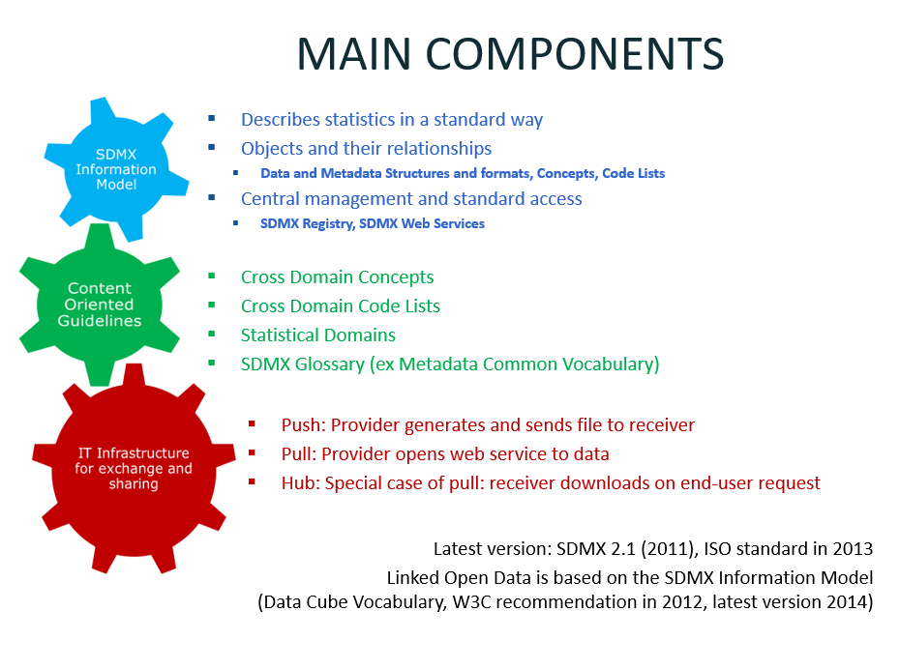

Figure 1: SDMX Main Components

A schematic view of the information model can be seen in Figure 2.

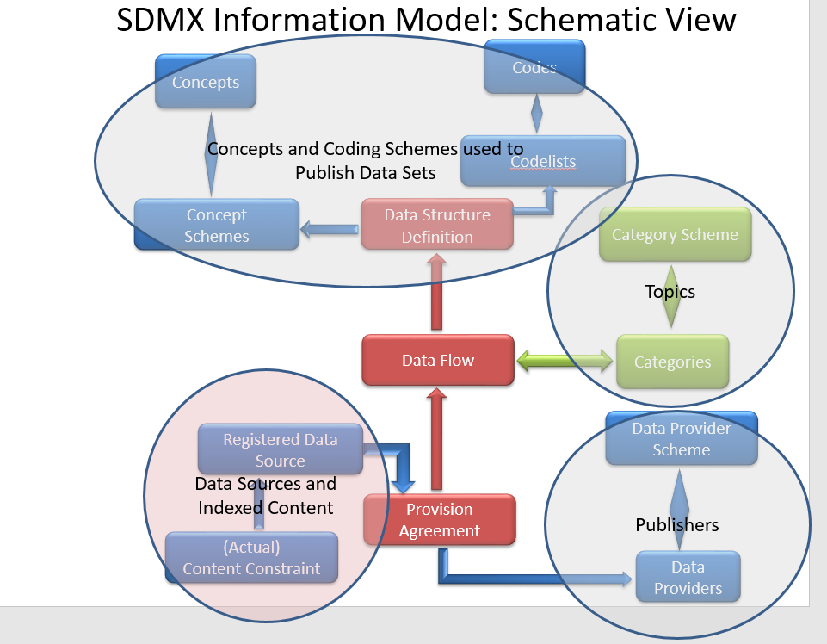

Figure 2: SDMX Information Model: Schematic View

### ESMS

The Euro SDMX Metadata Structure (ESMS)[25] contains the description and representation of statistical metadata concepts to be used for documenting statistical datasets and for providing summary information useful for assessing data quality and the production process in general. The broad concepts used are based on SDMX cross-domain concepts as published in the SDMX Glossary[26] (last version published in 2016). Its structure (i.e. allowed content) is defined using an SDMX Metadata Structure Definition.

The ESMS is addressed to the countries which are part of the European Statistical System and was embedded in a European Recommendation published in 2009[27]. It is implemented both at Eurostat and at national level: the application of the concepts and sub concepts at European level and at national level is stated in the ESS guidelines.

The information to be entered is normally free text, but some coded elements may be introduced in the future: this is indicated in the column "representation" below.

The ESMS allows the creation of different output files comprising information related to all the concepts listed or a subset of those concepts. These output files can be used for different purposes (data dissemination, quality reporting, etc.).

A fragment of the ESMS specification (release 4, 2014) is shown in Figure 3.

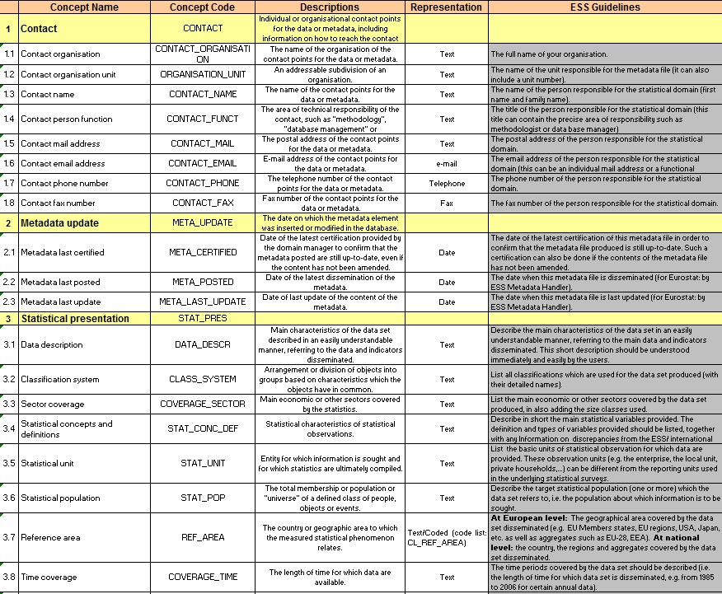

Figure 3: Fragment of ESMS specification

Another standardised metadata structure currently in use is the “ESS Standard Quality Report Structure” (ESQRS). Quality reports are produced and partly disseminated by Eurostat in this format. Eurostat has also recently introduced a "Single Integrated Metadata Structure" (SIMS), which represents the union of referential metadata attributes coming from ESMS and ESQRS, providing an integrated framework of concepts on quality assessment and more general reference metadata.

## Open Data standards and application profiles

### W3C DCAT

The basis for DCAT-AP is the specification of the Data Catalog Vocabulary (DCAT). DCAT was developed in the period from June 2011 through December 2013 by the Government Linked Data Working Group[28]. The specification was published as a W3C Recommendation in January 2014.

The abstract describes the specification as follows:

DCAT is an RDF vocabulary designed to facilitate interoperability between data catalogs published on the Web. This document defines the schema and provides examples for its use.

By using DCAT to describe datasets in data catalogs, publishers increase discoverability and enable applications easily to consume metadata from multiple catalogs. It further enables decentralized publishing of catalogs and facilitates federated dataset search across sites. Aggregated DCAT metadata can serve as a manifest file to facilitate digital preservation.[29]

The specification defines RDF Classes and Properties in a model that has four main entities:

* Catalogue (dcat:Catalog), defined as a curated collection of metadata about datasets
* Catalogue Record (dcat:CatalogRecord), defined as a record in a data catalog, describing a single dataset
* Dataset (dcat:Dataset), defined as a collection of data, published or curated by a single agent, and available for access or download in one or more formats
* Distribution (dcat:Distribution), defined as representing a specific available form of a dataset. Each dataset might be available in different forms, these forms might represent different formats of the dataset or different endpoints. Examples of distributions include a downloadable CSV*[30]* file, an API or an RSS feed

The data model of DCAT is presented in Figure 4.

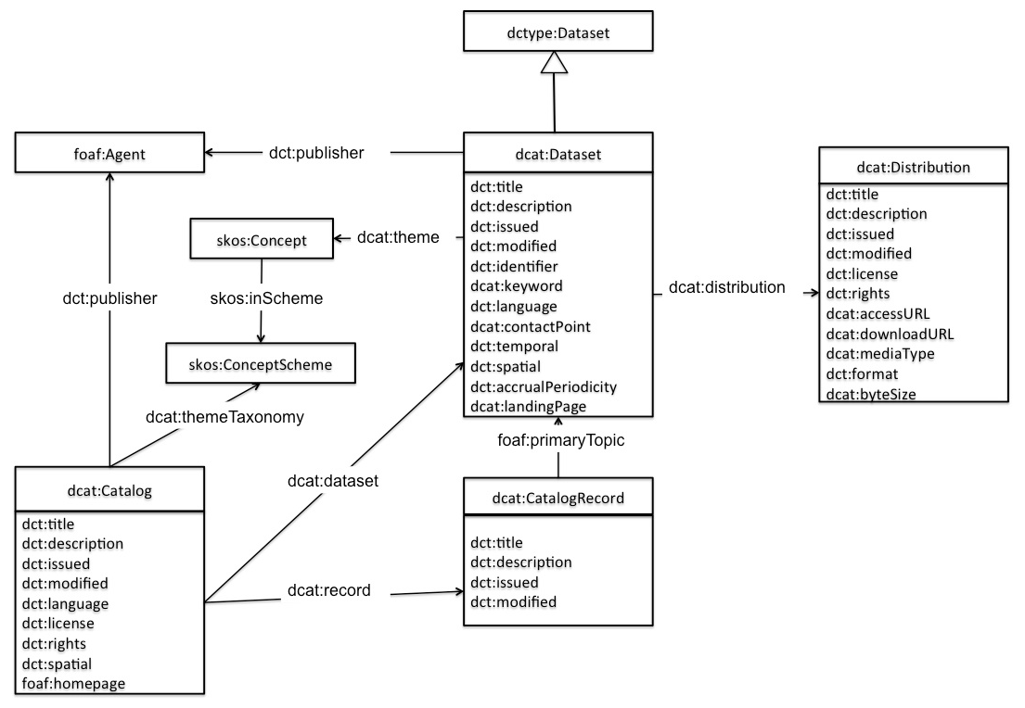

Figure 4: DCAT schematic data model

### DCAT-AP for open data portals in Europe

The DCAT Application profile for data portals in Europe (DCAT-AP) is a specification based on W3C's Data Catalogue vocabulary (DCAT) for describing public sector datasets in Europe. Its basic use case is to enable a cross-data portal search for data sets and make public sector data better searchable across borders and sectors. This can be achieved by the exchange of descriptions of data sets among data portals.

The specification of the DCAT-AP was a joint initiative of DG CONNECT, the EU Publications Office and the ISA Programme. The specification was elaborated by a multi-disciplinary Working Group with representatives from 16 European Member States, some European Institutions and the United States.

The first version (1.0)[31] of the Application Profile was published in September 2013. In 2015, a revised version (1.1)[32] was developed and published in November 2015 with changes based on feedback received from implementers.

The data model of DCAT-AP is presented in Figure 5.

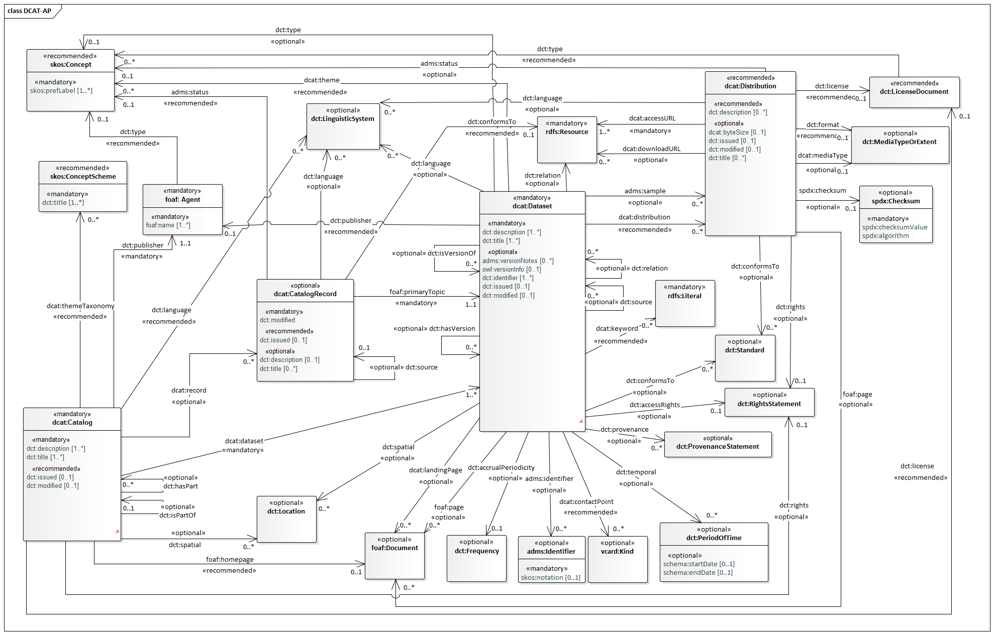

Figure 5: DCAT-AP Data Model

### GeoDCAT-AP

GeoDCAT-AP is an extension of DCAT-AP for describing geospatial datasets, dataset series, and services. It provides an RDF syntax binding for the union of metadata elements defined in the core profile of ISO 19115:2003 (Geographic information -- Metadata)[33] and those defined in the framework of the INSPIRE Directive. Its basic use case is to make spatial datasets, data series, and services searchable on general data portals, thereby making geospatial information better searchable across borders and sectors. This can be achieved by the exchange of descriptions of data sets among data portals.

In particular, GeoDCAT-AP intends to:

* Provide an RDF syntax binding for the *union* of the elements in the INSPIRE metadata schema and the core profile of ISO 19115:2003. The guiding design principle is to make the resulting RDF syntax as simple as possible; thereby maximally using existing RDF vocabularies – such as the Dublin Core and DCAT-AP–, and as much as possible avoiding minting new terms. The defined syntax must enable the conversion of metadata records *from* ISO 19115 / INSPIRE *to* a harmonised RDF representation. The ability to convert metadata records from RDF to ISO 19115 / INSPIRE is not a requirement.
* Formulate recommendations to the Working Group dealing with the revision of the DCAT-AP, to maximally align DCAT-AP and GeoDCAT-AP.
* To Take into account and refer to alignment of relevant controlled vocabularies (e.g., alignments between GEMET[34], INSPIRE themes, EuroVoc[35] carried out by the Publications Office of the EU[36]).

The GeoDCAT-AP specification builds upon prior work conducted by the European Commission’s Joint Research Centre in 2014. This work consisted of an alignment exercise between INSPIRE metadata and DCAT-AP (version 1.0) in the framework of ISA Action 1.17 [INSPIRE-DCAT]. The results of this alignment exercise, referred to as INSPIRE+DCAT-AP, are divided in two parts:

* A Core version which defines alignments for the subset of INSPIRE metadata elements supported by DCAT-AP.
* An Extended version which defines alignments for all the INSPIRE metadata elements using DCAT-AP and other vocabularies whenever DCAT-AP is not relevant.

GeoDCAT-AP is a joint initiative of the Joint Research Centre (JRC), Unit H.6 (Digital Earth and Reference Data), the Publications Office of the European Union (PO), and the Directorates-General for Informatics (DIGIT, in the context of the ISA Programme) and Communications Networks, Content & Technology (CONNECT) of the European Commission. More than 50 people from 12 EU Member States contributed to the specification in the Working Group or during the public review period.

The first version (1.0)[37] of the GeoDCAT-AP was published in December 2015.

### The Data Cube Vocabulary

The Data Cube Vocabulary is an RDF vocabulary for representing multi-dimensional “data cubes” in RDF.

The Data Cube Vocabulary is organised around the concept of the qb:DataSet, which is defined as *a collection of statistical data that corresponds to a defined structure*. The concept of a Dataset in DCAT (and DCAT-AP and StatDCAT-AP) is more generally defined as *a collection of data*. So, the main distinction is that DCAT is concerned with the overall characteristics of a dataset, while the Data Cube Vocabulary is concerned with the structure of the data itself. The specification of the Data Cube Vocabulary mentions the use of Dublin Core and DCAT terms to describe the overall characteristics of Data Cube datasets.

The Data Cube vocabulary provides a means to publish multi-dimensional data, such as statistics, on the web in such a way that it can be linked to related data sets and concepts using the W3C RDF (Resource Description Framework) standard. The model underpinning the Data Cube vocabulary builds upon the core of the SDMX Information Model with its concepts of dimensions, attributes and measures described in a data structure definition. The Data Cube vocabulary is a core foundation which supports extension vocabularies to enable publication of other aspects of statistical data flows or other multi-dimensional data sets. The Data Cube Vocabulary also recognises the use of SDMX cross-domain concepts and code lists on which several statistical data and metadata structures are being standardised.

The Data Cube vocabulary was published as a Recommendation[38] by W3C in January 2014.

An overview of its key terms and their relationships is shown in Figure 6.

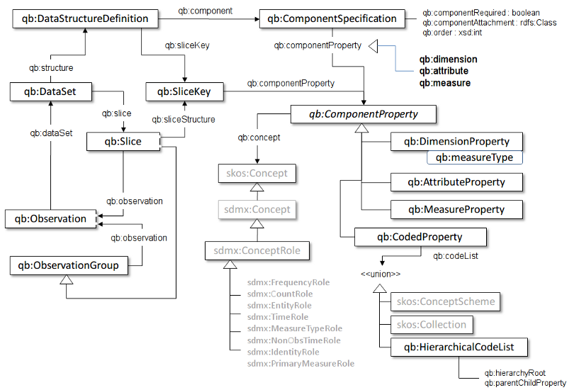

Figure 6: Data Cube vocabulary overview of key terms and relationships

# Use cases

## Improve discoverability of statistical datasets on open data portals

Within the EU, Eurostat is the organization having the mission to provide the European Union with statistics at European level that enable comparisons between countries and regions.

In February 2015, Eurostat published more than 6500 datasets on the European Union Open Data Portal (EU ODP) i.e. about 80% of the datasets in the European Union Open Data Portal. Many of the other datasets on the EU ODP are more elaborated datasets based on input datasets provided by Eurostat. On other governmental open data portals, the quantitative share of statistical data is similarly high.

So, improving the metadata quality by establishing a dedicated extended profile of DCAT-AP, StatDCAT-AP, for statistical data has an important impact on the already published dataset records. The improvement increases public and cross-sector access to this category of high value datasets.

## Federation of open data portals

At inter-institutional level, Eurostat plays an important and active role in constantly improving the exchange of statistical data. In the recent past, the most prominent international organizations involved in the compilation of statistical data, including Eurostat, defined and adopted the SDMX standard for the exchange of statistical data. SDMX ensures that the exchange of statistical data happens without loss of information, in particular provenance information. Decision-making at the sending and receiving ends of the exchange is hence based on the same information.

Open Data Portals are catalogues of dataset metadata descriptions. Within the European Union, the application profile of the W3C standard DCAT, DCAT-AP, harmonizes the dataset metadata descriptions. By correlating the metadata descriptions provided by SDMX and other existing standards for statistical data, both worlds get better connected. StatDCAT-AP aims to facilitate a better integration of the existing statistical data portals with the Open Data Portals, improving the discoverability of statistical datasets.

Today Eurostat and the Publications Office have made a first step towards such integration. This experience and the experience gathered during the work to define StatDCAT-AP can be transferred to similar setups in the EU Member States.

It should be noted that the objective of StatDCAT-AP is not to cover actual data values. For that the W3C vocabulary Data Cube[39] exists. Work on StatDCAT-AP may, however, include discussions at this level since it may improve insight.

# Methodology

## ISA Core Vocabulary process and methodology

This work was conducted using the process and methodology[40] defined for the ISA Programme. The process involved setting up a Working Group and submitting drafts of the specification to external public review. The methodology focused on the elements to be covered by the specification, including use cases and definition of terms and vocabularies.

The objective of the process and methodology was to involve the main stakeholders and to reach consensus in an open collaboration.

The work was conducted in a transparent manner, visible to the public through:

A Web page

<https://joinup.ec.europa.eu/asset/stat_dcat_application_profile/description>

An issue tracker

<https://joinup.ec.europa.eu/asset/stat_dcat_application_profile/issue/all>

A mailing list

<http://joinup.ec.europa.eu/mailman/listinfo/stat_dcat_application_profile>

## Analysis and decision framework

The principles underlying the work on StatDCAT-AP were the following:

* align with DCAT and DCAT-AP
* focus primarily on metadata elements that contribute to data discovery
* use metadata terms from existing, well-known and well-maintained vocabularies, including ISA Core Vocabularies and Eurostat metadata vocabularies
* encourage the use of common controlled vocabularies, preferably those maintained by the Publications Office in its EU Vocabularies, formerly known as ‘Metadata Registry’ (MDR)
* find an appropriate balance between simplicity and complexity from the perspective of the widest, non-specialist audience.

## Stakeholders

The main stakeholders of this work were:

* Eurostat
* Publications Office of the EU
* National and regional statistical offices
* Other potential stakeholders are the organisations responsible for operating general data portals that are interested in collecting and integrating statistical datasets in their services.

## Time plan

| **Target dates** | **Event, outcome** |
| --- | --- |
| **December 2015** | invitations to stakeholders, set up collaboration infrastructure |
| **January 2016** | collect requirements and suggestions |
| **5 February 2016** | familiarisation Webinar |
| **February 2016** | first draft based on initial analysis and issues raised |
| **11 March 2016** | first virtual Working Group (WG) meeting to discuss first draft |
| **15 April 2016** | second virtual WG meeting to discuss draft mapping and implementation options |
| **6 May 2016** | second draft submitted to public review, incorporating comments and further development |
| **13 May 2016** | third meeting (face-to-face combined with teleconference) in Rome to discuss mapping issues in practice |
| **End of May 2016** | third draft, including full mapping proposal and usage of controlled vocabularies |
| **3 June 2016** | fourth virtual WG meeting to agree schedule for public review |
| **30 August through 31 October 2016** | public review |
| **14 November 2016** | fifth virtual WG meeting to discuss and resolve public comments received |
| **December 2016** | approval of StatDCAT-AP version 1 for publication |

# The StatDCAT-AP data model

## Informal description

The StatDCAT Application Profile is an extension of the DCAT Application Profile for Data Portals in Europe, version 1.1 (DCAT-AP)[41], and can be used to describe datasets in any format, for example, those published in SDMX, Data Cube, CSV and other formats.

Its purpose is to provide a specification that is fully conformant with DCAT-AP version 1.1 as it meets all obligations of the DCAT-AP Conformance Statement. As a result, data portals that comply with DCAT-AP will be able to understand the core of StatDCAT-AP. In addition, StatDCAT-AP defines a small number of additions to the DCAT-AP model that are particularly relevant for statistical datasets. Considering the high number of statistical datasets that interest general data portals and their users, it is likely that recognising and exposing the additions to DCAT-AP proposed by StatDCAT-AP will benefit the general data portals which will then be able to provide enhanced services for collections of statistical data.

The StatDCAT-AP data model includes the four main entities that are also present in DCAT-AP (see also Figure 5 for a diagram of the DCAT-AP data model):

* The **Catalogue**: represents a collection of Datasets. It is defined in the DCAT Recommendation[42] as “*a curated collection of metadata about datasets*”. The description of the Catalogue includes links to the metadata for each of the Datasets that are in the Catalogue.
* The **Catalogue Record**: defined by DCAT as “*a record in a data catalog, describing a single dataset*”. The Catalogue Record enables statements about the description of a Dataset rather than about the Dataset itself. Catalogue Records may not be used by all implementations. It is optional in DCAT-AP and mostly used by aggregators to keep track of harvesting history.
* The **Dataset**: represents the published information. It is defined as “*a collection of data, published or curated by a single agent, and available for access or download in one or more formats*”. The description of a Dataset includes links to each of its Distributions, if they are available. A Dataset is not required to have a Distribution; examples are Datasets that are described before the associated data is collected, Datasets for which the data has been removed, and Datasets that are only accessible through a landing page.
* The **Distribution**: according to DCAT, “*represents a specific available form of a dataset. Each dataset might be available in different forms, these forms might represent different formats of the dataset or different endpoints. Examples of distributions include a downloadable CSV file, an API or an RSS feed*”. The description of a Distribution contains information about the location of the data files or access point and about the file format and licence for use or reuse. In the case of statistical datasets, Distributions may be available in specific formats like SDMX-ML or using the Data Cube vocabulary.

## Extensions and specific usage for description of statistical datasets

Discussions during the development of the StatDCAT-AP specifications brought out a number of requirements for the description of statistical datasets that were not met by existing properties in DCAT-AP. The following sections present the extensions that have been included in StatDCAT-AP to meet those requirements. Some of the extensions are re-used from existing RDF vocabularies, others are defined in a new namespace specific for StatDCAT-AP. The URI for this StatDCAT-AP dedicated namespace is <http://data.europa.eu/(xyz)/statdcat-ap/>. The string (xyz) will be assigned by the URI Committee responsible for the management of the persistent URIs of the EU institutions and bodies.

All issues discussed during the development of StatDCAT-AP can be seen at: <https://joinup.ec.europa.eu/asset/stat_dcat_application_profile/issue/all>.

### Dimensions and attributes

A requirement has been expressed to expose information about:

* Attributes: components used to qualify and interpret observed values such as units of measure, scaling factors
* Dimensions: components that identify observations such as time, sex, age, regions

The following two properties were created in the StatDCAT-AP namespace:

| Property | Attribute |
| --- | --- |
| **URI** | stat:attribute |
| **Range** | qb:AttributeProperty, expressed as a URI. |
| **Definition** | A component used to qualify and interpret observed values |
| **Comment** | Attributes enable specification of the units of measure, any scaling factors and metadata such as the status of the observation (e.g. estimated, provisional). |

| Property | Dimension |
| --- | --- |
| **URI** | stat:dimension |
| **Range** | qb:DimensionProperty, expressed as a URI. |
| **Definition** | A component that identifies observations |
| **Comment** | Examples of dimensions include the time to which the observation refers, or a geographic region which the observation covers. |

Both properties can be used irrespective of the format of the Distribution. Similar properties have been defined for the Data Cube Vocabulary, namely qb:attribute and qb:dimension. While a proposal was made to use these existing properties, it was decided that using them in StatDCAT-AP – as properties of a dcat:Dataset – would not be in line with the way they are defined in the Data Cube Vocabulary – which is in the specific context of a qb:DataStructureDefinition. However, if a Distribution is expressed as a Data Cube DataSet, the values provided for qb:attribute and qb:dimension properties can be used also for the values of stat:attribute and stat:dimension. If a Distribution is expressed in some other format (e.g. SDMX), the values for the properties stat:attribute and stat:dimension can be extracted from corresponding elements in that format if such elements exist. The use of the properties for all Distribution formats ensures coherence across descriptions of Datasets, irrespective of the Distribution format.

|  |
| --- |
| *Example:*  A dataset, provided by a national statistical portal, contains employment data concerning all five regions of the country, broken down by sex and age.  In the sample below, the property stat:dimension is used to represent the StatDCAT-AP descriptors of the observations contained in the dataset, in this case “age”, “sex” and “region”. Similarly, the property stat:attribute is used to represent the unit of measure, in this case “percentage of employment” based on the mentioned characteristics.  *<http://nationalportal.org/data/employment> a dcat:Dataset*  *stat:dimension <http://nationalportal.org/dimension/age#>;*  *stat:dimension <http://nationalportal.org/dimension/sex#>;*  *stat:dimension <http://nationalportal.org/dimension/geo#>;*  *stat:attribute <http://nationalportal.org/attribute/perc#>.* |

### Quality aspects

Quality aspects are very important for datasets in general and for statistical datasets in particular. The current specification includes a first approach that allows certain annotations related to quality to be made, either through linking to quality information that is already published elsewhere or by including text with quality information.

The following annotation property is included, re-used from the Data Quality Vocabulary[43] that is being developed by the Data on the Web Working Group at W3C.

| Property | Quality annotation |
| --- | --- |
| **URI** | dqv:hasQualityAnnotation |
| **Range** | oa:Annotation |
| **Definition** | A statement related to quality of the Dataset, including rating, quality certificate, feedback that can be associated to datasets or distributions. |
| **Comment** | The information may include quality aspects such as accuracy, reliability, comparability, coherence, relevance, timeliness etc. |
| **Usage note** | The annotation requires the provision of information about the motivation of the annotation (oa:motivation), and an explicit link to the resource being annotated (oa:hasTarget) together with either a link to a resource that contains the annotation (oa:hasBody) or text filed (oa:bodyText). |

|  |
| --- |
| *Example:*  In the sample code below is described the quality of information contained using the dqv:hasQualityAnnotation property of StatDCAT-AP.  *<http://qualifications.org/QualityCertificate1> a oa:Annotation.*  *<http://nationalportal.org/data/employment> a dcat:Dataset;*  *dqv:hasQualityAnnotation <http://qualifications.org/QualityCertificate1>.*  *<http://qualifications.org/QualityCertificate1> a dqv:QualityCertificate;*  *oa:hasBody <http://qualifications.org/QualityCertificate1/body>.* |

In future work, a more fundamental treatment of quality aspects may be undertaken, for example based on the work done at Eurostat on the Single Integrated Metadata Structure.

### Visualisation

One of the requirements raised during discussions was the need to be able to link to a visualisation of the data, for example a document or Webpage where a tabular or graphical representation of the data can be viewed, or an interactive service where the data can be accessed and viewed.

The agreed approach for these types of visualisations is to model them as Distributions with a type of “visualisation” type taken from the EU Vocabularies Distribution Type Named Authority List[44].

To implement this approach, a property indicating distribution type is added to the class Distribution, re-used from Dublin Core.

| Property | Type of distribution |
| --- | --- |
| **URI** | dct:type |
| **Range** | URI of a term in a controlled vocabulary |
| **Definition** | The nature or genre of the resource. |
| **Comment** | Recommended best practice is to use a controlled vocabulary |
| **Usage note** | This property is to be used to indicate the type of a Distribution, in particular when the Distribution is a visualisation. For visualisations, use the concept ‘Visualisation” from the MDR Distribution Type Named Authority List |

|  |
| --- |
| *Example:*  In the sample code below the type of a distribution, in this case a visualisation of the dataset, is described using the dct:type property of StatDCAT-AP.  *<*[*http://nationalportal.org/data/employment*](http://nationalportal.org/data/employment)*/emplvis> a dcat:Distribution.*  *dct:type <http://publications.europa.eu/resource/authority/distribution-type/VISUALIZATION> ;*  *dcat:accessURL <*[*http://nationalportal.org/data/employment*](http://nationalportal.org/data/employment)*/emplvis.html> .* |

Further use of the Type property on Distribution may be considered in the future, for example to indicate that data can be accessed through a service.

### Number of data series

One additional requirement was about expressing the number of data series contained in a dataset. A new property was created for this in the StatDCAT-AP namespace.

A series is a unique cross product of values of dimensions (excluding time). The number of data series therefore gives an indication of the potential scope of a data set. A Dataset could contain data for three regions with three values for each region. In this example, the number of series is three while the number of observations is nine.

| Property | Number of data series |
| --- | --- |
| **URI** | stat:numSeries |
| **Subproperty of** | dct:extent |
| **Range** | dct:SizeOrDuration, expressed as xsd:integer |
| **Definition** | The actual number of series in the data set as referenced in the Distribution. |
| **Comment** | The Cartesian Product is the number of modalities of each dimension, excluding what Data Cube calls the measure dimension (that denotes which particular measure is being conveyed by the observation). This is the total of the theoretical number of combinations of dimension values. The actual number of series (as represented in numSeries) might be less than the theoretical number calculated as the Cartesian Product, and when combined with the dimension list, a useful indication of the detail of the data in the data set )often called the ‘density’). |

|  |
| --- |
| *Example:*  *The sample code below describes the number of data series contained in the dataset using the stat:numSeries property of StatDCAT-AP.*  *<http://nationalportal.org/data/employment> a dcat:Dataset;*  *stat:numSeries ‘5’^^xsd:integer.* |

### Unit of measurement

A requirement was brought forward to allow expression of the unit of measurement. A new property was created for this in the StatDCAT-AP namespace.

| Property | Unit of measurement |
| --- | --- |
| **URI** | stat:statUnitMeasure |
| **Range** | skos:Concept |
| **Definition** | A unit of measurement of the observations in the dataset |
| **Comment** | Examples are Euro, square kilometre, purchasing power standard (PPS), full-time equivalent, percentage. Values should be taken from a controlled vocabulary, possible provided as an MDR authority. |

|  |
| --- |
| *Example:*  In the sample code below the unit of measurement, in this case ’percentage’, is described using the property stat:statUnitMeasure of StatDCAT-AP.  *<http://nationalportal.org/data/employment> a dcat:Dataset;*  *stat:statUnitMeasure <http://example.com/measures/percentage> .* |

### Specifying the length of time series

The StatDCAT Application Profile does not specify short-hand notations for time series, such as the notation used among National Statistical Institutes and Eurostat, e.g. 2016Q2 for a quarterly time series starting in the third quarter of 2006 for which the second quarter of 2016 is the latest quarter covered.

To describe such a time series, a StatDCAT-AP-compliant description would specify:

dct:accrualPeriodicity <http://publications.europa.eu/resource/authority/frequency/QUARTERLY> ;

dct:temporal [ schema:startDate “2006-07-01”^^xsd:date ;

schema:endDate “2016-06-30”^^xsd:date ] .

## Overview of the model

In the following sections, classes and properties are grouped under headings ‘mandatory’, ‘recommended’ and ‘optional’. These terms have the following meaning.

* **Mandatory class**: a receiver of data must be able to process information about instances of the class; a sender of data must provide information about instances of the class.
* **Recommended class**: a receiver of data must be able to process information about instances of the class; a sender of data should provide information about instances of the class. However, if information about the instances of a class is available, then the sender of data MUST provide this information, if such information is available.
* **Optional class**: a receiver must be able to process information about instances of the class; a sender may provide the information but is not obliged to do so.
* **Mandatory property**: a receiver must be able to process the information for that property; a sender must provide the information for that property.
* **Recommended property**: a receiver must be able to process the information for that property; a sender should provide the information for that property if it is available.
* **Optional property**: a receiver must be able to process the information for that property; a sender may provide the information for that property but is not obliged to do so.

The meaning of the terms must, must not, should and may in this section and in the following sections are as defined in RFC 2119[45].

In the given context, the term "processing" means that receivers must accept incoming data and transparently provide these data to applications and services. It does neither imply nor prescribe what applications and services finally do with the data (parse, convert, store, make searchable, display to users, etc.).

## Namespaces

The Application Profile reuses terms from various existing specifications. Classes and properties specified in the next sections have been taken from the following namespaces:

| **Prefix** | **Namespace URI** |
| --- | --- |
| **adms** | http://www.w3.org/ns/adms# |
| **dcat** | http://www.w3.org/ns/dcat# |
| **dct** | http://purl.org/dc/terms/ |
| **dqv** | http://www.w3.org/ns/dqv# |
| **foaf** | http://xmlns.com/foaf/0.1/ |
| **oa** | http://www.w3.org/ns/oa# |
| **qb** | http://purl.org/linked-data/cube# |
| **rdfs** | http://www.w3.org/2000/01/rdf-schema# |
| **schema** | http://schema.org/ |
| **skos** | http://www.w3.org/2004/02/skos/core# |
| **spdx** | http://spdx.org/rdf/terms# |
| **stat** | http://data.europa.eu/(xyz)/statdcat-ap/[46] |
| **vcard** | http://www.w3.org/2006/vcard/ns# |
| **xsd** | http://www.w3.org/2001/XMLSchema# |

## UML Class diagram

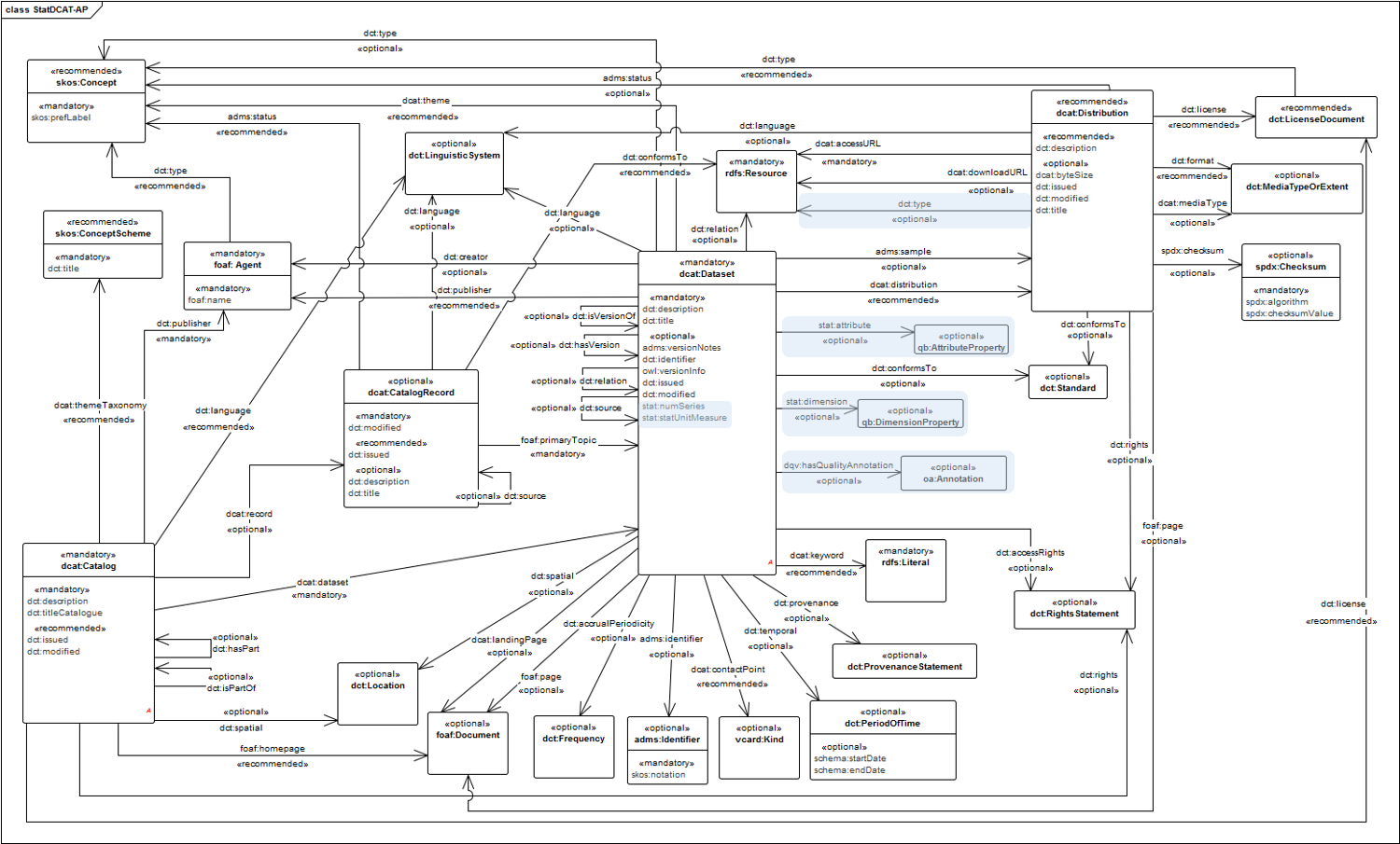

## Description of classes

### Mandatory Classes

| **Class name** | **Usage note for the Application Profile** | **URI** | **Reference** |
| --- | --- | --- | --- |
| Agent | An entity that is associated with Catalogues and/or Datasets. If the Agent is an organisation, the use of the Organization Ontology[47] is recommended. | foaf:Agent | <http://xmlns.com/foaf/spec/#term_Agent> , <http://www.w3.org/TR/vocab-org/> |
| Catalogue | A catalogue or repository that hosts the Datasets being described. | dcat:Catalog | <http://www.w3.org/TR/2013/WD-vocab-dcat-20130312/#class-catalog> |
| Dataset | A conceptual entity that represents the information published. | dcat:Dataset | <http://www.w3.org/TR/2013/WD-vocab-dcat-20130312/#class-dataset> |
| Literal | A literal value such as a string or integer; Literals may be typed, e.g. as a date according to xsd:date. Literals that contain human-readable text have an optional language tag as defined by BCP 47[48]. | rdfs:Literal | <http://www.w3.org/TR/rdf-concepts/#section-Literals> |
| Resource | Anything described by RDF. | rdfs:Resource | <http://www.w3.org/TR/rdf-schema/#ch_resource> |

### Recommended Classes

| **Class name** | **Usage note for the Application Profile** | **URI** | **Reference** |
| --- | --- | --- | --- |
| Category | A subject of a Dataset. | skos:Concept | <http://www.w3.org/TR/2013/WD-vocab-dcat-20130312/#class-category-and-category-scheme> |
| Category scheme | A concept collection (e.g. controlled vocabulary) in which the Category is defined. | skos:ConceptScheme | <http://www.w3.org/TR/2013/WD-vocab-dcat-20130312/#class-category-and-category-scheme> |
| Distribution | A physical embodiment of the Dataset in a particular format, including visualisations of the data | dcat:Distribution | <http://www.w3.org/TR/2013/WD-vocab-dcat-20130312/#class-distribution> |
| Licence document | A legal document giving official permission to do something with a resource. | dct:LicenseDocument | <http://dublincore.org/documents/2012/06/14/dcmi-terms/?v=terms#LicenseDocument> |

The class ‘Distribution’ is classified as ‘Recommended’ to allow for cases where a particular Dataset does not have a downloadable Distribution; in such cases the sender of data would not be able to provide this information. However, it can be expected that the vast majority of Datasets do have downloadable Distributions, and in such cases the provision of information on the Distribution is mandatory.

### Optional Classes

|  |  |  |  |
| --- | --- | --- | --- |
| Class name | Usage note for the Application Profile | URI | Reference |
| Catalogue Record | A description of a Dataset’s entry in the Catalogue. | dcat:CatalogRecord | <http://www.w3.org/TR/2013/WD-vocab-dcat-20130312/#class-catalog-record> |
| Checksum | A value that allows the contents of a file to be authenticated. This class allows the results of a variety of checksum and cryptographic message digest algorithms to be represented. | spdx:Checksum | <http://spdx.org/rdf/terms#Checksum> |
| Document | A textual resource intended for human consumption that contains information, e.g. a web page about a Dataset. | foaf:Document | <http://xmlns.com/foaf/spec/#term_Document> |
| Frequency | A rate at which something recurs, e.g. the publication of a Dataset. | dct:Frequency | <http://dublincore.org/documents/dcmi-terms/#terms-Frequency> |
| Identifier | An identifier in a particular context, consisting of the string that is the identifier; an optional identifier for the identifier scheme; an optional identifier for the version of the identifier scheme; an optional identifier for the agency that manages the identifier scheme | adms:Identifier | <http://www.w3.org/TR/vocab-adms/#identifier> |
| Kind | A description following the vCard specification, e.g. to provide telephone number and e-mail address for a contact point. Note that the class Kind is the parent class for the four explicit types of vCard (Individual, Organization, Location, Group). | vcard:Kind | <http://www.w3.org/TR/2014/NOTE-vcard-rdf-20140522/#d4e181> |
| Linguistic system | A system of signs, symbols, sounds, gestures, or rules used in communication, e.g. a language | dct:LinguisticSystem | <http://dublincore.org/documents/dcmi-terms/#terms-LinguisticSystem> |
| Location | A spatial region or named place. It can be represented using a controlled vocabulary or with geographic coordinates. In the latter case, the use of the Core Location Vocabulary[49] is recommended, following the approach described in the GeoDCAT-AP specification. | dct:Location | <http://dublincore.org/documents/dcmi-terms/#terms-Location> |
| Media type or extent | A media type or extent, e.g. the format of a computer file | dct:MediaTypeOrExtent | <http://dublincore.org/documents/dcmi-terms/#terms-MediaTypeOrExtent> |
| Period of time | An interval of time that is named or defined by its start and end dates. | dct:PeriodOfTime | <http://dublincore.org/documents/dcmi-terms/#terms-PeriodOfTime> |
| Publisher type | A type of organisation that acts as a publisher | skos:Concept | <http://www.w3.org/TR/vocab-adms/#dcterms-type> |
| Rights statement | A statement about the intellectual property rights (IPR) held in or over a resource, a legal document giving official permission to do something with a resource, or a statement about access rights. | dct:RightsStatement | <http://dublincore.org/documents/dcmi-terms/#terms-RightsStatement> |
| Standard | A standard or other specification to which a Dataset or Distribution conforms | dct:Standard | <http://dublincore.org/documents/dcmi-terms/#terms-Standard> |
| Status | An indication of the maturity of a Distribution or the type of change of a Catalogue Record. | skos:Concept | <http://www.w3.org/TR/vocab-adms/#status> |
| Provenance Statement | A statement of any changes in ownership and custody of a resource since its creation that are significant for its authenticity, integrity, and interpretation | dct:ProvenanceStatement | <http://dublincore.org/documents/dcmi-terms/#terms-ProvenanceStatement> |

**Additional optional classes for StatDCAT-AP**

|  |  |  |  |
| --- | --- | --- | --- |
| Class name | Usage note for the Application Profile | URI | Reference |
| Annotation | A statement providing explanatory information about a resource. In this profile, used for statements related to quality of the Dataset, including rating, quality certificate, feedback that can be associated to datasets or distributions. | oa:Annotation | <https://www.w3.org/TR/2016/WD-annotation-vocab-20160331/#annotation> |
| Attribute Property | A component property which represents an attribute of observations in the Dataset, e.g. unit of measurement | qb:AttributeProperty | <https://www.w3.org/TR/vocab-data-cube/#ref_qb_AttributeProperty> |
| Dimension Property | A component property which represents a dimension in the Dataset | qb:DimensionProperty | <https://www.w3.org/TR/vocab-data-cube/#ref_qb_DimensionProperty> |
| Size or duration | A dimension or extent, e.g. the number of data series in a Dataset | dct:SizeOrDuration | <http://dublincore.org/documents/dcmi-terms/#terms-SizeOrDuration> |

## Description of properties per class

The following section describes the properties to be used in StatDCAT-AP. It contains the specification for DCAT-AP and indicates the extensions for StatDCAT-AP separately under the relevant classes. The extensions are described in section 7.2.

### Catalogue

StatDCAT-AP does not specify additional properties for Catalogue on top pf those used in DCAT-AP 1.1.

*Mandatory properties for Catalogue*

| **Property** | **URI** | **Range** | **Usage note** | **Card.** |
| --- | --- | --- | --- | --- |
| dataset | dcat:dataset | dcat:Dataset | This property links the Catalogue with a Dataset that is part of the Catalogue. | 1..n |
| description | dct:description | rdfs:Literal | This property contains a free-text account of the Catalogue. This property can be repeated for parallel language versions of the description. For further information on multilingual issues, please refer to section 12. | 1..n |
| publisher | dct:publisher | foaf:Agent | This property refers to an entity (organisation) responsible for making the Catalogue available. | 1..1 |
| title | dct:title | rdfs:Literal | This property contains a name given to the Catalogue. This property can be repeated for parallel language versions of the name. | 1..n |

*Recommended properties for Catalogue*

| **Property** | **URI** | **Range** | **Usage note** | **Card.** |
| --- | --- | --- | --- | --- |
| homepage | foaf:homepage | foaf:Document | This property refers to a web page that acts as the main page for the Catalogue. | 0..1 |
| language | dct:language | dct:LinguisticSystem | This property refers to a language used in the textual metadata describing titles, descriptions, etc. of the Datasets in the Catalogue. This property can be repeated if the metadata is provided in multiple languages. | 0..n |
| licence | dct:license | dct:LicenseDocument | This property refers to the licence under which the Catalogue can be used or reused. | 0..1 |
| release date | dct:issued | rdfs:Literal typed as xsd:date or xsd:dateTime | This property contains the date of formal issuance (e.g., publication) of the Catalogue. | 0..1 |
| themes | dcat:themeTaxonomy | skos:ConceptScheme | This property refers to a knowledge organisation system used to classify the Catalogue's Datasets. | 0..n |
| update/ modification date | dct:modified | rdfs:Literal typed as xsd:date or xsd:dateTime | This property contains the most recent date on which the Catalogue was modified. | 0..1 |

*Optional properties for Catalogue*

|  |  |  |  |  |
| --- | --- | --- | --- | --- |
| **Property** | **URI** | **Range** | **Usage note** | **Card.** |
| has part | dct:hasPart | dcat:Catalog | This property refers to a related Catalogue that is part of the described Catalogue. | 0..n |
| is part of | dct:isPartOf | dcat:Catalog | This property refers to a related Catalogue in which the described Catalogue is physically or logically included. | 0..1 |
| record | dcat:record | dcat:CatalogRecord | This property refers to a Catalogue Record that is part of the Catalogue. | 0..n |
| rights | dct:rights | dct:RightsStatement | This property refers to a statement that specifies rights associated with the Catalogue. | 0..1 |
| spatial / geographic | dct:spatial | dct:Location | This property refers to a geographical area covered by the Catalogue. | 0..n |

### Catalogue Record

StatDCAT-AP does not specify additional properties for Catalogue Record on top of those used in DCAT-AP 1.1

*Mandatory properties for Catalogue Record*

| **Property** | **URI** | **Range** | **Usage note** | **Card.** |
| --- | --- | --- | --- | --- |
| primary topic | foaf:primaryTopic | dcat:Dataset | This property links the Catalogue Record to the Dataset described in the record. | 1..1 |
| update/ modification date | dct:modified | rdfs:Literal typed as xsd:date or xsd:dateTime | This property contains the most recent date on which the Catalogue entry was changed or modified. | 1..1 |

*Recommended properties for Catalogue Record*

| **Property** | **URI** | **Range** | **Usage note** | **Card.** |
| --- | --- | --- | --- | --- |
| application profile | dct:conformsTo | rdfs:Resource | This property refers to an Application Profile that the Dataset’s metadata conforms to. | 0..1 |
| change type | adms:status | skos:Concept | This property refers to the type of the *latest* revision of a Dataset's entry in the Catalogue. It MUST take one of the values :created, :updated or :deleted depending on whether this *latest* revision is a result of a creation, update or deletion. | 0..1 |
| listing date | dct:issued | rdfs:Literal typed as xsd:date or xsd:dateTime | This property contains the date on which the description of the Dataset was included in the Catalogue. | 0..1 |

*Optional properties for Catalogue Record*

| **Property** | **URI** | **Range** | **Usage note** | **Card.** |
| --- | --- | --- | --- | --- |
| description | dct:description | rdfs:Literal | This property contains a free-text account of the record. This property can be repeated for parallel language versions of the description. | 0..n |
| language | dct:language | dct:LinguisticSystem | This property refers to a language used in the textual metadata describing titles, descriptions, etc. of the Dataset. This property can be repeated if the metadata is provided in multiple languages. | 0..n |
| source metadata | dct:source | dcat:CatalogRecord | This property refers to the original metadata that was used in creating metadata for the Dataset | 0..1 |
| title | dct:title | rdfs:Literal | This property contains a name given to the Catalogue Record. This property can be repeated for parallel language versions of the name. | 0..n |

### Dataset

On top of the properties used in DCAT-AP 1.1, StatDCAT-AP specifies six additional properties for Dataset.

*Mandatory properties for Dataset*

| **Property** | **URI** | **Range** | **Usage note** | **Card** |
| --- | --- | --- | --- | --- |
| description | dct:description | rdfs:Literal | This property contains a free-text account of the Dataset. This property can be repeated for parallel language versions of the description. | 1..n |
| title | dct:title | rdfs:Literal | This property contains a name given to the Dataset. This property can be repeated for parallel language versions of the name. | 1..n |

*Recommended properties for Dataset*

| **Property** | **URI** | **Range** | **Usage note** | **Card** |
| --- | --- | --- | --- | --- |
| contact point | dcat:contactPoint | vcard:Kind | This property contains contact information that can be used for sending comments about the Dataset. | 0..n |
| dataset distribution | dcat:distribution | dcat:Distribution | This property links the Dataset to an available Distribution. | 0..n |
| keyword/ tag | dcat:keyword | rdfs:Literal | This property contains a keyword or tag describing the Dataset. | 0..n |
| publisher | dct:publisher | foaf:Agent | This property refers to an entity (organisation) responsible for making the Dataset available. | 0..1 |
| theme/ category | dcat:theme, subproperty of dct:subject | skos:Concept | This property refers to a category of the Dataset. A Dataset may be associated with multiple themes. | 0..n |

*Optional properties for Dataset*

| **Property** | **URI** | **Range** | **Usage note** | **Card.** |
| --- | --- | --- | --- | --- |
| access rights | dct:accessRights | dct:RightsStatement | This property specifies whether the Dataset is open data, has access restrictions or is not public. | 0..1 |
| conforms to | dct:conformsTo | dct:Standard | This property refers to an implementing rule or other specification. | 0..n |
| documentation | foaf:page | foaf:Document | This property refers to a page or document about this Dataset. | 0..n |
| frequency | dct:accrualPeriodicity | dct:Frequency | This property refers to the frequency at which the Dataset is updated. | 0..1 |
| has version | dct:hasVersion | dcat:Dataset | This property refers to a related Dataset that is a version, edition, or adaptation of the described Dataset. | 0..n |
| identifier | dct:identifier | rdfs:Literal | This property contains the main identifier for the Dataset, e.g. the URI or other unique identifier in the context of the Catalogue. | 0..n |
| is version of | dct:isVersionOf | dcat:Dataset | This property refers to a related Dataset of which the described Dataset is a version, edition, or adaptation. | 0..n |
| landing page | dcat:landingPage | foaf:Document | This property refers to a web page that provides access to the Dataset, its Distributions and/or additional information. It is intended to point to a landing page at the original data provider, not to a page on a site of a third party, such as an aggregator. | 0..n |
| language | dct:language | dct:LinguisticSystem | This property refers to a language of the Dataset. This property can be repeated if there are multiple languages in the Dataset. | 0..n |
| other identifier | adms:identifier | adms:Identifier | This property refers to a secondary identifier of the Dataset, such as MAST/ADS[50], DataCite[51], DOI[52], EZID[53] or W3ID[54]. | 0..n |
| provenance | dct:provenance | dct:ProvenanceStatement | This property contains a statement about the lineage of a Dataset. | 0..n |
| related resource | dct:relation | rdfs:Resource | This property refers to a related resource. | 0..n |
| release date | dct:issued | rdfs:Literal typed as xsd:date or xsd:dateTime | This property contains the date of formal issuance (e.g., publication) of the Dataset. | 0..1 |
| sample | adms:sample | dcat:Distribution | This property refers to a sample distribution of the dataset | 0..n |
| source | dct:source | dcat:Dataset | This property refers to a related Dataset from which the described Dataset is derived. | 0..n |
| spatial/ geographical coverage | dct:spatial | dct:Location | This property refers to a geographic region covered by the Dataset. | 0..n |
| temporal coverage | dct:temporal | dct:PeriodOfTime | This property refers to a temporal period covered by the Dataset. | 0..n |
| type | dct:type | skos:Concept | This property refers to the type of the Dataset. A controlled vocabulary for the values has not been established. | 0..1 |
| update/ modification date | dct:modified | rdfs:Literal typed as xsd:date or xsd:dateTime | This property contains the most recent date on which the Dataset was changed or modified. | 0..1 |
| version | owl:versionInfo | rdfs:Literal | This property contains a version number or other version designation of the Dataset. | 0..1 |
| version notes | adms:versionNotes | rdfs:Literal | This property contains a description of the differences between this version and a previous version of the Dataset. This property can be repeated for parallel language versions of the version notes. | 0..n |

*Additional optional properties for Dataset*

|  |  |  |  |  |
| --- | --- | --- | --- | --- |
| Property | URI | Range | Usage note | Card |
| **attribute** | stat:attribute | qb:AttributeProperty | This property links to a component used to qualify and interpret observed values, e.g. units of measure, any scaling factors and metadata such as the status of the observation (e.g. estimated, provisional). Attribute is a ‘conceptual’ entity that applies to all distribution formats, e.g. in case a dataset is provided both in SDMX and in Data Cube. | 0..n |
| **dimension** | stat:dimension | qb:DimensionProperty | This property links to a component that identifies observations, e.g. the time to which the observation applies, or a geographic region which the observation covers. Dimension is a ‘conceptual’ entity that applies to all distribution formats, e.g. in case a dataset is provided both in SDMX and in Data Cube. | 0..n |
| **number of data series** | stat:numSeries | rdfs:Literal typed as xsd:integer | This property contains the number of data series contained in the Dataset |  |
| **quality annotation** | dqv:hasQualityAnnotation | oa:Annotation | This property links to a statement related to quality of the Dataset, including rating, quality certificate, feedback that can be associated to the Dataset. | 0..n |
| **unit of measurement** | stat:statUnitMeasure | skos:Concept | This property links to a unit of measurement of the observations in the dataset, for example Euro, square kilometre, purchasing power standard (PPS), full-time equivalent, percentage. Unit of measurement is a ‘conceptual’ entity that applies to all distribution formats, e.g. in the case when a dataset is provided both in SDMX and in Data Cube. | 0..n |

### Distribution

On top of the properties used in DCAT-AP 1.1, StatDCAT-AP specifies one additional property for Distribution.

*Mandatory property for Distribution*

|  |  |  |  |  |
| --- | --- | --- | --- | --- |
| **Property** | **URI** | **Range** | **Usage note** | **Card** |
| access URL | dcat:accessURL | rdfs:Resource | This property contains a URL that gives access to a Distribution of the Dataset. The resource at the access URL may contain information about how to get the Dataset. | 1..n |

*Recommended properties for Distribution*

|  |  |  |  |  |
| --- | --- | --- | --- | --- |
| **Property** | **URI** | **Range** | **Usage note** | **Card** |
| description | dct:description | rdfs:Literal | This property contains a free-text account of the Distribution. This property can be repeated for parallel language versions of the description. | 0..n |
| format | dct:format | dct:MediaTypeOrExtent | This property refers to the file format of the Distribution. | 0..1 |
| licence | dct:license | dct:LicenseDocument | This property refers to the licence under which the Distribution is made available. | 0..1 |

*Optional properties for Distribution*

| **Property** | **URI** | **Range** | **Usage note** | **Card.** |
| --- | --- | --- | --- | --- |
| byte size | dcat:byteSize | rdfs:Literal typed as xsd:decimal | This property contains the size of a Distribution in bytes. | 0..1 |
| checksum | spdx:checksum | spdx:Checksum | This property provides a mechanism that can be used to verify that the contents of a distribution have not changed | 0..1 |
| documentation | foaf:page | foaf:Document | This property refers to a page or document about this Distribution. | 0..n |
| download URL | dcat:downloadURL | rdfs:Resource | This property contains a URL that is a direct link to a downloadable file in a given format. | 0..n |
| language | dct:language | dct:LinguisticSystem | This property refers to a language used in the Distribution. This property can be repeated if the metadata is provided in multiple languages. | 0..n |
| linked schemas | dct:conformsTo | dct:Standard | This property refers to an established schema to which the described Distribution conforms. | 0..n |
| media type | dcat:mediaType, subproperty of dct:format | dct:MediaTypeOrExtent | This property refers to the media type of the Distribution as defined in the official register of media types managed by Internet Assigned Numbers Authority (IANA). | 0..1 |
| release date | dct:issued | rdfs:Literal typed as xsd:date or xsd:dateTime | This property contains the date of formal issuance (e.g., publication) of the Distribution. | 0..1 |
| rights | dct:rights | dct:RightsStatement | This property refers to a statement that specifies rights associated with the Distribution. | 0..1 |
| status | adms:status | skos:Concept | This property refers to the maturity of the Distribution. | 0..1 |
| title | dct:title | rdfs:Literal | This property contains a name given to the Distribution. This property can be repeated for parallel language versions of the description. | 0..n |
| update/ modification date | dct:modified | rdfs:Literal typed as xsd:date or xsd:dateTime | This property contains the most recent date on which the Distribution was changed or modified. | 0..1 |

*Additional optional property for Distribution*

|  |  |  |  |  |
| --- | --- | --- | --- | --- |
| Property | URI | Range | Usage note | Card |
| **type** | dct:type | rdfs:Resource | This property links to a type of the Distribution, e.g. that it is a visualisation | 0..1 |

### Agent

*Mandatory property for Agent*

|  |  |  |  |  |
| --- | --- | --- | --- | --- |
| Property | URI | Range | Usage note | Card. |
| name | foaf:name | rdfs:Literal | This property contains a name of the agent. This property can be repeated for different versions of the name (e.g. the name in different languages) | 1..n |

*Recommended property for Agent*

|  |  |  |  |  |
| --- | --- | --- | --- | --- |
| Property | URI | Range | Usage note | Card. |
| type | dct:type | skos:Concept | This property refers to a type of the agent that makes the Catalogue or Dataset available | 0..1 |

### Category Scheme

*Mandatory property for Category Scheme*

|  |  |  |  |  |
| --- | --- | --- | --- | --- |
| Property | URI | Range | Usage note | Card. |
| title | dct:title | rdfs:Literal | This property contains a name of the category scheme. May be repeated for different versions of the name | 1..n |

### Category

*Mandatory property for Category*

|  |  |  |  |  |
| --- | --- | --- | --- | --- |
| Property | URI | Range | Usage note | Card. |
| preferred label | skos:prefLabel | rdfs:Literal | This property contains a preferred label of the category. This property can be repeated for parallel language versions of the label. | 1..n |

### Checksum

*Mandatory properties for Checksum*

|  |  |  |  |  |
| --- | --- | --- | --- | --- |
| Property | URI | Range | Usage note | Card. |
| algorithm | spdx:algorithm | spdx:checksumAlgorithm_sha1 | This property identifies the algorithm used to produce the subject Checksum. Currently, Secure Hash Algorithm 1 (SHA-1) is the only supported algorithm. It is anticipated that other algorithms will be supported at a later time. | 1..1 |
| checksum value | spdx:checksumValue | rdfs:Literal typed as xsd:hexBinary | This property provides a lower case hexadecimal encoded digest value produced using a specific algorithm. | 1..1 |

### Identifier

*Mandatory property for Identifier*

|  |  |  |  |  |
| --- | --- | --- | --- | --- |
| Property | URI | Range | Usage note | Card. |
| notation | skos:notation | rdfs:Literal typed with the URI of one of the members of the DataCite Resource Identifier Scheme[55] | This property contains a string that is an identifier in the context of the identifier scheme referenced by its datatype. | 0..1 |

### Licence Document

*Recommended property for Licence Document*

|  |  |  |  |  |
| --- | --- | --- | --- | --- |
| Property | URI | Range | Usage note | Card. |
| licence type | dct:type | skos:Concept | This property refers to a type of licence, e.g. indicating ‘public domain’ or ‘royalties required’. | 0..1 |

### Period of Time

*Optional properties for Period of Time*

|  |  |  |  |  |
| --- | --- | --- | --- | --- |
| Property | URI | Range | Usage note | Card. |
| start date/time | schema:startDate | rdfs:Literal typed as xsd:date or xsd:dateTime | This property specifies the start of the period | 0..1 |
| end date/time | schema:endDate | rdfs:Literal typed as xsd:date or xsd:dateTime | This property specifies the end of the period | 0..1 |
| Please note that while both properties are optional, one of the two must be present for each instance of the class dct:PeriodOfTime, if such an instance is present.  The start of the period should be understood as the start of the date, hour, minute etc. given (e.g. starting at midnight at the beginning of the day if the value is a date); the end of the period should be understood as the end of the date, hour, minute etc. given (e.g. ending at midnight at the end of the day if the value is a date). | | | | |

## Controlled vocabularies

StatDCAT-AP uses the same controlled vocabularies as DCAT-AP. Section 7.8.2 specifies the controlled vocabularies to be used, while section 7.8.3 provides Table 2 with the mappings between the Eurostat theme vocabulary and the EU Vocabularies data themes.

### Requirements for controlled vocabularies

The following is a list of requirements that were identified for the controlled vocabularies to be recommended in this Application Profile.

Controlled vocabularies should:

* be published under an open licence;
* be operated and/or maintained by an institution of the European Union, by a recognised standards organisation or another trusted organisation;
* be properly documented;
* have labels in multiple languages, ideally in all official languages of the European Union;
* contain a relatively small number of terms (e.g. 10-25) that are general enough to enable a wide range of resources to be classified;
* have terms that are identified by URIs with each URI resolving to documentation about the term; and
* have associated persistence and versioning policies.

These criteria do not intend to define a set of requirements for controlled vocabularies in general; they are only intended to be used for the selection of the controlled vocabularies that are proposed for this Application Profile.

### Controlled vocabularies to be used

Table 1 below associates a number of properties with their MANDATORY controlled vocabularies. The declaration of these vocabularies as MANDATORY ensures a minimum level of interoperability.

Table 1 Controlled vocabularies in DCAT-AP

|  |  |  |  |  |
| --- | --- | --- | --- | --- |
| **Property URI** | **Used for Class** | **Vocabulary name** | **Vocabulary URI** | **Usage note** |
| dcat:mediaType | Distribution | IANA Media Types[56] | <http://www.iana.org/assignments/media-types/media-types.xhtml> |  |
| dcat:theme | Dataset | EU Vocabularies Dataset Theme Vocabulary | <http://publications.europa.eu/resource/authority/data-theme> | The values to be used for this property are the URIs of the concepts in the vocabulary. |
| dcat:themeTaxonomy | Catalogue | EU Vocabularies Dataset Theme Vocabulary | <http://publications.europa.eu/resource/authority/data-theme> | The value to be used for this property is the URI of the vocabulary itself, i.e. the concept scheme, not the URIs of the concepts in the vocabulary. |
| dct:accessRights | Dataset | EU Vocabularies Access Rights Named Authority List[57] | <http://publications.europa.eu/resource/authority/access-right/> |  |
| dct:accrualPeriodicity | Dataset | EU Vocabularies Frequency Named Authority List[58] | <http://publications.europa.eu/resource/authority/frequency/> |  |
| dct:format | Distribution | EU Vocabularies File Type Named Authority List[59] | <http://publications.europa.eu/resource/authority/file-type/> |  |
| dct:language | Catalogue, Dataset | EU Vocabularies Languages Named Authority List[60] | <http://publications.europa.eu/resource/authority/language/> |  |
| dct:publisher | Catalogue, Dataset | EU Vocabularies Corporate Bodies Named Authority List[61] | <http://publications.europa.eu/resource/authority/corporate-body/> | The Corporate bodies NAL must be used for European institutions and a small set of international organisations. For other types of organisations, national, regional or local vocabularies should be used. |
| dct:spatial | Catalogue, Dataset | EU Vocabularies Continents Named Authority List[62], EU Vocabularies Countries Named Authority List[63], EU Vocabularies Places Named Authority List[64], Geonames | <http://publications.europa.eu/resource/authority/country/>, <http://publications.europa.eu/resource/authority/place/>,  <http://publications.europa.eu/resource/authority/continent/>, <http://sws.geonames.org/> | The MDR Name Authority Lists must be used for continents, countries and places that are in those lists; if a particular location is not in one of the mentioned Named Authority Lists, Geonames URIs must be used. |
| adms:status | Catalogue Record | ADMS change type vocabulary | [http://purl.org/adms/changetype](http://purl.org/adms/status/)/ | :created, :updated, :deleted. |
| adms:status | Distribution | ADMS status vocabulary | <http://purl.org/adms/status/> | The list of terms in the ADMS status vocabulary is included in the ADMS specification[65]. |
| dct:type | Agent | ADMS publisher type vocabulary | <http://purl.org/adms/publishertype/> | The list of terms in the ADMS publisher type vocabulary is included in the ADMS specification. |
| dct:type | Licence Document | ADMS licence type vocabulary | <http://purl.org/adms/licencetype/> | The list of terms in the ADMS licence type vocabulary is included in the ADMS specification. |

### Mapping Eurostat theme vocabulary to the EU Vocabularies data themes

Table 2 Mappings between the Eurostat theme vocabulary and the EU Vocabularies data themes

| **Eurostat theme** | **MDR data theme** |
| --- | --- |
| **General and regional statistics** | No mapping |
| **Economy and finance** | Economy and finance |
| **Population and social conditions** | Population and society |
| **Industry, trade and services** | Economy and finance |
| **Agriculture, forestry and fisheries** | Agriculture, fisheries, forestry, foods |
| **International trade** | Economy and finance |
| **Transport** | Transport |
| **Environment and energy** | Maps to the following themes:   * Environment * Energy |
| **Science and technology** | Science and technology |

Notes:

* There is no mapping for the Eurostat theme ‘General and regional statistics’
* Three Eurostat themes ‘Economy and finance’, ‘Industry, trade and services’ and ‘International trade’ all map to the single EU Vocabularies data theme ‘Economy and finance’
* The single Eurostat theme ‘Environment and energy’ maps to two EU Vocabularies data themes ‘Environment’ and ‘Energy’

### Other controlled vocabularies

In addition to the proposed common vocabularies in section 7.8.27.8.2, which are mandatory to ensure minimal interoperability, implementers are encouraged to publish and to use further region or domain-specific vocabularies that are available online. While those may not be recognised by general implementations of the Application Profile, they may serve to increase interoperability across applications in the same region or domain. Examples are the full set of concepts in EuroVoc[66], the Common European Research Information Format (CERIF) standard vocabularies[67], the Dewey Decimal Classification[68] and numerous other schemes.

### Licence vocabularies

Concerning licence vocabularies, implementers are encouraged to use widely recognised licences such as Creative Commons licences[69], and in particular the CC Zero Public Domain Dedication[70], the Open Data Commons Public Domain Dedication and License (PDDL)[71], the ISA Open Metadata Licence[72], the European Union Public Licence (EUPL)[73] or an open government licence such as the UK Open Government Licence[74].

Further activities in this area are undertaken by the Open Data Institute[75] with the Open Data Rights Statement Vocabulary[76] and by the Open Digital Rights Language (ODRL) Initiative[77].

# Mapping and Extraction approaches

It is not expected that systems will implement StatDCAT-AP as a native format, at least not in the short term. As the StatDCAT-AP format is intended as a common target format for exporting metadata that may exist in a variety of standard and local formats, the provision of information based on the StatDCAT-AP specification will involve some form of extraction or mapping process.

The approach to this extraction of mapping will be dependent on the local data structures and technical environment, and this document does not restrict in any way the approach that local implementers may want to use to build the necessary extraction and mapping mechanisms. This is entirely the responsibility of the local implementers.

While it is likely that there will be cases where the export to StatDCAT-AP is done directly from the local structures, it might also be helpful for implementers who manage local systems that are based on SDMX (e.g. Eurostat and other statistical agencies) to map their metadata to a SDMX-based intermediary format.

Such a format may enable common approaches among SDMX implementers and may lower the threshold for the export of metadata conformant to StatDCAT-AP from SDMX-based systems.

So, while for implementers that opt for directly exporting StatDCAT-AP from local formats, the specification of StatDCAT-AP in section 7 is all they need to develop their extraction and mapping modules, SDMX implementers may consider basing their work on the approaches presented in Annex IV, Annex V and Annex VI.

# Conformance statement

## Provider requirements

In order to conform to this Application Profile, an application that provides metadata must provide:

* a description of the Catalogue, including at least the mandatory properties specified for this class;
* information for the mandatory properties specified for the Catalogue Record class, if descriptions of Catalogue Records are provided – please note that the provision of descriptions of Catalogue Records is optional;
* descriptions of Datasets in the Catalogue, including at least the mandatory properties specified for this class;
* descriptions of Distributions, if any, of Datasets in the Catalogue, including at least the mandatory properties specified for this class;
* descriptions of all organisations involved in the descriptions of Catalogue and Datasets, including at least the mandatory properties specified for the Agent class;
* descriptions of all category schemes that contain the categories that are mentioned in any of the descriptions of Datasets in the Catalogue, including at least the mandatory properties specified for the Category Scheme class; and
* descriptions of all categories involved in the descriptions of Datasets in the Catalogue, including at least the mandatory properties specified for the Category class.

For the properties listed in “Table 1 Controlled vocabularies in DCAT-AP”, the associated controlled vocabularies must be used. Additional controlled vocabularies may be used.

In addition to the mandatory properties, any of the recommended and optional properties defined for any of the classes may be provided.

Recommended and optional classes may have mandatory properties, but those only apply if and when an instance of such a class is present in a description.

## Receiver requirements

In order to conform to this Application Profile, an application that receives metadata MUST be able to process information for:

* all classes specified;
* all properties specified; and
* all controlled vocabularies specified.

In this context, "processing" means that receivers must accept incoming data and transparently provide these data to applications and services. It does neither imply nor prescribe what applications and services finally do with the data (parse, convert, store, make searchable, display to users, etc.).

# Agent roles

StatDCAT has a single property to relate an Agent (typically, an organisation) to a Dataset. The only such ‘agent role’ that can be expressed in the current version of the profile is through the property dct:publisher (<http://purl.org/dc/terms/publisher>), defined as “An entity responsible for making the dataset available”. A second property is available in the DCAT recommendation, dcat:contactPoint (<http://www.w3.org/TR/vocab-dcat/#Property:dataset_contactPoint>), defined as “Link a dataset to relevant contact information which is provided using VCard”, but this is not an agent role as the value of this property is contact data, rather than a representation of the organisation as such.

In specific cases, e.g. when exchanging data across domain-specific portals, it may be useful to express other, more specific agent roles. In such cases, extensions to the base profile may be defined using additional properties with more specific meanings.

Two possible approaches have been discussed, particularly in the context of the development of the domain-specific GeoDCAT Application Profile, an extension of the base DCAT Application Profile.

The first possible approach is based on the use of a predicate vocabulary that provides a set of properties that represent additional types of relationships between Datasets and Agents. For example, properties could be defined, such as foo:owner, foo:curator or foo:responsibleParty, in addition to the use of existing well-known properties, such as dct:creator and dct:rightsHolder. A possible source for such additional properties is the Roles Named Authority List[78] maintained by the Publications Office of the EU. Other domain-specific sources for additional properties are the INSPIRE Responsible Party roles[79], the Library of Congress’ MARC relators[80] and DataCite’s contributor types[81]. To enable the use of such properties, they must be defined as RDF properties with URIs in a well-managed namespace.

A second approach is based on the use of W3C’s PROV ontology[82] which provides a powerful mechanism to express a set of classes, properties, and restrictions that can be used to represent and interchange provenance information generated in different systems and under different contexts. In the context of work on GeoDCAT-AP, a PROV-conformant solution for expressing agent roles was agreed[83]. This solution uses prov:qualifiedAttribution in combination with a dct:type assertion pointing to the code list for Responsible Party Role in the INSPIRE registry. To enable the use of such types, they must be defined with URIs in a well-managed namespace.

Based on the experience gained with the use of domain-specific extensions for additional ‘agent roles’ in the exchange of information about Datasets, the base DCAT Application Profile may in the future be extended with additional roles that have proven to be useful across domains.

It should be noted that, even if a more expressive approach is used in a particular implementation, the provision of information using dct:publisher for the Catalogue is still mandatory under the rules laid down in the Conformance Statement in section 9, while the provision of information using dct:publisher is strongly recommended for Dataset. The provision of such information using dct:publisher will ensure interoperability with implementations that use the basic approach of DCAT-AP.

# Date and Time

Throughout the specification, properties that have values related to temporal aspects are all defined with a range of

**rdfs:Literal typed as xsd:date or xsd:dateTime**

In all cases, the value is either of the format “2011-12-05” (xsd:date) or “2011-12-05T13:10:25” (xsd:dateTime).

The decision as to the proper format to use in instance metadata will depend on the granularity of the information available for the described entity. For example, if a dataset is published only once or with a low frequency, only the publication date may be available without the exact time; however, if a dataset is published more than once per day, more precise information about the actual publication time will be needed.

Allowing implementers to use any of these two formats will make it possible to exchange the information as is available. Limiting the choice to one of the options would require addition of time information where it is not available – e.g. adding “T00:00:00” or “T23:59:59” – or removing it where it is available. Both consequences of limiting the choice, either requiring addition of irrelevant information or deletion of relevant information, are undesirable.

In any case, the information provided must be properly typed, e.g.:

dct:modified "2011-12-05"^^**xsd:date**

or:

dct:modified "2011-12-05T13:10:25"^^**xsd:dateTime**

The price to pay for this flexibility is that the information receivers must be able to process both formats. However, this is already a requirement for the basic DCAT-AP, and fully in line with the specification of the W3C Recommendation of the Data Catalog Vocabulary.

# Accessibility and Multilingual Aspects

**Accessibility** in the context of this Application Profile is limited to information about the technical format of distributions of datasets. The properties dcat:mediaType and dct:format provide information that can be used to determine what software can be deployed to process the data. The accessibility of the data within the datasets needs to be taken care of by the software that processes the data and is out of the scope of this Application Profile.

**Multilingual aspects** related to this Application Profile concern all properties whose contents are expressed as strings (i.e. rdfs:Literal) with human-readable text. Wherever such properties are used, the string values are of one of two types:

* The string is free text. Examples are descriptions and labels. Such text may be translated into several languages.
* The string is an appellation of a ‘named entity’. Examples are names of organisations or persons. These names may have parallel versions in other languages but those versions don’t need to be literal translations.

Wherever values of properties are expressed with either type of string, the property can be repeated with translations in the case of free text and with parallel versions in case of named entities. For free text, e.g. for titles, descriptions and keywords, the **language tag** is mandatory.

Language tags to be used with [rdfs:Literal](http://www.w3.org/TR/rdf11-concepts/#section-Graph-Literal) are defined by [BCP47](http://tools.ietf.org/html/bcp47)[84], which allows the use of the "t" extension for text transformations defined in [RFC6497](http://tools.ietf.org/html/rfc6497)[85], with field ["t0"](http://unicode.org/cldr/trac/browser/trunk/common/bcp47/transform_mt.xml)[86] indicating a machine translation.

A language tag will look like: "en-t-es-t0-abcd", which conveys the information that the string is in English, translated from Spanish by machine translation using a tool named "abcd".

For named entities, the language tag is optional and should only be provided if the parallel version of the name is strictly associated with a particular language. For example, the name ‘European Union’ has parallel versions in all official languages of the Union, while a name like ‘W3C’ is not associated with a particular language and has no parallel versions.

For linking to the different language versions of associated web pages (e.g. landing pages) or documentation, a content negotiation[87] mechanism may be used whereby different content is served based on the Accept-Languages indicated by the browser. Using such a mechanism, the link to the page or document can resolve to different language versions of the page or document.

All the occurrences of the property dct:language, which can be repeated if the metadata is provided in multiple languages, must have a URI as their object, not a literal string from the ISO 639 code list.

How multilingual information is handled in systems, for example in indexing and user interfaces, is out of the scope of this Application Profile.

# Acknowledgements

This work was elaborated by a Working Group under the ISA programme. The Working Group was co-chaired by **Norbert Hohn** from the Publications Office of the European Union and **Marco Pellegrino** from Eurostat. The ISA Programme of the European Commission was represented by **Vassilios Peristeras** and **Athanasios Karalopoulos**. **Makx Dekkers** was the editor of the specification with important contributions from **Chis Nelson** and **Stefanos Kotoglou**.

In release 1.0.1 , the ISA Programme of the European Commission was represented by **Suzanne Wigard** and **Fidel Santiago**. **Adina Dragan** and **Natasa Sofou** were the editors of the specification.

The members of the Working Group:

|  |  |
| --- | --- |
| **Name** | **Organisation** |
| Hohn Norbert | Publications Office of the European Union. Co-chair. |
| Pellegrino Marco | Eurostat. Co-chair. |
| Abruzzini Stefano | DG CONNECT. |
| Barreda Ana | Spanish National Catalogue. |
| Bonnet Aurelien | IWEPS, Belgium. |
| Boyd Gregor | Scottish Government. |
| Cloodt Hubertus | Eurostat. |
| Combetto Marco | Informatica Trentina S.p.A, Italy. |
| Davidson Rob | Office for National Statistics, UK. |
| Dekkers Makx | SEMIC team. |
| Delcambre Danny | Eurostat. |
| Dimou Anastasia | Data Science Lab, Ghent University – iMinds. |
| Dumas Pierre | Swiss Federal Archives SFA. |
| Dvořák Jan | euroCRIS, the Netherlands. |
| Gamba Giacomo | Data dissemination unit of the regional statistics institute of Trento, Italy. |
| Grofils Denis | Eurostat. |
| Janev Valentina | PUPIN, Serbia. |
| Karalopoulos Athanasios | Programme Officer of ISA and responsible for the SEMIC project. |
| Klimek Jakub | University of Economics in Prague and Ministry or Interior of the Czech Republic. |
| Kotoglou Stefanos | PwC EU Services. SEMIC team. |
| Lee Deirdre | Derilinx, Ireland. |
| Loutas Nikolaos | PwC EU Services, SEMIC team. |
| Masuy Amandine | IWEPS, Belgium. |
| Melis Andrei | DG CONNECT. |
| Menard Martial | Eurostat. |
| Mijović Vuk | PUPIN, Serbia. |
| Milošević Uroš | Tenforce, Belgium. |
| Miranda Cristina | Spanish National Catalogue. |
| Nelson Chris | Metadata Technology Ltd, UK. |
| Perego Andrea | Joint Research Centre (JRC). |
| Peristeras Vassilios | Programme Officer of ISA and responsible for the SEMIC project. |
| Pesoli Davide | SciamLab, Italy. |
| Rizzi Daniele | European Data Portal. |
| Roug Søren | European Environmental Agency. |
| Starace Paolo | Sciamlab, Italy. |
| Van Gemert Willem | Publications Office of the European Union. |
| Van Nuffelen Bert | Tenforce, Belgium. |
| Vask Alan | Marketing and Dissemination Department, Estonia. |
| Winstanley Peter | Scottish Government. |
| Yang Jim J. | Agency for Public Management and eGovernment (Difi), Norway. |
| Zajac Agnieszka | Publications Office of the European Union. |

1. Quick Reference of Classes and Properties

|  |  |  |  |  |  |
| --- | --- | --- | --- | --- | --- |
| **Class** | **Class URI** | **Mandatory properties** | **Recommended properties** | **Optional properties** | **Additional optional properties** |
| Agent | foaf:Agent | foaf:name | dct:type |  |  |
| Annotation | oa:Annotation |  |  |  |  |
| Attribute Property | qb:AttributeProperty |  |  |  |  |
| Catalogue | dcat:Catalog | dcat:dataset  dct:description  dct:publisher  dct:title | foaf:homepage  dct:language  dct:license  dct:issued  dcat:themeTaxonomy  dct:modified | dct:hasPart  dct:isPartOf  dcat:record  dct:rights  dct:spatial |  |
| Catalogue Record | dcat:CatalogRecord | dct:modified  foaf:primaryTopic | dct:conformsTo  adms:status  dct:issued | dct:description  dct:language  dct:source  dct:title |  |
| Category | skos:Concept | skos:prefLabel |  |  |  |
| Category Scheme | skos:ConceptScheme | dct:title |  |  |  |
| Checksum | spdx:Checksum | spdx:algorithm  spdx:checksumValue |  |  |  |
| Dataset | dcat:Dataset | dct:description  dct:title | dcat:contactPoint  dcat:distribution  dcat:keyword  dct:publisher  dcat:theme | dct:accessRights  dct:conformsTo  foaf:page  dct:accrualPeriodicity  dct:hasVersion  dct:identifier  dct:isVersionOf  dcat:landingPage  dct:language  adms:identifier  dct:provenance  dct:relation  dct:issued  adms:sample  dct:source  dct:spatial  dct:temporal  dct:type  dct:modified  owl:versionInfo  adms:versionNotes | stat:attribute  stat:dimension  stat:numSeries  dqv:hasQualityAnnotation  stat:statUnitMeasure |
| Dimension Property | qb:DimensionProperty |  |  |  |  |
| Distribution | dcat:Distribution | dcat:accessURL | dct:description  dct:format  dct:license | dcat:byteSize  spdx:checksum  foaf:page  dcat:downloadURL  dct:language  dct:conformsTo  dcat:mediaType, subproperty of dct:format  dct:issued  dct:rights  adms:status  dct:title  dct:modified | dct:type |
| Document | foaf:Document |  |  |  |  |
| Frequency | dct:Frequency |  |  |  |  |
| Identifier | adms:Identifier | skos:notation |  |  |  |
| Kind | vcard:Kind |  |  |  |  |
| Licence Document | dct:LicenseDocument | dct:type |  |  |  |
| Linguistic System | dct:LinguisticSystem |  |  |  |  |
| Literal | rdfs:Literal |  |  |  |  |
| Location | dct:Location |  |  |  |  |
| Media Type or Extent | dct:MediaTypeOrExtent |  |  |  |  |
| Period Of Time | dct:PeriodOfTime |  |  | schema:startDate  schema:endDate |  |
| Provenance Statement | dct:ProvenanceStatement |  |  |  |  |
| Publisher Type | skos:Concept |  |  |  |  |
| Resource | rdfs:Resource |  |  |  |  |
| Rights Statement | dct:RightsStatement |  |  |  |  |
| Size or duration | dct:SizeOrDuration |  |  |  |  |
| Standard | dct:Standard |  |  |  |  |
| Status | skos:Concept |  |  |  |  |

1. StatDCAT-AP new properties log

|  |  |  |  |
| --- | --- | --- | --- |
| **Class URI** | **Type** | **Description** | **Issue** |
| stat:attribute | Optional property (Dataset) | Range: qb:AttributeProperty  Cardinality: 0..n  This property links to a component used to qualify and interpret observed values, e.g. units of measure, any scaling factors and metadata such as the status of the observation (e.g. estimated, provisional). Attribute is a ‘conceptual’ entity that applies to all distribution formats, e.g. in case a dataset is provided both in SDMX and in Data Cube. | [Issue link 1](https://joinup.ec.europa.eu/node/153934)  [Issue link 2](https://joinup.ec.europa.eu/node/156469) |
| stat:dimension | Optional property (Dataset) | Range: qb:DimensionProperty  Cardinality: 0..n  This property links to a component that identifies observations, e.g. the time to which the observation applies, or a geographic region which the observation covers. Dimension is a ‘conceptual’ entity that applies to all distribution formats, e.g. in case a dataset is provided both in SDMX and in Data Cube. | [Issue link 1](https://joinup.ec.europa.eu/node/153934)  [Issue link 2](https://joinup.ec.europa.eu/node/156469) |
| stat:numSeries | Optional property (Dataset) | Range: rdfs:Literal typed as xsd:integer  This property contains the number of data series contained in the Dataset.  "Cartesian Product of the number of modalities of each dimension, excluding what Data Cube calls the measure dimension (that denotes which particular measure is being conveyed by the observation)“. The numSeries is the actual number of series in the data set as referenced in the Distribution. This is usually less than the theoretical number calculated as the Cartesian Product (and sometimes significantly less). The actual number of series is, when combined with the dimension list, a useful indication of the detail of the data in the data set. | [Issue link](https://joinup.ec.europa.eu/node/156471) |
| dqv:hasQualityAnnotation | Optional property (Dataset) | Range: oa:Annotation  Cardinality: 0..n  This property links to a statement related to quality of the Dataset, including rating, quality certificate, feedback that can be associated to the Dataset. | [Issue link](https://joinup.ec.europa.eu/node/151144) |
| stat:statUnitMeasure | Optional property (Dataset) | Range: skos:Concept  Cardinality: 0..n  This property links to a unit of measurement of the observations in the dataset, for example Euro, square kilometre, purchasing power standard (PPS), full-time equivalent, percentage. Unit of measurement is a ‘conceptual’ entity that applies to all distribution formats, e.g. in the case when a dataset is provided both in SDMX and in Data Cube. | [Issue link 1](https://joinup.ec.europa.eu/node/156473)  [Issue link 2](https://joinup.ec.europa.eu/node/153937) |
| dct:type | Optional property (Distribution) | Range: rdfs:Resource  Cardinality: 0..1  This property links to a type of the Distribution, e.g. that it is a visualisation. | [Issue link](https://joinup.ec.europa.eu/node/153936/) |

1. Resolution log

StatDCAT-AP entered its public review period on 30 August 2016, which lasted until 31 October 2016. During that period twenty issues from five bodies (the National Statistics Institutes of France and Norway, Open Data Portal in the Czech Republic, the Permanent Representation of Denmark to the European Union and the Ministry of Finance of Brazil) were submitted on the draft version 4[88]. Following the methodology, all the working documents were published on Joinup[89], and all the issues were documented in an issue tracker[90] and discussed via a public accessible mailing list[91].

The issues were grouped in four categories for facilitating their resolution:

* Issues for which we propose changes (Accept/Reject).
* Issues for which we propose the inclusion of clarifications for implementers
* Issues that need further work (outside the scope at the time being).
* Additional issues/errors that will be corrected (editorial issues, typos).

All the issues were discussed during the last meeting of the working group, and after reaching consensus amongst the members of the working group on their resolution, all the changes and updates were applied in the Final version[92] of StatDCAT-AP.

|  |  |  |  |
| --- | --- | --- | --- |
| **Issue** | **Description** | **Proposed resolution** | **Final resolution** |
| Definition & label of property stat:statMeasure  [Issue link](https://joinup.ec.europa.eu/node/156473) | The property stat:statMeasure is defined as "unit of measurement" not as SDMX/Data Cube ‘measure‘. | * Rename statMeasure to statUnitMeasure. * Add a property that is equivalent with SDMX/Data Cube measure. | * Accepted proposed resolution. * Consider adding 'measure' property for future revisions of StatDCAT-AP |
| Property stat:statMeasure on Distribution  [Issue link](https://joinup.ec.europa.eu/node/153937) | The property stat:statMeasure is a characteristic of the Dataset and applies to all Distributions. | Define the property on Distribution to allow different Distributions to use different units of measurement | * Rejected proposed resolution. * Add a clarification that attributes, dimensions and measures are ‘conceptual’ entities that apply to all distribution formats, e.g. in case a dataset is provided both in SDMX and in Data Cube, and therefore fit better on the Dataset level. |
| Properties stat:dimension and stat:attribute on RDF Distribution  [Issue link](https://joinup.ec.europa.eu/node/153934) | On RDF Distribution stat:dimension and stat:attribute could replaced by link to qb:DataStructureDefinition. | Use dct:conformsTo to link to qb:DataStructureDefinition instead of stat:dimension and stat:attribute for RDF Distributions | * Rejected proposed resolution. * Add clarification that using the stat properties for all types of distributions preserves coherence across formats; a RDF distribution may use dct:conformsTo in addition. |
| Definition of numSeries property  [Issue link](https://joinup.ec.europa.eu/node/156471) | Definition is not formally correct. | * Define as: "Cartesian Product of the number of modalities of each dimension, excluding what Data Cube calls the measure dimension (that denotes which particular measure is being conveyed by the observation)“. The numSeries is the actual number of series in the data set as referenced in the Distribution. This is usually less than the theoretical number calculated as the Cartesian Product (and sometimes significantly less). The actual number of series is, when combined with the dimension list, a useful indication of the detail of the data in the data set. * A review of the definition will be proposed in the future. | Accepted proposed resolution |
| Choice between xsd:date and xsd:dateTime  [Issue link](https://joinup.ec.europa.eu/node/156467) | Specification allows both xsd:date and xsd:dateTime. | Make a clear choice between the two based on statistical use cases. | * Accepted proposed resolution * Leave both options in specification; preserves maximum interoperability with DCAT-AP-compliant systems as those already need to support both options. * Choose xsd:dateTime; requires indication of time always (possibly default e.g. 00:00:00 or 23:59:59 if not known).   Note xsd:date cannot be chosen as this does not support publication more than once per day. |
| stat:attribute/dimension versus qb:attribute/dimension  [Issue link](https://joinup.ec.europa.eu/node/156469) | Why are these properties defined in the stat: namespace and does StatDCAT-AP not use the Data Cube properties directly? | Add clarification in the specification that the qb: properties are defined in the context of a DataStructureDefinition and that using them in a different context received negative advice form the Data Cube editors. | Accepted proposed resolution. |
| Properties stat:dimension/attribute for non-RDF distributions?  [Issue link](https://joinup.ec.europa.eu/node/153933) | Can these properties, and StatDCAT-AP in general, only be used on RDF distributions? | * Add clarification in section 6.1 that StatDCAT-AP can be used to describe datasets in any format, including SDMX, Data Cube, CSV and other formats. * Add clarification in section 6.2.1 that these properties can be used irrespective of the format of the Distribution; add examples of how the values would be extracted from SDMX. | Accepted proposed resolution. |
| Specifying the length of time series  [Issue link](https://joinup.ec.europa.eu/node/153788) | How can weekly and quarterly series be expressed? | Add clarification in section 6.2.4 how the combination of temporal coverage and frequency can be used to express all types of time series. | Accepted proposed resolution. |
| Relationship StatDCAT-AP and Data Cube  [Issue link 1](https://joinup.ec.europa.eu/node/153935)  [Issue link 2](https://joinup.ec.europa.eu/node/156468)  [Issue link 3](https://joinup.ec.europa.eu/node/153932) | How are dcat:Dataset, qb:DataSet, dcat:Distribution and qb:DataStructureDefinition related? | * Add full example of a StatDCAT-AP-compliant description of a Data Cube DataSet. * W3C SDSVoc workshop in Amsterdam 30 November-1 December 2016 might provide further advice. | Accepted proposed resolution. |
| Relationship between StatDCAT-AP and DDI  [Issue link](https://joinup.ec.europa.eu/node/155606) | How can DDI descriptions of datasets be expressed using StatDCAT-AP? | * Contacts have been established with the DDI initiative, which may lead to development of an additional Annex in the future. * No change in the specification. | Accepted proposed resolution. |
| Full RDF expression of SIMS  [Issue link](https://joinup.ec.europa.eu/node/156476) | Suggests development of a full RDF expression of SIMS. | * It is out of scope for the StatDCAT-AP activity but may be taken up by others. * No change in the specification. | Accepted proposed resolution. |
| SIMS as part of the StatDCAT vocabulary  [Issue link](https://joinup.ec.europa.eu/node/156474) | Suggests that SIMS could be a part of StatDCAT-AP. | * It may be considered in future work in relation with more elaborate treatment of quality aspects. * No change in the specification. | Accepted proposed resolution. |
| Modelling SDMX Metadataflow in StatDCAT-AP  [Issue link](https://joinup.ec.europa.eu/node/156474) | Suggests an extension to model the SDMX metadata flow in StatDCAT-AP. | * The subject of SIMS has been raised in Issues 13 and 14 and the relevance of support for the SDMX Metadataflow will be taken into account when assessing how best to expand the support for quality metadata in the next version of StatDCAT-AP. * No change in the specification. | Accepted proposed resolution. |
| Visualisation for other types of datasets  [Issue link](https://joinup.ec.europa.eu/node/153936/) | Suggests that the approach to identify visualisations is also relevant for other types of data sets, not just statistical datasets. | * It will be considered in further development of DCAT-AP. * No change in the specification. | Accepted proposed resolution. |
| Typo DVAT  [Issue link](https://joinup.ec.europa.eu/node/156475) | Error/editorial comment | Correct the reported error. | Accepted proposed resolution. |
| Property schema:population in UML class diagram  [Issue link](https://joinup.ec.europa.eu/node/153938) | Error/editorial comment | Correct the reported error. | Accepted proposed resolution. |
| Example of Visualisation  [Issue link](https://joinup.ec.europa.eu/node/153939/) | Error/editorial comment | Correct the reported error. | Accepted proposed resolution. |
| Missing namespaces  [Issue link](https://joinup.ec.europa.eu/node/153940/) | Error/editorial comment | Correct the reported error. | Accepted proposed resolution. |

1. Mapping SDMX to StatDCAT-AP

Scope

The scope of this section is to describe the mapping of StatDCAT-AP to the SDMX Information Model. This is achieved by means of schematic diagrams of the SDMX Information Model and also by a worked example where the SDMX-ML content is mapped to the classes and properties of DCAT-AP.

The intent of this mapping is twofold:

1. It enables organisations using SDMX to know which metadata structures to use in order to generate DCAT-AP compliant messages directly from their SDMX metadata repositories (such as an SDMX Registry).
2. It enables organisations that intend to use SDMX-ML structural metadata as format for the Transformation Mechanism (described in Annex V of this specification) to map SDMX-ML elements or attributes to DCAT-AP classes or properties.

Diagrams

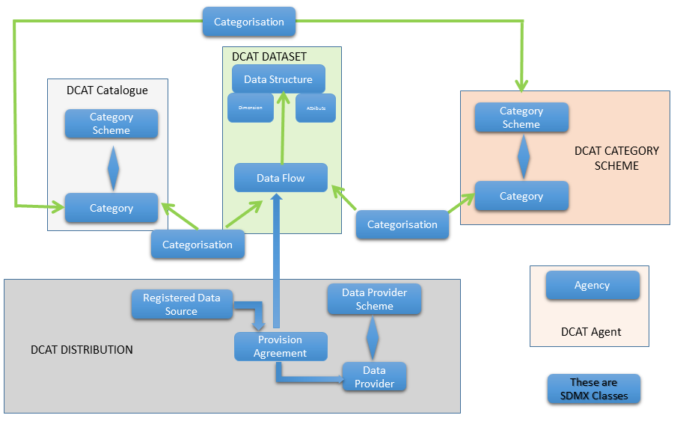

Figure 7: Schematic map of SDMX Classes to DCAT-AP

This is a schematic diagram of those high level classes in the SDMX Information Model that provide the metadata required by StatDCAT-AP.

A narrative explanation is:

1. The DCAT Catalogue is mapped to an SDMX Category Scheme. The Category can link to any other structural metadata object in SDMX using a Categorisation. The Categorisation provides the link, i.e. the Categorisation references both the object and the Category to which it is linked. Two Categories are present in the Category Scheme representing the DCAT-Catalogue, one for linking the Dataflows, and one for linking the Category Scheme containing the topic themes. There will be multiple Categorisations, each one linking the object (e.g. Dataflow) to the relevant Category. Therefore, for instance, there will be one Categorisation for each Dataflow, each Categorisation referencing the same Category. In this way all of the Dataflows that are contained in the catalogue are linked to the same Category.
2. The StatDCAT-AP Dataset maps to the SDMX Dataflow.
3. Dimension and Attribute in the StatDCAT-AP Dataset map to Dimension and Attribute in the SDMX Data Structure
4. The DCAT Category Scheme maps to the SDMX Category Scheme. However, it should be noted that this Category Scheme will be different from the one that contains the DCAT Catalogue. The Categories in this Category Scheme are the topics or themes that categorise the type of data. Each Category links to the Dataflows that are relevant to the topic by means of a Categorisation. A Dataflow may be linked to many such topics (Categories) and a topic (Category) can be linked to many Dataflows.
5. The DCAT Distribution maps to the SDMX Provision Agreement which links a Data Provider with a Dataflow. The Data Provider and the Dataflow have a many-to- many association, each one-to-one association is represented as a Provision Agreement. The actual data source for one Data Provider and its linked Dataflow is the Registered Data Source linked to the Provision Agreement. The URL of the Registered Data Source is a link to a data source, which can be a URL that resolves to an actual set of data or it may be a URL to a web service that can be queried for the data. SDMX makes a distinction between the two.
6. The DCAT Agent maps to the SDMX Agency which is the “Maintenance Agency” for the metadata such as the Dataflow. Note that in SDMX the Maintenance Agency is maintained in a different scheme from the Data Provider. So, the Data Provider is a different construct from the Agency. In SDMX the Data Provider (of the actual data) can be different from the Maintenance Agency of the metadata describing the data (the SDMX Dataflow): they may both have the same Id but are different entities.

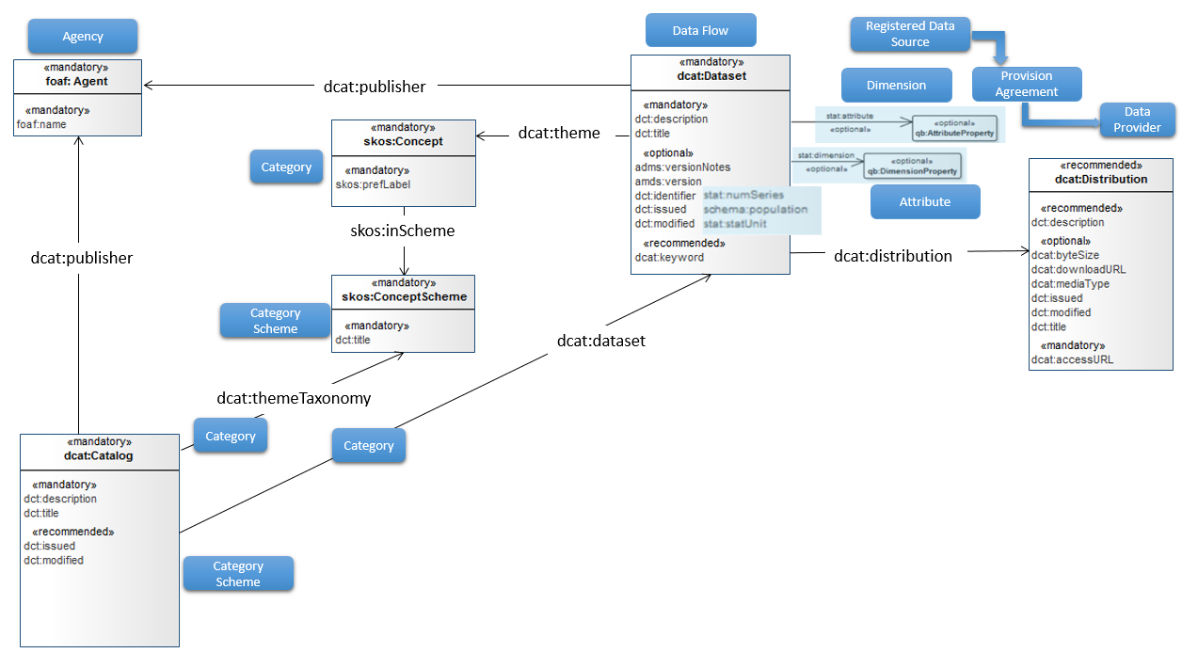

Figure 8: DCAT-AP Model mapped to SDMX Model Classes

This shows the same mapping but from the perspective of the DCAT-AP model.

Example

Introduction

This example shows how the SDMX structural metadata are mapped to the DCAT-AP classes and properties. The mapping shows the XML instances of the structural metadata authored in an SDMX Registry and exported as SDMX-ML.

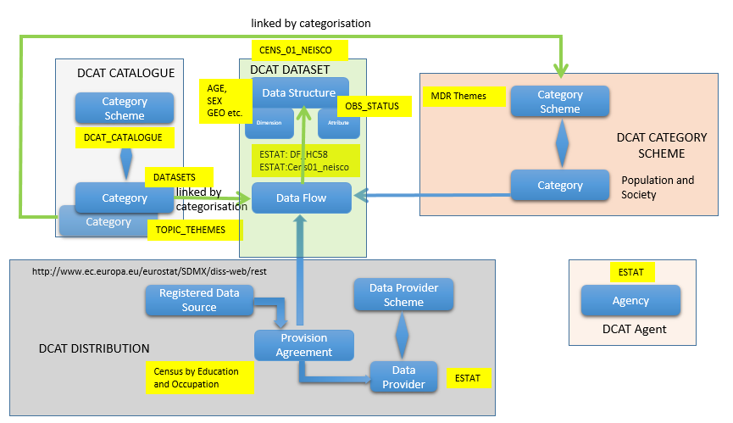

Figure 9: Metadata Used in the Mapping Example

This shows the schematic diagram of the high level SDMX classes and the content of these for the instance of these classes used in the examples that follow.

A narrative explanation is:

1. The SDMX Category Scheme containing the DCAT Catalogue has two Categories: one called *TOPIC_SCHEMES*, links to the DCAT Category Scheme of *MDR Themes*, while the other called *DATASETS*, links to all the DCAT Datasets (in SDMX this is called a Dataflow) listed in the Catalogue.
2. In the example two Dataflows are present: *DF_HC58* (Census Hub Hypercube 58) and *Cens01_neisco* (Census data broken down by education and occupation). Both Dataflows are maintained by Eurostat (Agent=*ESTAT*). The Dataflow *DF_HC58* is included only to show how the SDMX Category can link to multiple Dataflows. The Dataflow *Cens01_neisco* is the one used for the detailed mapping of SDMX to the StatDCAT-AP classes – Dataset, Distribution, Category Scheme, Agent
3. The Dataflow is linked to the Data Structure *CENS_01_NEISCO* which has a number of Dimensions including Age, Sex, Geography, and one Attribute, Observation Status
4. The SDMX Category Scheme containing the list of statistical themes has the name *MDR Themes* in the examples.
5. The Provision Agreement containing the DCAT Distribution in the example is named *Census by Education and Occupation* and links the Data Provider (*ESTAT)* to the Dataflow *Cens01_neisco*. The URL of the Registered Data Source is a link to a web service that can be queried for the data.
6. The SDMX Agency containing the DCAT Agent is *ESTAT.* The Data Provider is a different construct from the *ESTAT* Agency, but in this example it is given the same Id (*ESTAT*).
7. The URL in the Registered Data Source ([*http://www.ec.europa.eu/eurostat/SDMX/diss-web/rest*](http://www.ec.europa.eu/eurostat/SDMX/diss-web/rest)) is the dcat:accessURL in the DCAT Distribution.

SDMX Annotations

SDMX does not support some of the mandatory or recommended properties of DCAT-AP. However, SDMX has an extensibility mechanism called “Annotations”. Annotations can be added to any SDMX object that can be identified.

The structure of an Annotation is shown below:

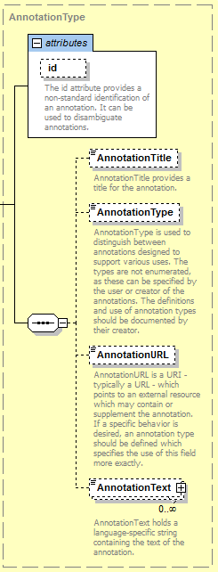

Figure 10: SDMX XML schema specification for Annotation

In the examples that follow the following elements are used:

*AnnotationTitle* contains the DCAT-AP property value

*AnnotationType* contains the value StatDCAT-AP indicating that this is a StatDCAT-AP property

*AnnotationURL* is a URI

*AnnotationText* is a text value (this can occur many times to support be multilingual variants)

Explanation of the mapping diagrams

In all cases the mapping is shown between the DCAT-AP property and the location of the property in an SDMX XML message. Table 3 under the mapping diagram maps the DCAT-AP properties to the corresponding SDMX XML elements or attributes. In all cases the SDMX message is a <Structure> message (i.e. the start tag is the <Structure> element)

e.g. 

In Table 3 the additional StatDCAT-AP properties are shown in turquoise.

e.g. 

Data Catalogue

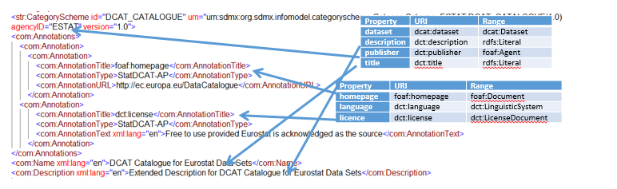 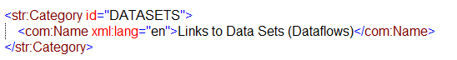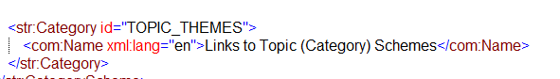

Figure 11: SDMX-DCAT mapping example for the DCAT Catalogue

Table 3 DCAT-AP properties mapped to the corresponding SDMX XML elements or attributes

| **DCAT-AP Property** | **SDMX Element or Element.Attribute** |
| --- | --- |
| **dct:description** | Description |
| **dct:publisher** | CategoryScheme.agencyID |
| **dct:title** | Name |
| **foaf:homepage** | AnnotationTitle |
| **dct:license** | AnnotationTitle |

Linking to Categories using Categorisations

*Schematic*

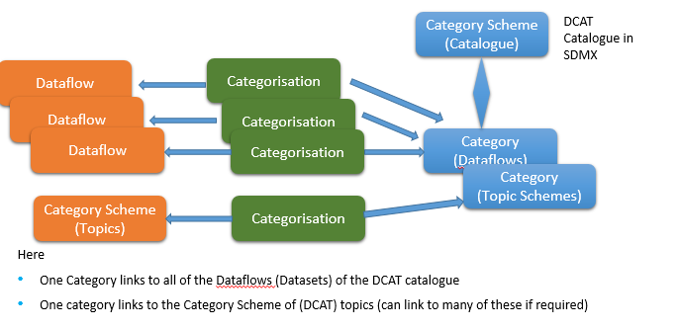

Figure 12: Schematic showing links between SDMX Categories and other SDMX objects

*Example*

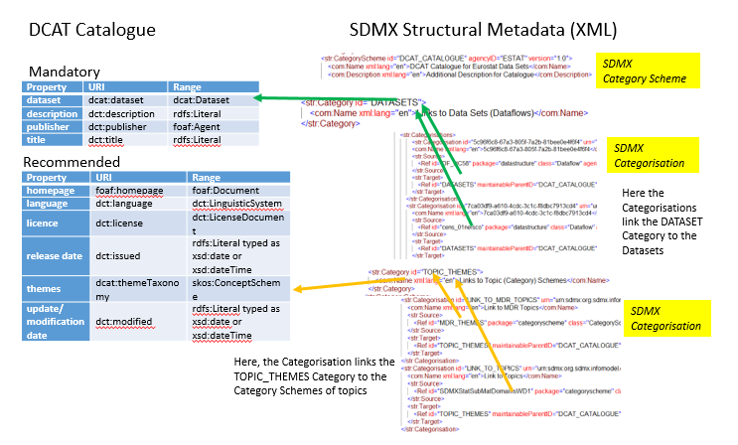

Figure 13: Linking Catalogue to DCAT Datasets and Category (Topic) Scheme

| **DCAT-AP Property** | **SDMX Element or Element.Attribute** |
| --- | --- |
| **dcat:dataset** | Source/Ref.id (id of the Dataflow  Source/Ref.agencyId (agency of the Dataflow)  Source/Ref.version (version of the Dataflow)  Target/Ref.id (id of the Category)  Target/maintainableParentId (id of the Category Scheme that is the DCAT-AP Catalogue)  Target/agencyId (agency of the Category Scheme)  Target/version (version of the Category Scheme) |
| **dcat:themeTaxonomy** | Source/Ref.id (id of the Dataflow)  Source/Ref.agencyId (agency of the Dataflow)  Source/Ref.version (version of the Dataflow)  Target/Ref.id (id of the Category)  Target/maintainableParentId (id of the Category Scheme that is the DCAT-AP Category Scheme)  Target/agencyId (agency of the Category Scheme)  Target/version (version of the Category Scheme) |

Dataset

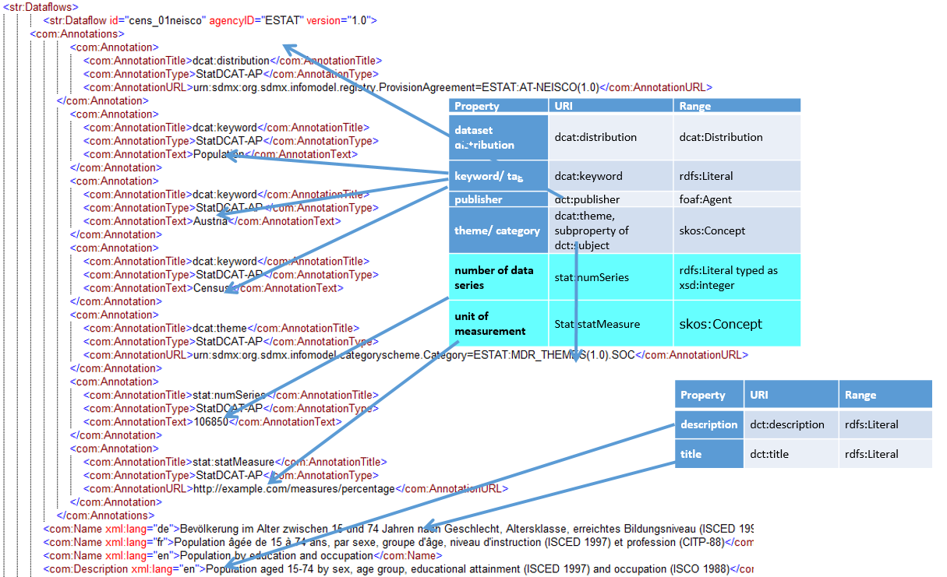

Figure 14: SDMX to DCAT mapping example for the StatDCAT-AP Dataset

| **DCAT-AP Property** | **SDMX Element or Element.Attribute** |
| --- | --- |
| **dcat:distribution** | AnnotationURL |
| **dcat:keyword** | AnnotatationText |
| **dct:publisher** | Dataflow.agencyID |
| **dcat:theme** | AnnotationURL |
| **stat:numSeries** | AnnotationText |
| **stat:statUnitMeasure** | AnnotationURL |
| **dct:description** | Description |
| **dct:title** | Name |

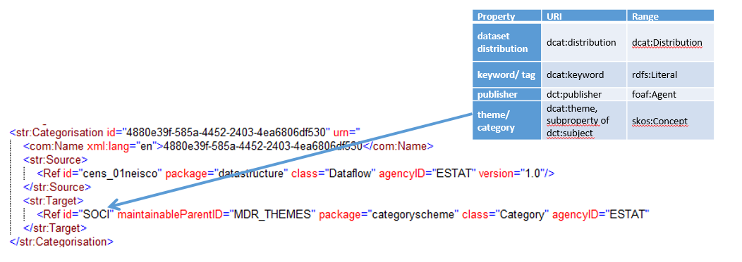

Figure 15: Linking a Dataflow to the SDMX Category (Topic)

This links the Dataflow cens_01neisco version 1.0 maintained by ESTAT to the Category SOCI in the Category Scheme representing the MDR Themes (MDR_THEMES). This (SDMX) Category is the map to the dcat:theme.

Dimension Property and Attribute Property

The URL must resolve to a qb:dimension or qb:attribute.

Quality Annotation

If required as SDMX structural metadata this will be an Annotation in the Dataflow

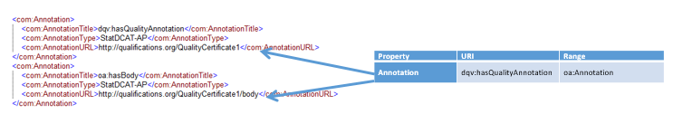

Figure 16: SDMX to DCAT mapping example for the StatDCAT-AP Annotation

Distribution

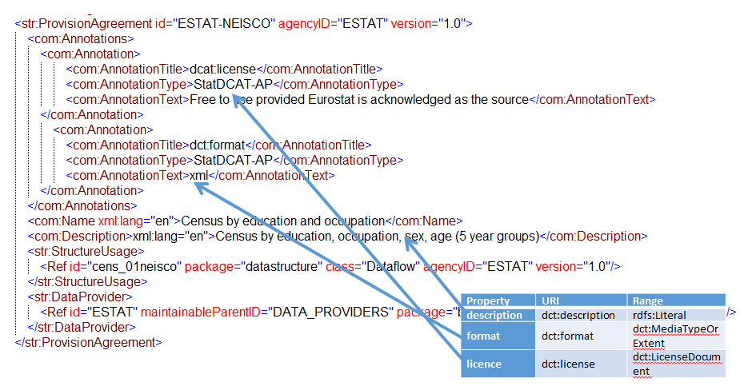

Figure 17: Linking a Distribution to the SDMX Provision Agreement

| **DCAT-AP Property** | **SDMX Element or Eelement.Attribute** |
| --- | --- |
| **dct:description** | Description |
| **dct:format** | AnnotationText |
| **dct:license** | AnnotationText |

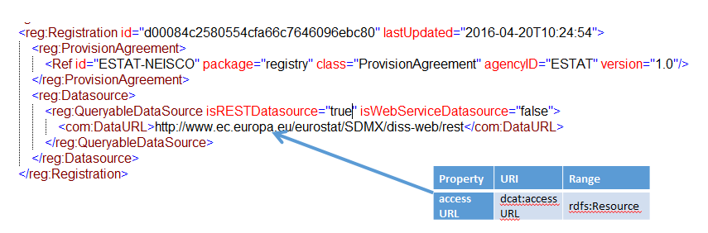

Figure 18: Linking a Distribution (accessURL) to the SDMX Provision Agreement

| **DCAT-AP Property** | **SDMX Element or Element.Attribute** |
| --- | --- |
| **dcat:accessURL** | QueryableDataSource/DataURL |

Agent

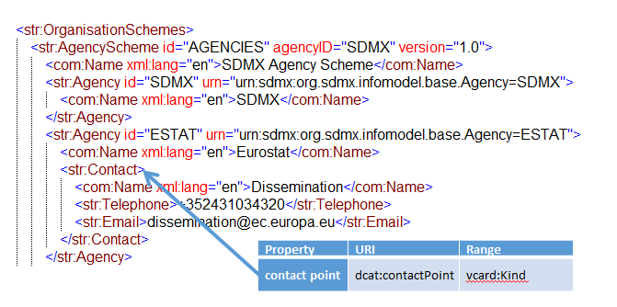

Figure 19:Linking an Agent to the SDMX Agency

| **DCAT-AP Property** | **SDMX Element or Eelement.Attribute** |
| --- | --- |
| **dcat:contactPoint** | Contact/Name  Contact/Telephone  Contact/Email |

Summary

The mapping above is the recommended mapping between SDMX classes and attributes and DCAT-AP classes and properties. Clearly, an organisation is free to use whatever input source(s) it wishes, including a mixture of sources. The use of SDMX Annotations to curate the DCAT-AP properties is a recommendation for those organisations that wish to use 100% SDMX structural metadata for this mapping. In order to achieve interoperability between systems, StatDCAT-AP will specify a controlled vocabulary for the AnnotationTitle (this contains the DCAT-AP property).

1. SDMX-based Transformation Mechanism

Scope of this section

The scope of this section is to describe a mechanism intended to assist statistical organisations to create StatDCAT-AP messages without the need for the organisation to understand the syntax and rules of DCAT-AP. This mechanism is referred to as here the “Transformation Mechanism”.

Whilst any organisation is free to choose whichever mechanism it prefers in order to create and publish DCAT-AP RDF, it is the intention that the Transformation Mechanism described here will be provided in the form of tools that an organisation can use to convert an XML file based on SDMX-formatted structures (SDMX-ML) into DCAT-AP.

The intent of this Transformation Mechanism is to assist organisations that do not wish to invest in resources to understand RDF technologies and vocabularies and thus to encourage organisations to use DCAT-AP to publish the content of their open data. Whilst the two formats used in this Transformation Mechanism will be familiar to organisations already using SDMX, the Metadata Set variant of the format is a very simple XML structure and it should therefore be easy for organisations with general XML skills to create the metadata required from their own metadata sources, even if they do not use SDMX.

The Transformation Mechanism is first explained. This is followed by an example of the mapping of the input format used by the Transformation Mechanism to the DCAT-AP properties.

Transformation mechanism

The essence of this mechanism is shown in the following diagram and explanation.

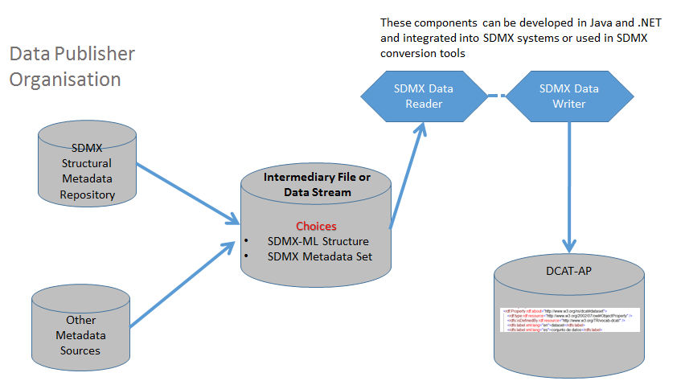

Figure 20: Diagram of the flow of metadata though the Intermediary Mechanism

The structural metadata required to populate the DCAT-AP can be derived from many types of source. The sources may be multiple and may include a maintained structural metadata repository which could be an SDMX-compliant source such as an SDMX Registry.

The metadata required for the intermediary format may be made available either as SDMX structural metadata or as an SDMX metadata set. Both of these options are described later in this section.

The metadata provided is read by a “Data Reader” which understands the format of the metadata stream (i.e. SDMX structural metadata or SDMX metadata set), and makes these metadata available to a Data Writer via an API that is conformant to the SDMX Common Component Architecture. The Data Writer creates the DCAT-AP output. Therefore, the Transformation Mechanism comprises two Data Readers (one for each of the two formats) and one Data Writer. It should be noted that under the SDMX Common Component Architecture, the Data Reader and the Data Writer are totally independent from each other and so any Data Reader can supply data to any Data Writer. Thus the Data Readers and Writers can be integrated into an organisation’s system or can be built easily into transformation tools. There are a number of SDMX validation and transformation tools that can be extended to use these two Data Readers and the DCAT-AP Data Writer.

Transformation input formats

Choice of mechanisms

It is the responsibility of the user system to extract the metadata from the metadata source(s) and write the metadata to the relevant transformation input format. So, the question that requires an answer is “why, then, not just create DCAT-AP directly?”

Of course if an organisation can create DCAT-AP messages directly from its own systems, then it should do so. However, if an organisation is not comfortable with this direct approach (e.g., because it does not have RDF skills, or it already has SDMX systems in place and is more familiar with SDMX formats) then the Transformation Mechanism is an attractive approach as it uses SDMX formats and has built-in validation procedures ensuring that the metadata are DCAT-AP-compliant.

SDMX Structural Metadata

The format is an SDMX Structure Message. The mapping of SDMX to DCAT-AP has been described in Annex IV of this specification and examples of the mapping are also given in that Annex.

However, there is one difference between the mapping given in Annex IV and the format used in the Transformation Mechanism. This concerns the accessURL of the DCAT Distribution. In SDMX the Registration element is not an output in the SDMX Structure Message, it is an output in the SDMX Registry Interface Message. Therefore, for the purpose of this transformation this metadata is represented as an Annotation in the Provision Agreement.

So, taking the example from Annex IV:



Figure 21: From Section 9 - Linking a Distribution (accessURL) to the SDMX Provision Agreement

Using the Transformation Mechanism the output is the following:

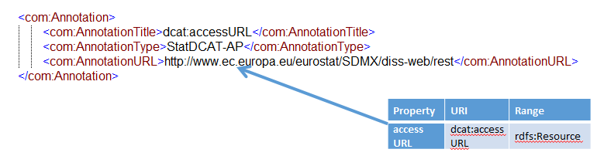

Figure 22: Transformation format - Linking a Distribution (accessURL) to the SDMX Provision Agreement

So, the full example of the Provision Agreement will look like this:

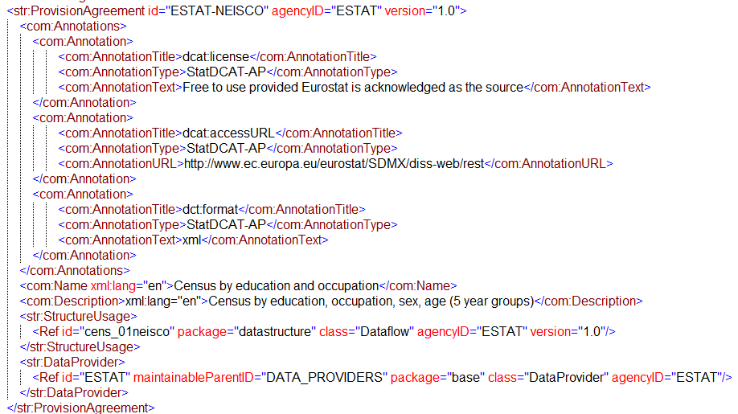

Figure 23: Example of a Provision Agreement for DCAT-AP Distribution

The full example of the Structure Message is shown in Annex VI.

It is a simple software development to create an extract process from an SDMX Registry to create the SDMX format required for the Transformation Mechanism, as the relevant metadata can be retrieved using SDMX web services which are supported already by an SDMX Registry.

SDMX Metadata Set

**Structure**

A Metadata Set represents metadata for some or all of the DCAT Classes and Properties as Metadata Attributes. The structure of a Metadata Set is defined by a Metadata Structure Definition (MSD). The MSD contains all of the information required to structure the content of a Metadata Set in terms of:

For each Metadata Attribute:

* the Concept used (i.e. the DCAT-AP Class or Property);
* the valid content (e.g. a Code List, text, URL, integer, no content etc.); and
* child Metadata Attributes if a hierarchy is specified.

The MSD also specifies the type of object (class) to which the metadata pertains, such as an SDMX Dataflow. The identification of the actual instance (e.g., an actual Dataflow) is contained in the Metadata Set together with the content of the Metadata Attributes.

A schematic of the MSD is shown below.

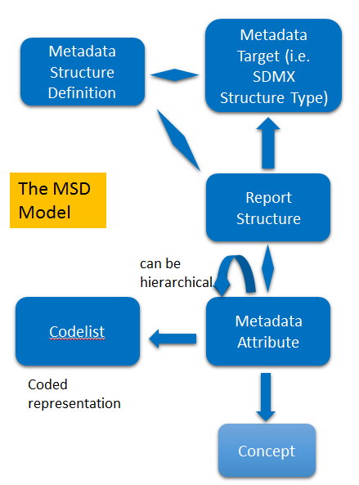

Figure 24: Schematic diagram of the SDMX Metadata Structure Definition model

A schematic representation of the Metadata Set is shown below.

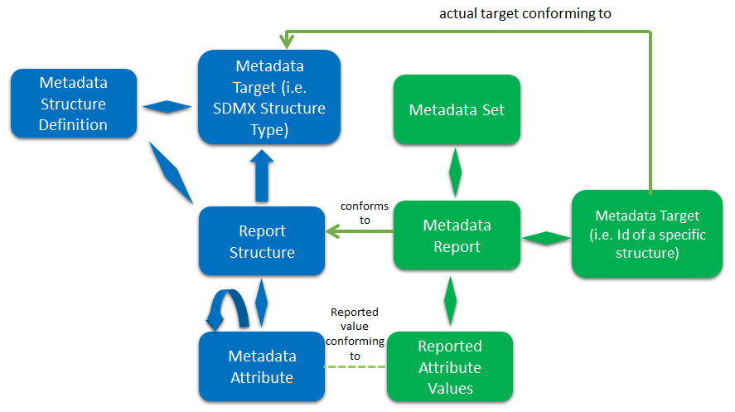

Figure 25: Schematic diagram of the SDMX Metadata Set

The green boxes represent the content of the Metadata Set. The MSD is not a part of the Metadata Set but both the MSD and the Report Structure are identified in the Metadata Set. The Id of the Metadata Attribute is contained in the Reported Attribute thus enabling the structure and content of the Reported Attribute to be validated. The Metadata Target contains the Id of SDMX structural component to which the metadata pertains. In the example the target is the SDMX Category Scheme that represents the DCAT-AP Catalogue.

**Example MSD**

Note that this MSD is not finalised. At the moment is contains the Mandatory and Recommended properties of DCAT-AP, and the extensions added by StatDCAT-AP.

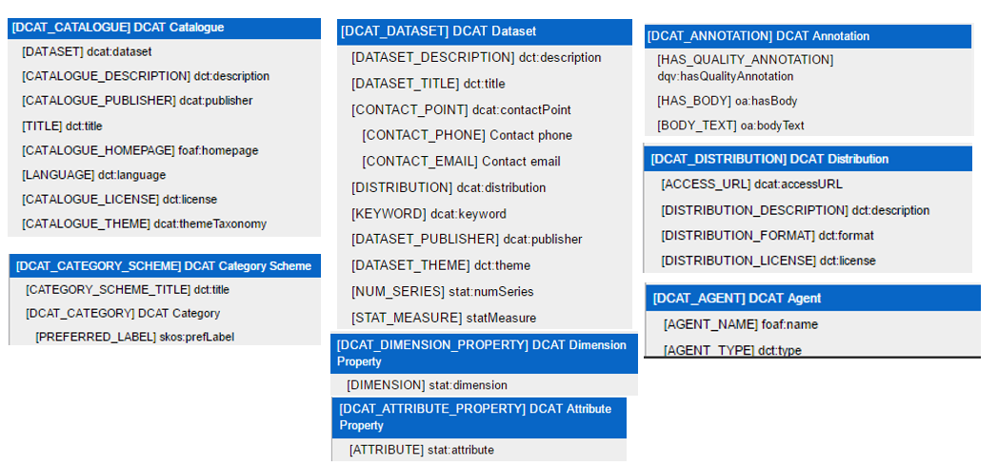

Figure 26: Metadata Attributes in the DCAT-AP MSD

Each DCAT-AP class and StatDCAT-AP class are top level Metadata Attributes in the MSD. The properties of the class are the child Metadata Attributes. Additional hierarchies are defined where appropriate (e.g., in DCAT_DATASET the CONTACT_POINT has two child Metadata Attributes).

The Metadata Attributes representing the DCAT-AP classes are for grouping purposes which enable the transformation software to determine to which DCAT-AP class the metadata pertains. They have no content themselves but have child Metadata Attributes. The following picture shows some examples of the type of valid content that can be specified.

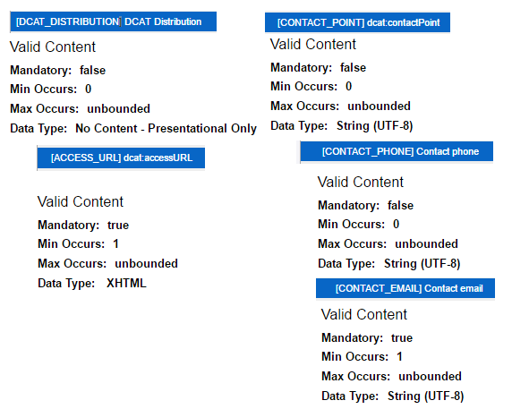

Figure 27: Example of Metadata Attribute Specification

The examples above show:

1. DCAT_DISTRIBUTION is used for grouping purposes only and so no actual value is reported in a Metadata Set.
2. accessURL is mandatory if DCAT_DISTRIBUTION information is present; in this case its valid representation is XHTML.
3. Contact Point can occur many times; if this information is available CONTACT_PHONE is optional while CONTACT_EMAIL is mandatory.

Note that a code list may be specified as the valid representation, in which case the value of the reported attribute in the Metadata Set must be a code in the assigned code list. There is no example of this in the Figure 27 above.

**Example of Metadata Report**

The following SDMX Metadata Set Report shows how the DCAT-AP metadata are represented in a Metadata Set structured according to the MSD.

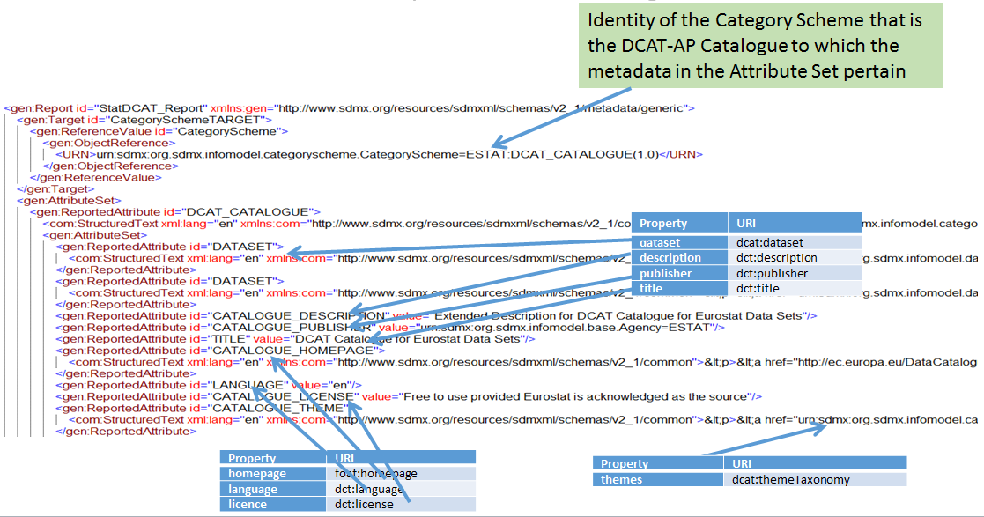

Figure 28: SDMX catalogue metadata pertaining to the DCAT-AP Catalogue

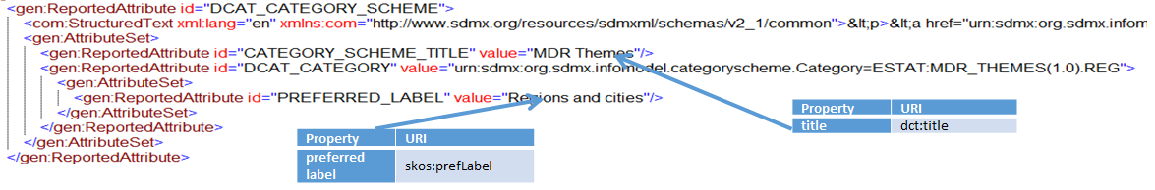

Figure 29: SDMX category scheme metadata pertaining to the DCAT-AP Catalogue

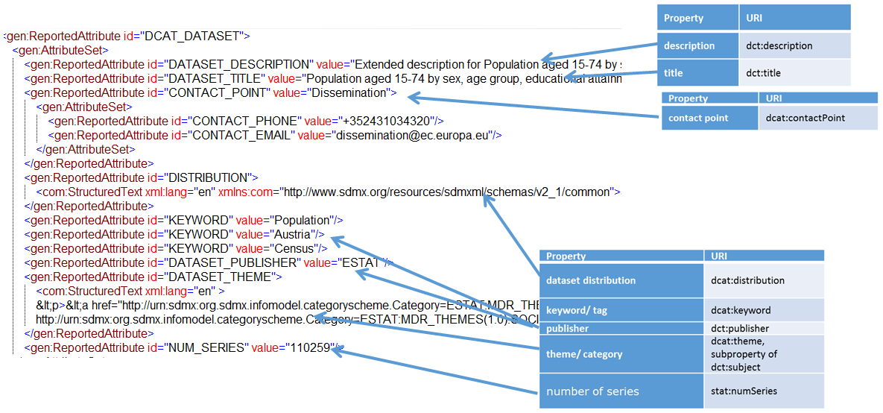

Figure 30: SDMX dataset metadata pertaining to the DCAT-AP Catalogue including StatDCAT-AP extensions to the Dataset.

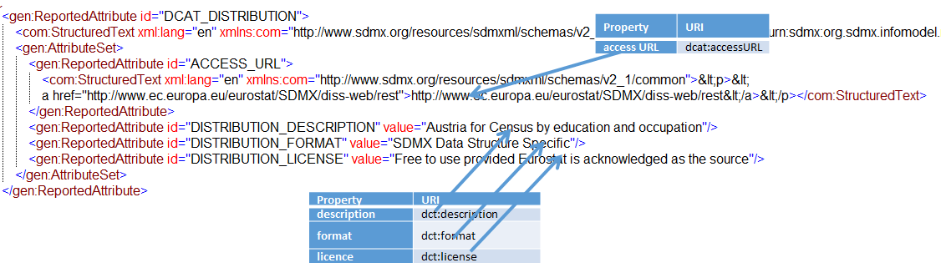

Figure 31: SDMX distribution metadata pertaining to the DCAT-AP Catalogue including StatDCAT-AP extensions to the Distribution

It is possible to create a Metadata Set for any or all of the DCAT-AP classes to be supported by StatDCAT-AP. Therefore, an entire catalogue can be published including all its associated Datasets, Distributions, Category Schemes., and Agents. Alternatively, metadata may be added to an existing Catalogue incrementally.

Advantages and disadvantages of the two transformation formats

SDMX Structure Message

**Advantages**

* Familiar to organisations using SDMX
* Can be generated easily from an SDMX Registry

**Disadvantages**

* The XML can be complex and verbose
* Annotations cannot be
  + coded (representation is restricted to text and URL)
  + hierarchical (but there is a mechanism to achieve this)
  + validated by SDMX validators (e.g. check that Title is valid)
  + given mandatory and optional status (all Annotations are optional)
* Such messages could create unnecessary “noise” when exchanging structural metadata with other organisations if this is the source of the metadata in an SDMX Registry-compliant metadata source

**However**

It is possible to use the MSD for the Metadata Set option to validate that the content of the structural metadata is complete and that the Annotation metadata is correct (e.g. text representing a coded value can be validated against a code list) and that the correct hierarchy is built in DCAT-AP.

SDMX Metadata Set

**Advantages**

* Simple XML structure
* Attributes can be:
  + assigned any type of representation (e.g. coded, text, HTML, Boolean etc.);
  + hierarchical;
  + validated; and
  + assigned mandatory or optional usage status.
* The Metadata Set Report can reference any object that can be identified (e.g., Dataflow, Provision Agreement, Category Scheme)
* Is separate from the structural metadata so does not affect the structural metadata components
* If present, a Metadata Attribute can be “presentational”, just giving structure to child attributes

**Disadvantages**

* Not always well understood by SDMX users (may result in some reluctance to use this mechanism)
* Not widely used

Summary

Whilst an organisation can choose to generate DCAT-AP directly from its own systems, having an intermediary Transformation Mechanism will be of benefit to some organisations. This will be particularly true for organisations already using SDMX.

There is a need for all organisations to validate the metadata to ensure that it is compliant with the DCAT-AP classes and properties. The MSD can play a role in the validation process regardless of the intermediary transformation format because the MSD describes the valid content of DCAT-AP metadata.

The Metadata Set intermediary format is simpler than the SDMX structural metadata. However, for organisations using an SDMX Registry, these registry systems will probably be able to harvest the metadata and export it as DCAT-AP using the Transformation Mechanism.

1. SDMX Files used for the examples

SDMX Structural Metadata

In the following example, to avoid any ambiguity, instead of using keywords e.g DCAT-AP, URIs are used. For DCAT-AP, the URI: [http://www.w3.org/ns/dcat#](http://www.w3.org/ns/dcat) is used. For StatDCAT-AP, the fictitious URI <http://data.europa.eu/xyz> is used that corresponds to the namespace URI of StatDCAT-AP.

<?xml version="1.0" encoding="UTF-8"?>

<mes:Structure xmlns:xsi="http://www.w3.org/2001/XMLSchema-instance" xmlns:xml="http://www.w3.org/XML/1998/namespace" xmlns:mes="http://www.sdmx.org/resources/sdmxml/schemas/v2_1/message" xmlns:str="http://www.sdmx.org/resources/sdmxml/schemas/v2_1/structure" xmlns:com="http://www.sdmx.org/resources/sdmxml/schemas/v2_1/common" xsi:schemaLocation="http://www.sdmx.org/resources/sdmxml/schemas/v2_1/message https://registry.sdmx.org/schemas/v2_1/SDMXMessage.xsd">

<mes:Header>

<mes:ID>IDREF169</mes:ID>

<mes:Test>false</mes:Test>

<mes:Prepared>2016-05-05T15:11:56</mes:Prepared>

<mes:Sender id="FR"/>

<mes:Receiver id="not_supplied"/>

</mes:Header>

<mes:Structures>

<str:OrganisationSchemes>

DCAT Agent

<str:AgencyScheme id="AGENCIES" urn="urn:sdmx:org.sdmx.infomodel.base.AgencyScheme=SDMX:AGENCIES(1.0)" isExternalReference="false" agencyID="SDMX" isFinal="false" version="1.0">

<com:Name xml:lang="en">SDMX Agency Scheme</com:Name>

<str:Agency id="ESTAT" urn="urn:sdmx:org.sdmx.infomodel.base.Agency=ESTAT">

<com:Name xml:lang="en">Eurostat</com:Name>

<str:Contact>

<com:Name xml:lang="en">Dissemination</com:Name>

<str:Telephone>+352431034320</str:Telephone>

<str:Email>dissemination@ec.europa.eu</str:Email>

</str:Contact>

</str:Agency>

</str:AgencyScheme>

</str:OrganisationSchemes>

<str:Dataflows>

DCAT Dataset

<str:Dataflow id="cens_01neisco" agencyID="ESTAT" version="1.0">

<com:Annotations>

<com:Annotation>

<com:AnnotationTitle>http://www.w3.org/ns/dcat#distribution</com:AnnotationTitle>

<com:AnnotationType> http://data.europa.eu/xyz</com:AnnotationType>

<com:AnnotationURL>urn:sdmx:org.sdmx.infomodel.registry.ProvisionAgreement=ESTAT:AT- NEISCO(1.0)</com:AnnotationURL>

</com:Annotation>

<com:Annotation>

<com:AnnotationTitle> http://www.w3.org/ns/dcat#keyword</com:AnnotationTitle>

<com:AnnotationType> http://data.europa.eu/xyz </com:AnnotationType>

<com:AnnotationText>Population</com:AnnotationText>

</com:Annotation>

<com:Annotation>

<com:AnnotationTitle> http://www.w3.org/ns/dcat#keyword</com:AnnotationTitle>

<com:AnnotationType> http://data.europa.eu/xyz </com:AnnotationType>

<com:AnnotationText>Austria</com:AnnotationText>

</com:Annotation>

<com:Annotation>

<com:AnnotationTitle> http://www.w3.org/ns/dcat#keyword</com:AnnotationTitle>

<com:AnnotationType> http://data.europa.eu/xyz </com:AnnotationType>

<com:AnnotationText>Census</com:AnnotationText>

</com:Annotation>

<com:Annotation>

<com:AnnotationTitle> http://www.w3.org/ns/dcat#theme</com:AnnotationTitle>

<com:AnnotationType> http://data.europa.eu/xyz </com:AnnotationType> <com:AnnotationURL>urn:sdmx:org.sdmx.infomodel.categoryscheme.Category=ESTAT:MDR_THEMES(1.0).SOC</com:AnnotationURL>

</com:Annotation>

<com:Annotation>

<com:AnnotationTitle>stat:numSeries</com:AnnotationTitle>

<com:AnnotationType> http://data.europa.eu/xyz </com:AnnotationType>

<com:AnnotationText>106850</com:AnnotationText>

</com:Annotation>

<com:Annotation>

<com:AnnotationTitle>stat:statUnitMeasure</com:AnnotationTitle>

<com:AnnotationType> http://data.europa.eu/xyz </com:AnnotationType>

<com:AnnotationURL>http://example.com/measures/percentage</com:AnnotationURL>

</com:Annotation>

<com:Annotation>

<com:AnnotationTitle>dqv:hasQualityAnnotation</com:AnnotationTitle>

<com:AnnotationType> http://data.europa.eu/xyz </com:AnnotationType>

<com:AnnotationURL>http://qualifications.org/QualityCertificate1</com:AnnotationURL>

</com:Annotation>

<com:Annotation>

<com:AnnotationTitle>oa:hasBody</com:AnnotationTitle>

<com:AnnotationType> http://data.europa.eu/xyz </com:AnnotationType>

<com:AnnotationURL>http://qualifications.org/QualityCertificate1/body</com:AnnotationURL>

</com:Annotation>

</com:Annotations>

<com:Name xml:lang="de">Bevölkerung im Alter zwischen 15 und 74 Jahren nach Geschlecht, Altersklasse, erreichtes Bildungsniveau (ISCED 1997) und Beruf (ISCO-88)</com:Name>

<com:Name xml:lang="fr">Population âgée de 15 à 74 ans, par sexe, groupe d'âge, niveau d'instruction (ISCED 1997) et profession (CITP-88)</com:Name>

<com:Name xml:lang="en">Population by education and occupation</com:Name>

<com:Description xml:lang="en">Population aged 15-74 by sex, age group, educational attainment (ISCED 1997) and occupation (ISCO 1988)</com:Description>

<str:Structure>

<Ref id="CENS_01_NEISCO" package="datastructure" class="DataStructure" agencyID="ESTAT" version="1.0"/>

</str:Structure>

</str:Dataflow>

DCAT Catalogue

<str:CategoryScheme id="DCAT_CATALOGUE" urn="urn:sdmx:org.sdmx.infomodel.categoryscheme.CategoryScheme=ESTAT:DCAT_CATALOGUE(1.0)" isExternalReference="false" agencyID="ESTAT" isFinal="false" version="1.0">

<com:Annotations>

<com:Annotation>

<com:AnnotationTitle> http://www.w3.org/ns/dcat#dataset</com:AnnotationTitle>

<com:AnnotationType> http://data.europa.eu/xyz </com:AnnotationType>

<com:AnnotationURL>urn:sdmx:org.sdmx.infomodel.datastructure.Dataflow=ESTAT:DF_HC58(1.0)</com:AnnotationURL>

</com:Annotation>

<com:Annotation>

<com:AnnotationTitle>foaf:homepage</com:AnnotationTitle>

<com:AnnotationType> http://data.europa.eu/xyz </com:AnnotationType>

<com:AnnotationURL>[http://ec.europa.eu/DataCatalogue</com:AnnotationURL](http://ec.europa.eu/DataCatalogue%3c/com:AnnotationURL)>

</com:Annotation>

<com:Annotation>

<com:AnnotationTitle>dct:license</com:AnnotationTitle>

<com:AnnotationType> http://data.europa.eu/xyz </com:AnnotationType>

<com:AnnotationText xml:lang="en">Free to use provided Eurostat is acknowledged as the source</com:AnnotationText>

</com:Annotation>

</com:Annotations>

<com:Name xml:lang="en">DCAT Catalogue for Eurostat Data Sets</com:Name>

<str:Category id="DATASETS" urn="urn:sdmx:org.sdmx.infomodel.categoryscheme.Category=ESTAT:DCAT_CATALOGUE(1.0).DATASETS">

<com:Name xml:lang="en">Links to Data Sets (Dataflows)</com:Name>

</str:Category>

<str:Category id="TOPIC_THEMES" urn="urn:sdmx:org.sdmx.infomodel.categoryscheme.Category=ESTAT:DCAT_CATALOGUE(1.0).TOPIC_THEMES">

<com:Name xml:lang="en">Links to Topic (Category) Schemes</com:Name>

</str:Category>

</str:CategoryScheme>

DCAT Category Scheme

<str:CategoryScheme id="MDR_THEMES" urn="urn:sdmx:org.sdmx.infomodel.categoryscheme.CategoryScheme=ESTAT:MDR_THEMES(1.0)" isExternalReference="false" agencyID="ESTAT" isFinal="false" version="1.0">

<com:Name xml:lang="en">MDR Themes</com:Name>

<str:Category id="AGRI" urn="urn:sdmx:org.sdmx.infomodel.categoryscheme.Category=ESTAT:MDR_THEMES(1.0).AGRI">

<com:Name xml:lang="en">Agriculture, fisheries, forestry and food</com:Name>

<com:Description xml:lang="en">This concept identifies datasets covering such domains as agriculture, fisheries, forestry or food.</com:Description>

</str:Category>

<str:Category id="ECON" urn="urn:sdmx:org.sdmx.infomodel.categoryscheme.Category=ESTAT:MDR_THEMES(1.0).ECON">

<com:Name xml:lang="en">Economy and finance</com:Name>

<com:Description xml:lang="en">This concept identifies datasets covering such domains as economy or finance.</com:Description>

</str:Category>

<str:Category id="EDUC" urn="urn:sdmx:org.sdmx.infomodel.categoryscheme.Category=ESTAT:MDR_THEMES(1.0).EDUC">

<com:Name xml:lang="en">Education, culture and sport</com:Name>

<com:Description xml:lang="en">This concept identifies datasets covering such domains as education, culture or sport.</com:Description>

</str:Category>

<str:Category id="ENER" urn="urn:sdmx:org.sdmx.infomodel.categoryscheme.Category=ESTAT:MDR_THEMES(1.0).ENER">

<com:Name xml:lang="en">Energy</com:Name>

<com:Description xml:lang="en">This concept identifies datasets covering the domain of energy.</com:Description>

</str:Category>

<str:Category id="ENVI" urn="urn:sdmx:org.sdmx.infomodel.categoryscheme.Category=ESTAT:MDR_THEMES(1.0).ENVI">

<com:Name xml:lang="en">Environment</com:Name>

<com:Description xml:lang="en">This concept identifies datasets covering the domain of environment</com:Description>

</str:Category>

<str:Category id="GOVE" urn="urn:sdmx:org.sdmx.infomodel.categoryscheme.Category=ESTAT:MDR_THEMES(1.0).GOVE">

<com:Name xml:lang="en">Government and public sector</com:Name>

<com:Description xml:lang="en">This concept identifies datasets covering such domains as government or public sector.</com:Description>

</str:Category>

<str:Category id="HEAL" urn="urn:sdmx:org.sdmx.infomodel.categoryscheme.Category=ESTAT:MDR_THEMES(1.0).HEAL">

<com:Name xml:lang="en">Health</com:Name>

<com:Description xml:lang="en">This concept identifies datasets covering the domain of health.</com:Description>

</str:Category>

<str:Category id="INTR" urn="urn:sdmx:org.sdmx.infomodel.categoryscheme.Category=ESTAT:MDR_THEMES(1.0).INTR">

<com:Name xml:lang="en">International issues</com:Name>

<com:Description xml:lang="en">This concept identifies datasets covering the domain of international issues.</com:Description>

</str:Category>

<str:Category id="JUST" urn="urn:sdmx:org.sdmx.infomodel.categoryscheme.Category=ESTAT:MDR_THEMES(1.0).JUST">

<com:Name xml:lang="en">Justice, legal system and public safety</com:Name>

<com:Description xml:lang="en">This concept identifies datasets covering such domains as justice, legal system or public safety.</com:Description>

</str:Category>

<str:Category id="REGI" urn="urn:sdmx:org.sdmx.infomodel.categoryscheme.Category=ESTAT:MDR_THEMES(1.0).REGI">

<com:Name xml:lang="en">Regions and cities</com:Name>

<com:Description xml:lang="en">This concept identifies datasets covering such domains as regions or cities.</com:Description>

</str:Category>

<str:Category id="SOCI" urn="urn:sdmx:org.sdmx.infomodel.categoryscheme.Category=ESTAT:MDR_THEMES(1.0).SOCI">

<com:Name xml:lang="en">Population and society</com:Name>

<com:Description xml:lang="en">This concept identifies datasets covering such domains as population or society.</com:Description>

</str:Category>

<str:Category id="TECH" urn="urn:sdmx:org.sdmx.infomodel.categoryscheme.Category=ESTAT:MDR_THEMES(1.0).TECH">

<com:Name xml:lang="en">Science and technology</com:Name>

<com:Description xml:lang="en">This concept identifies datasets covering such domains as science or technology.</com:Description>

</str:Category>

<str:Category id="TRAN" urn="urn:sdmx:org.sdmx.infomodel.categoryscheme.Category=ESTAT:MDR_THEMES(1.0).TRAN">

<com:Name xml:lang="en">Transport</com:Name>

<com:Description xml:lang="en">This concept identifies datasets covering such domains as transport</com:Description>

</str:Category>

</str:CategoryScheme>

</str:CategorySchemes>

<str:Categorisations>

Link between Dataflow and Category in the MDR Scheme of Topics

<str:Categorisation id="4880e39f-585a-4452-2403-4ea6806df530" urn="urn:sdmx:org.sdmx.infomodel.categoryscheme.Categorisation=ESTAT:4880e39f-585a-4452-2403-4ea6806df530(1.0)" isExternalReference="false" agencyID="ESTAT" isFinal="false" version="1.0">

<com:Name xml:lang="en">4880e39f-585a-4452-2403-4ea6806df530</com:Name>

<str:Source>

<Ref id="cens_01neisco" package="datastructure" class="Dataflow" agencyID="ESTAT" version="1.0"/>

</str:Source>

<str:Target>

<Ref id="SOCI" maintainableParentID="MDR_THEMES" package="categoryscheme" class="Category" agencyID="ESTAT" maintainableParentVersion="1.0"/>

</str:Target>

</str:Categorisation>

Links between Dataflows and DATASET Category of the DCAT-Catalogue

<str:Categorisation id="5c96f6c8-67a3-805f-7a2b-81bee0e4f6f4" urn="urn:sdmx:org.sdmx.infomodel.categoryscheme.Categorisation=ESTAT:5c96f6c8-67a3-805f-7a2b-81bee0e4f6f4(1.0)" isExternalReference="false" agencyID="ESTAT" isFinal="false" version="1.0">

<com:Name xml:lang="en">5c96f6c8-67a3-805f-7a2b-81bee0e4f6f4</com:Name>

<str:Source>

<Ref id="DF_HC58" package="datastructure" class="Dataflow" agencyID="ESTAT" version="1.0"/>

</str:Source>

<str:Target>

<Ref id="DATASETS" maintainableParentID="DCAT_CATALOGUE" package="categoryscheme" class="Category" agencyID="ESTAT" maintainableParentVersion="1.0"/>

</str:Target>

</str:Categorisation>

<str:Categorisation id="7ca03df9-a610-4cdc-3c1c-f8dbc7913cd4" urn="urn:sdmx:org.sdmx.infomodel.categoryscheme.Categorisation=ESTAT:7ca03df9-a610-4cdc-3c1c-f8dbc7913cd4(1.0)" isExternalReference="false" agencyID="ESTAT" isFinal="false" version="1.0">

<com:Name xml:lang="en">7ca03df9-a610-4cdc-3c1c-f8dbc7913cd4</com:Name>

<str:Source>

<Ref id="cens_01neisco" package="datastructure" class="Dataflow" agencyID="ESTAT" version="1.0"/>

</str:Source>

<str:Target>

<Ref id="DATASETS" maintainableParentID="DCAT_CATALOGUE" package="categoryscheme" class="Category" agencyID="ESTAT" maintainableParentVersion="1.0"/>

</str:Target>

</str:Categorisation>

Link between DCAT-Catalogue and Category Scheme of Topics

<str:Categorisation id="LINK_TO_MDR_TOPICS" urn="urn:sdmx:org.sdmx.infomodel.categoryscheme.Categorisation=ESTAT:LINK_TO_MDR_TOPICS(1.0)" isExternalReference="false" agencyID="ESTAT" isFinal="false" version="1.0">

<com:Name xml:lang="en">Link to MDR Topics</com:Name>

<str:Source>

<Ref id="MDR_THEMES" package="categoryscheme" class="CategoryScheme" agencyID="ESTAT" version="1.0"/>

</str:Source>

<str:Target>

<Ref id="TOPIC_THEMES" maintainableParentID="DCAT_CATALOGUE" package="categoryscheme" class="Category" agencyID="ESTAT" maintainableParentVersion="1.0"/>

</str:Target>

</str:Categorisation>

</str:Categorisations>

DCAT Distribution

<str:ProvisionAgreements>

<str:ProvisionAgreement id="ESTAT-NEISCO" urn="urn:sdmx:org.sdmx.infomodel.registry.ProvisionAgreement=ESTAT:ESTAT-NEISCO(1.0)" isExternalReference="false" agencyID="ESTAT" isFinal="false" version="1.0">

<com:Annotations>

<com:Annotation>

<com:AnnotationTitle> http://www.w3.org/ns/dcat#:license</com:AnnotationTitle>

<com:AnnotationType> http://data.europa.eu/xyz </com:AnnotationType>

<com:AnnotationText>Free to use provided Eurostat is acknowledged as the source</com:AnnotationText>

</com:Annotation>

<com:Annotation>

<com:AnnotationTitle> http://www.w3.org/ns/dcat#:accessURL</com:AnnotationTitle>

<com:AnnotationType> http://data.europa.eu/xyz </com:AnnotationType>

<com:AnnotationURL>http://www.ec.europa.eu/eurostat/SDMX/diss-web/rest/</com:AnnotationURL>

</com:Annotation>

</com:Annotations>

<com:Name xml:lang="en">Census by education and occupation</com:Name>

<com:Description>xml:lang="en">Census by education and occupation,sex, age (5-year groups)</com:Description>

<str:StructureUsage>

<Ref id="cens_01neisco" package="datastructure" class="Dataflow" agencyID="ESTAT" version="1.0"/>

</str:StructureUsage>

<str:DataProvider>

<Ref id="ESTAT" maintainableParentID="DATA_PROVIDERS" package="base" class="DataProvider" agencyID="ESTAT" maintainableParentVersion="1.0"/>

</str:DataProvider>

</str:ProvisionAgreement>

</str:ProvisionAgreements>

</mes:Structures>

</mes:Structure>

SDMX Metadata Set

Content

The section below describes the content of the Metadata Set, first in a synthetic view, followed by its SDMX-ML detailed representation.

Metadata Set – Start

<mes:MetadataSet structureRef="MDS2" setID="ba70fc24-f95b-4f0f-a2e2-658d993c2078">

<com:Name xml:lang="en" xmlns:com="http://www.sdmx.org/resources/sdmxml/schemas/v2_1/common">DCAT_CATALOGUE_1</com:Name>

<gen:Report id="StatDCAT_Report" xmlns:gen="http://www.sdmx.org/resources/sdmxml/schemas/v2_1/metadata/generic">

<gen:Target id="CategorySchemeTARGET">

<gen:ReferenceValue id="CategoryScheme">

<gen:ObjectReference>

<URN>urn:sdmx:org.sdmx.infomodel.categoryscheme.CategoryScheme=ESTAT:DCAT_CATALOGUE(1.0)</URN>

</gen:ObjectReference>

</gen:ReferenceValue>

</gen:Target>

<gen:AttributeSet>

Followed by the Reported Attributes for the properties of the various DCAT-AP classes

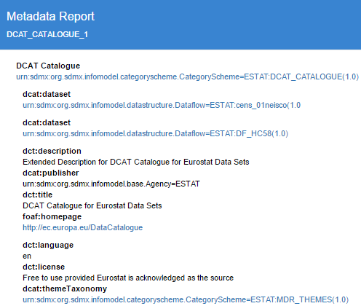

<gen:ReportedAttribute id="DCAT_CATALOGUE">

<com:StructuredText xml:lang="en" xmlns:com="http://www.sdmx.org/resources/sdmxml/schemas/v2_1/common">&lt;p>&lt;a href="urn:sdmx:org.sdmx.infomodel.categoryscheme.CategoryScheme=ESTAT:DCAT_CATALOGUE(1.0)">urn:sdmx:org.sdmx.infomodel.categoryscheme.CategoryScheme=ESTAT:DCAT_CATALOGUE(1.0)&lt;/a>&lt;/p></com:StructuredText>

<gen:AttributeSet>

<gen:ReportedAttribute id="DATASET">

<com:StructuredText xml:lang="en" xmlns:com="http://www.sdmx.org/resources/sdmxml/schemas/v2_1/common">&lt;p>&lt;a href="urn:sdmx:org.sdmx.infomodel.datastructure.Dataflow=ESTAT:cens_01neisco(1.0">urn:sdmx:org.sdmx.infomodel.datastructure.Dataflow=ESTAT:cens_01neisco(1.0&lt;/a>&lt;/p></com:StructuredText>

</gen:ReportedAttribute>

<gen:ReportedAttribute id="DATASET">

<com:StructuredText xml:lang="en" xmlns:com="http://www.sdmx.org/resources/sdmxml/schemas/v2_1/common">&lt;p>&lt;a href="urn:sdmx:org.sdmx.infomodel.datastructure.Dataflow=ESTAT:DF_HC58(1.0)">urn:sdmx:org.sdmx.infomodel.datastructure.Dataflow=ESTAT:DF_HC58(1.0)&lt;/a>&lt;/p></com:StructuredText>

</gen:ReportedAttribute>

<gen:ReportedAttribute id="CATALOGUE_DESCRIPTION" value="Extended Description for DCAT Catalogue for Eurostat Data Sets"/>

<gen:ReportedAttribute id="CATALOGUE_PUBLISHER" value="urn:sdmx:org.sdmx.infomodel.base.Agency=ESTAT"/>

<gen:ReportedAttribute id="TITLE" value="DCAT Catalogue for Eurostat Data Sets"/>

<gen:ReportedAttribute id="CATALOGUE_HOMEPAGE">

<com:StructuredText xml:lang="en" xmlns:com="http://www.sdmx.org/resources/sdmxml/schemas/v2_1/common">&lt;p>&lt;a href="http://ec.europa.eu/DataCatalogue">http://ec.europa.eu/DataCatalogue&lt;/a>&lt;/p></com:StructuredText>

</gen:ReportedAttribute>

<gen:ReportedAttribute id="LANGUAGE" value="en"/>

<gen:ReportedAttribute id="CATALOGUE_LICENSE" value="Free to use provided Eurostat is acknowledged as the source"/>

<gen:ReportedAttribute id="CATALOGUE_THEME">

<com:StructuredText xml:lang="en" xmlns:com="http://www.sdmx.org/resources/sdmxml/schemas/v2_1/common">&lt;p>&lt;a href="urn:sdmx:org.sdmx.infomodel.categoryscheme.CategoryScheme=ESTAT:MDR_THEMES(1.0)">urn:sdmx:org.sdmx.infomodel.categoryscheme.CategoryScheme=ESTAT:MDR_THEMES(1.0)&lt;/a>&lt;/p></com:StructuredText>

</gen:ReportedAttribute>

</gen:AttributeSet>

</gen:ReportedAttribute>

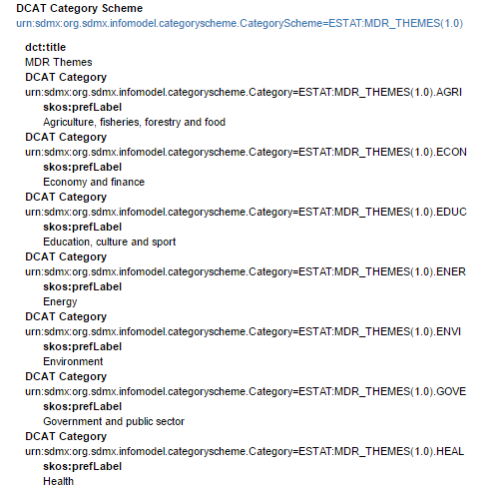

And so on….

<gen:ReportedAttribute id="DCAT_CATEGORY_SCHEME">

<com:StructuredText xml:lang="en" xmlns:com="http://www.sdmx.org/resources/sdmxml/schemas/v2_1/common">&lt;p>&lt;a href="urn:sdmx:org.sdmx.infomodel.categoryscheme.CategoryScheme=ESTAT:MDR_THEMES(1.0)">urn:sdmx:org.sdmx.infomodel.categoryscheme.CategoryScheme=ESTAT:MDR_THEMES(1.0)&lt;/a>&lt;/p></com:StructuredText>

<gen:AttributeSet>

<gen:ReportedAttribute id="CATEGORY_SCHEME_TITLE" value="MDR Themes"/>

<gen:ReportedAttribute id="DCAT_CATEGORY" value="urn:sdmx:org.sdmx.infomodel.categoryscheme.Category=ESTAT:MDR_THEMES(1.0).AGRI">

<gen:AttributeSet>

<gen:ReportedAttribute id="PREFERRED_LABEL" value="Agriculture, fisheries, forestry and food"/>

</gen:AttributeSet>

</gen:ReportedAttribute>

gen:ReportedAttribute id="DCAT_CATEGORY" value="urn:sdmx:org.sdmx.infomodel.categoryscheme.Category=ESTAT:MDR_THEMES(1.0).ECON">

<gen:AttributeSet>

<gen:ReportedAttribute id="PREFERRED_LABEL" value="Economy and finance"/>

</gen:AttributeSet>

</gen:ReportedAttribute>

<gen:ReportedAttribute id="DCAT_CATEGORY" value="urn:sdmx:org.sdmx.infomodel.categoryscheme.Category=ESTAT:MDR_THEMES(1.0).EDUC">

<gen:AttributeSet>

<gen:ReportedAttribute id="PREFERRED_LABEL" value="Education, culture and sport"/>

</gen:AttributeSet>

</gen:ReportedAttribute>

<gen:ReportedAttribute id="DCAT_CATEGORY" value="urn:sdmx:org.sdmx.infomodel.categoryscheme.Category=ESTAT:MDR_THEMES(1.0).ENER">

<gen:AttributeSet>

<gen:ReportedAttribute id="PREFERRED_LABEL" value="Energy"/>

</gen:AttributeSet>

</gen:ReportedAttribute>

And so on….

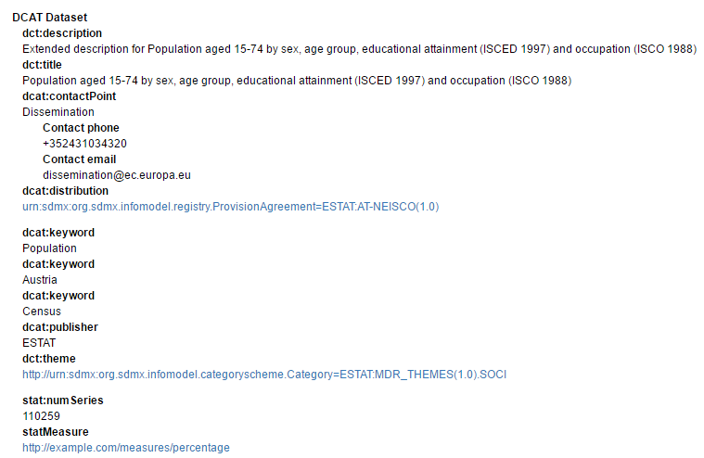

<gen:ReportedAttribute id="DCAT_DATASET">

<gen:AttributeSet>

<gen:ReportedAttribute id="DATASET_DESCRIPTION" value="Extended description for Population aged 15-74 by sex, age group, educational attainment (ISCED 1997) and occupation (ISCO 1988)"/>

<gen:ReportedAttribute id="DATASET_TITLE" value="Population aged 15-74 by sex, age group, educational attainment (ISCED 1997) and occupation (ISCO 1988)"/>

<gen:ReportedAttribute id="CONTACT_POINT" value="Dissemination">

<gen:AttributeSet>

<gen:ReportedAttribute id="CONTACT_PHONE" value="+352431034320"/>

<gen:ReportedAttribute id="CONTACT_EMAIL" value="dissemination@ec.europa.eu"/>

</gen:AttributeSet>

</gen:ReportedAttribute>

<gen:ReportedAttribute id="DISTRIBUTION">

<com:StructuredText xml:lang="en" xmlns:com="http://www.sdmx.org/resources/sdmxml/schemas/v2_1/common">&lt;p>&lt;a href="urn:sdmx:org.sdmx.infomodel.registry.ProvisionAgreement=ESTAT:AT-NEISCO(1.0)">urn:sdmx:org.sdmx.infomodel.registry.ProvisionAgreement=ESTAT:AT-NEISCO(1.0)&lt;/a>&lt;/p></com:StructuredText>

</gen:ReportedAttribute>

<gen:ReportedAttribute id="KEYWORD" value="Population"/>

<gen:ReportedAttribute id="KEYWORD" value="Austria"/>

<gen:ReportedAttribute id="KEYWORD" value="Census"/>

<gen:ReportedAttribute id="DATASET_PUBLISHER" value="ESTAT"/>

<gen:ReportedAttribute id="DATASET_THEME">

<com:StructuredText xml:lang="en" xmlns:com="http://www.sdmx.org/resources/sdmxml/schemas/v2_1/common">&lt;p>&lt;a href="http://urn:sdmx:org.sdmx.infomodel.categoryscheme.Category=ESTAT:MDR_THEMES(1.0).SOCI">http://urn:sdmx:org.sdmx.infomodel.categoryscheme.Category=ESTAT:MDR_THEMES(1.0).SOCI&lt;/a>&lt;/p></com:StructuredText>

</gen:ReportedAttribute>

<gen:ReportedAttribute id="NUM_SERIES" value="110259"/>

<gen:ReportedAttribute id="STAT_MEASURE">

<com:StructuredText xml:lang="en" xmlns:com="http://www.sdmx.org/resources/sdmxml/schemas/v2_1/common">&lt;p>&lt;a href="http://example.com/measures/percentage">http://example.com/measures/percentage&lt;/a>&lt;/p></com:StructuredText>

</gen:ReportedAttribute>

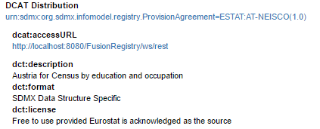

<gen:ReportedAttribute id="DCAT_DISTRIBUTION">

<com:StructuredText xml:lang="en" xmlns:com="http://www.sdmx.org/resources/sdmxml/schemas/v2_1/common">&lt;p>&lt;a href="urn:sdmx:org.sdmx.infomodel.registry.ProvisionAgreement=ESTAT:AT-NEISCO(1.0)">urn:sdmx:org.sdmx.infomodel.registry.ProvisionAgreement=ESTAT:AT-NEISCO(1.0)&lt;/a>&lt;/p></com:StructuredText>

<gen:AttributeSet>

<gen:ReportedAttribute id="ACCESS_URL">

<com:StructuredText xml:lang="en" xmlns:com="http://www.sdmx.org/resources/sdmxml/schemas/v2_1/common">&lt;p>&lt;a href="http://localhost:8080/FusionRegistry/ws/rest">http://localhost:8080/FusionRegistry/ws/rest&lt;/a>&lt;/p></com:StructuredText>

</gen:ReportedAttribute>

<gen:ReportedAttribute id="DISTRIBUTION_DESCRIPTION" value="Austria for Census by education and occupation"/>

<gen:ReportedAttribute id="DISTRIBUTION_FORMAT" value="SDMX Data Structure Specific"/>

<gen:ReportedAttribute id="DISTRIBUTION_LICENSE" value="Free to use provided Eurostat is acknowledged as the source"/>

</gen:AttributeSet>

</gen:ReportedAttribute>

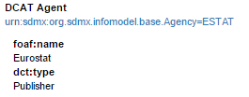

<gen:ReportedAttribute id="DCAT_AGENT">

<com:StructuredText xml:lang="en" xmlns:com="http://www.sdmx.org/resources/sdmxml/schemas/v2_1/common">&lt;p>&lt;a href="urn:sdmx:org.sdmx.infomodel.base.Agency=ESTAT">urn:sdmx:org.sdmx.infomodel.base.Agency=ESTAT&lt;/a>&lt;/p></com:StructuredText>

<gen:AttributeSet>

<gen:ReportedAttribute id="AGENT_NAME" value="Eurostat"/>

<gen:ReportedAttribute id="AGENT_TYPE" value="Publisher"/>

</gen:AttributeSet>

</gen:ReportedAttribute>

End of Metadata Set

</gen:AttributeSet>

</gen:Report>

</mes:MetadataSet>

1. Examples of StatDCAT-AP descriptions of Data Cube DataSets

RDF Example 1

Derived from <https://www.w3.org/TR/vocab-data-cube/#full-example>

@prefix dcat: <http://www.w3.org/ns/dcat#> .

@prefix dct: <http://purl.org/dc/terms/> .

@prefix eg: <http://example.org/ns#> .

@prefix geonames: <http://sws.geonames.org/> .

@prefix sdmx-dimension: <http://purl.org/linked-data/sdmx/2009/dimension#> .

@prefix sdmx-attribute: <http://purl.org/linked-data/sdmx/2009/attribute#> .

@prefix stat : <http://data.europa.eu/(xyz)/statdcat-ap/> .

@prefix theme: <http://publications.europa.eu/resource/authority/data-theme/> .

@prefix xsd: <http://www.w3.org/2001/XMLSchema#> .

# -- Dataset --------------------------------------------

eg:dataset-le3 a dcat:Dataset ;

dct:title "Life expectancy"@en ;

dct:description "Life expectancy within Welsh Unitary authorities - extracted from Stats Wales"@en ;

dct:publisher eg:organization ;

dct:issued "2010-08-11"^^xsd:date ;

# These four properties have been copied from the source metadata.

dcat:theme

theme:HEAL , # Health

theme:REGI ; # Regions and cities

# dct:subject

# sdmx-subject:3.2 , # regional and small area statistics

# sdmx-subject:1.4 , # Health

#

# These subjects have been mapped to the MDR Data Theme NAL. Note that this is not a

# trivial mapping but may require specific mapping tables or owl:sameAs assertions.

dct:spatial geonames:2634865 ; #Wales

# ex-geo:wales; # Wales

# The subject in the source mapped to dct:spatial and value from Geonames. Note again that

# this may require specific mapping tables or owl:sameAs assertions.

stat:dimension eg:refArea ;

stat:dimension eg:refPeriod ;

stat:dimension sdmx-dimension:sex ;

stat:attribute sdmx-attribute:unitMeasure ;

# The values of these properties copied from the qb:attribute and qb:dimension properties

# in the source metadata.

stat:statUnitMeasure <http://dbpedia.org/resource/Year> .

# The value of this property copied from the sdmx-attribute:unitMeasure property

# in the source metadata.

# -- Distribution -----------------------------------------

eg:distribution-le3 a dcat:Distribution ;

dcat:accessURL <http://example.org/file.rdf> ;

dct:format <http://publications.europa.eu/mdr/authority/file-type/RDF_TURTLE> .

# The format is not specified in the source metadata but added here for completeness.

# The URI for Distribution is declared in the eg: namespace – this was not specified in the

# the source metadata as this did not describe the distribution separately.

# In addition, a link to a file is shown as value for dcat:accessURL which was not

# specified in the source metadata.

# Note that the definitions of eg:organization, eg:refArea and eg:refPeriod have not been

# reproduced here. They are defined in the source metadata.

RDF Example 2

Derived from <https://digital-agenda-data.eu/datasets/digital_agenda_scoreboard_key_indicators/@@get_dataset_metadata>

@prefix adms: <http://www.w3.org/ns/adms#> .

@prefix dad-prop: <http://semantic.digital-agenda-data.eu/def/property/> .

@prefix dcat: <http://www.w3.org/ns/dcat#> .

@prefix dct: <http://purl.org/dc/terms/> .

@prefix ns22: <http://semantic.digital-agenda-data.eu/dataset/> .

@prefix ns25: <http://ec.europa.eu/geninfo/legal_notices_en.htm#> .

@prefix ns26: <http://publications.europa.eu/resource/authority/access-right/> .

@prefix ns27: <http://publications.europa.eu/resource/authority/language/> .

@prefix ns28: <http://publications.europa.eu/resource/authority/corporate-body/> .

@prefix ns29: <http://publications.europa.eu/resource/authority/country/> .

@prefix ns30: <http://semantic.digital-agenda-data.eu/dataset/digital-agenda-scoreboard-key-indicators/distribution/> .

@prefix ns31: <http://publications.europa.eu/resource/authority/data-theme/> .

@prefix ns33: <http://purl.org/adms/status/> .

@prefix ns35: <http://publications.europa.eu/resource/authority/frequency/> .

@prefix ns38: <http://publications.europa.eu/resource/authority/file-type/> .

@prefix ns39: <http://publications.europa.eu/resource/authority/distribution-type/> .

@prefix ns40: <http://digital-agenda-data.eu/datasets/digital_agenda_scoreboard_key_indicators#> .

@prefix ns41: <http://digital-agenda-data.eu/datasets/> .

@prefix stat : <http://data.europa.eu/(xyz)/statdcat-ap/> .

@prefix vcard: <http://www.w3.org/2006/vcard/ns#> .

@prefix xsd: <http://www.w3.org/2001/XMLSchema#> .

# ---- Dataset ----------------------------------------------------

ns22:digital-agenda-scoreboard-key-indicators a dcat:Dataset ;

dct:title "Digital Agenda Key Indicators" ;

dct:description "European Commission services selected more than 100 indicators, divided into thematic groups, which illustrate some key dimensions of the European information society (Telecom sector, Broadband, Mobile, Internet usage, Internet services, eGovernment, eCommerce, eBusiness, ICT Skills, Research and Development).\nThese indicators allow a comparison of progress across European countries as well as over time.\nYou can also browse the data with the help of a visualisation tools going at http://digital-agenda-data.eu/, where you are also able to download selected information." ;

dct:identifier "digital-agenda-scoreboard-key-indicators" ;

dct:issued "2011-05-01T00:00:00Z"^^xsd:dateTime ;

dct:modified "2016-11-11T10:31:56+02:00"^^xsd:dateTime ;

dct:publisher ns28:CNECT ;

dct:language ns27:ENG ;

dct:accessRights ns26:PUBLIC ;

dct:spatial ns29:TUR , ns29:NOR , ns29:ISL , ns29:EUR , ns29:CHE ;

dcat:keyword "ebusiness" , "broadband" , "internet" , "ICT research" , "ecommerce" , "digital agenda" , "telecom market" , "ICT skills" , "information-society" ;

dcat:theme ns31:SOCI , ns31:TECH , ns31:GOVE ;

dct:temporal [ schema:startDate "2002-01-01+03:00"^^xsd:date ] ;

dcat:distribution ns30:download ;

dcat:distribution ns30:visualisation ;

adms:status ns33:Completed ;

dcat:landingPage <http://digital-agenda-data.eu/> ;

# all properties above are copies of the source metadata.

# <https://digital-agenda-data.eu/datasets/digital_agenda_scoreboard_key_indicators>.

# However, the duplicated values of dct:title and dct:description in rdfs:label and

# rdfs:comment have not been included here.

dcat:contactPoint [ vcard:fn "DG CONNECT - Digital Economy and Skills (Unit F.4)" ;

vcard:hasEmail <mailto:CNECT-F4@ec.europa.eu> ;

vcard:hasURL <https://ec.europa.eu/digital-single-market/en/> ] ;

# The information for contact point has been adapted to follow DCAT-AP guidelines

# <https://joinup.ec.europa.eu/node/150343/>, using vcard properties. The source treats contact

# point as both a vcard:Organization and an org:Organization which seems to be sematically

# questionable.

dct:accrualPeriodicity ns35:ANNUAL_2 ;

# The source metadata has the statement

# dcat:accrualPeriodicity ns35:ANNUAL_2 ; which is incorrect

stat:attribute dad-prop:flag ;

stat:attribute dad-prop:note ;

stat:dimension dad-prop:breakdown ;

stat:dimension dad-prop:indicator ;

stat:dimension dad-prop:ref-area ;

stat:dimension dad-prop:time-period ;

stat:dimension dad-prop:unit-measure .

# The values of the properties stat:attribute and stat:dimensions have been copied from all

# occurrences of qb:attribute and qb:dimension properties as suggested in the StatDCAT-AP

# specification.

# ---- Distributions ----------------------------------------------

ns30:download a dcat:Distribution ;

dct:format ns38:RDF_TURTLE ;

dct:type ns39:DOWNLOADABLE_FILE ;

dcat:accessURL ns40:download ;

dct:license ns25:copyright .

ns30:visualisation a dcat:Distribution ;

dct:type ns39:VISUALIZATION ;

dcat:accessURL ns41:digital_agenda_scoreboard_key_indicators ;

dct:license ns25:copyright .

# All properties for the distributions have been copied from the source. The only exception

# is dct:license. The source assigns this to the dataset; here it is copied to each of

# the distributions in line with DCAT.

# Note that the definitions of the terms in the dad-prop namespace have not been

# reproduced here. They are defined in the source metadata.

1. Change Log

The table below summarises the changes applied to the current release of the StatDCAT-AP.

|  |  |  |  |  |  |
| --- | --- | --- | --- | --- | --- |
| URI | Type | Action | Description | Issue | Release |
| dcat:  StatDCAT-AP: | URI  (in example) | Updated | dcat:→ http://www.w3.org/ns/dcat#  *StatDCAT-AP* → http://data.europa.eu/xyz | [StatDCAT-AP-2](https://github.com/SEMICeu/StatDCAT-AP/issues/2) | 1.0.1 |
| <http://purl.org/dc/terms/> | Prefix  (in example) | Updated | *@prefix dcterms:* → *@prefix dct:* | [StatDCAT-AP-1](https://github.com/SEMICeu/StatDCAT-AP/issues/1) | 1.0.1 |
| schema:startDate  schema:endDate | DCAT-AP UML schema | Updated | *Updates :*  *Reversed the order of the properties startDate and endDate from dct:PeriodOfTime* | [DCAT-AP-50](https://github.com/SEMICeu/DCAT-AP/issues/50) | 1.0.1 |
|  |  |  |  |  |  |

Further textual changes (release1.0.1):

1. To make the specification consistent as in [StatDCAT-AP-1](https://github.com/SEMICeu/StatDCAT-AP/issues/1), in Annex VII, example 2 : *@prefix dcterm :*→ *@prefix dct :.*
2. Updated links to authority files as in [DCAT-AP-54](https://github.com/SEMICeu/DCAT-AP/issues/54) :

* Publications Office Metadata Registry→ *EU Vocabularies .*
* (<http://publications.europa.eu/mdr/authority/>)→ (<https://publications.europa.eu/en/web/eu-vocabularies/home>)**.**
* Updatedreferences 41, 44, 57-64, 78 .
* *Table1*, *Column - Vocabulary name*: MDR →EU Vocabularies.

1. *In Section 3.2.2,* DCAT-AP UML data model has been updated as in[DCAT-AP-50](https://github.com/SEMICeu/DCAT-AP/issues/50).

1. European Commission. ISA – Interoperability Solutions for European Public Administrations. DCAT Application Profile for data portals in Europe. <http://ec.europa.eu/isa/ready-to-use-solutions/dcat-ap_en.htm>
2. SDMX. <http://ec.europa.eu/eurostat/data/sdmx-data-metadata-exchange>
3. Draft 4. <https://joinup.ec.europa.eu/node/152858>
4. European Commission. Joinup. Process and methodology for developing semantic agreements. <https://joinup.ec.europa.eu/community/core_vocabularies/document/process-and-methodology-developing-semantic-agreements>
5. StatDCAT-AP Working documents. <https://joinup.ec.europa.eu/asset/stat_dcat_application_profile/asset_release/all>
6. StatDCAT-AP issue tracker. <https://joinup.ec.europa.eu/asset/stat_dcat_application_profile/issue/all>
7. StatDCAT-AP mailing list. <http://joinup.ec.europa.eu/mailman/listinfo/stat_dcat_application_profile>
8. Gov.uk. Cabinet Office. G8 Open Data Charter and Technical Annex. Policy paper, 18 June 2013. Action 2: Release of high value data. <https://www.gov.uk/government/publications/open-data-charter/g8-open-data-charter-and-technical-annex>
9. European Commission. Digital Agenda for Europe. EU Implementation of the G8 Open Data Charter. 31 October 2013. <http://ec.europa.eu/digital-agenda/en/news/eu-implementation-g8-open-data-charter>
10. EUR-Lex. Commission notice — Guidelines on recommended standard licences, datasets and charging for the reuse of documents. OJ C 240, 24.7.2014, p. 1–10. <http://eur-lex.europa.eu/legal-content/EN/TXT/?qid=1480418678733&uri=CELEX:52014XC0724(01)>
11. EUR-Lex. Directive 2013/37/EU of the European Parliament and of the Council of 26 June 2013 amending Directive 2003/98/EC on the re-use of public sector information. <http://eur-lex.europa.eu/legal-content/EN/TXT/?qid=1480419242202&uri=CELEX:32013L0037>
12. European Commission. European Data Portal. <http://www.europeandataportal.eu/>
13. European Commission. ISA – Interoperability Solutions for European Public Administrations. DCAT Application Profile for data portals in Europe. <http://ec.europa.eu/isa/ready-to-use-solutions/dcat-ap_en.htm>
14. European Commission. ISA – Interoperability Solutions for European Public Administrations. <http://ec.europa.eu/isa/about-isa/>
15. ESMS: <http://ec.europa.eu/eurostat/data/metadata/metadata-structure>
16. StatDCAT-AP - Draft 4. <https://joinup.ec.europa.eu/node/152858>
17. W3C. The RDF Data Cube Vocabulary. W3C Recommendation 16 January 2014. <https://www.w3.org/TR/2014/REC-vocab-data-cube-20140116/>
18. W3C. Data Catalog Vocabulary (DCAT). W3C Recommendation 16 January 2014. <http://www.w3.org/TR/vocab-dcat/>
19. Publications Office of the European Union. EU Vocabularies. Metadata Registry (MDR). <https://publications.europa.eu/en/web/eu-vocabularies>
20. Statistical Data and Metadata eXchange. <https://sdmx.org/>
21. IETF. RFC 3986. Uniform Resource Identifier (URI): Generic Syntax. <https://www.ietf.org/rfc/rfc3986.txt>
22. IETF. RFC 1738. Uniform Resource Locators (URL). <https://www.ietf.org/rfc/rfc1738.txt>
23. European Union Open Data Portal. <http://open-data.europa.eu>
24. See the file ESTAT_xxx.zip in <http://ec.europa.eu/eurostat/estat-navtree-portlet-prod/BulkDownloadListing>
25. ESMS: <http://ec.europa.eu/eurostat/data/metadata/metadata-structure>
26. SDMX Glossary: <https://sdmx.org/wp-content/uploads/SDMX_Glossary_Version_1_0_February_2016.docx>
27. Commission Recommendation of 23 June 2009 on reference metadata for the European Statistical System (2009/498/EC) (Official Journal of the European Union No L 168, 30.6.2009). <http://eur-lex.europa.eu/LexUriServ/LexUriServ.do?uri=OJ:L:2009:168:0050:0055:EN:PDF>
28. W3C. Government Linked Data Working Group. <https://www.w3.org/2011/gld/charter>
29. US spelling from the original.
30. CSV. <https://tools.ietf.org/html/rfc4180>
31. European Commission. Joinup. DCAT application profile for data portals in Europe. Final. <https://joinup.ec.europa.eu/asset/dcat_application_profile/asset_release/dcat-application-profile-data-portals-europe-final>
32. European Commission. Joinup. DCAT application profile for data portals in Europe. DCAT-AP v1.1. <https://joinup.ec.europa.eu/asset/dcat_application_profile/asset_release/dcat-ap-v11>
33. Directive 2007/2/EC of the European Parliament and of the Council of 14 March 2007 establishing an Infrastructure for Spatial Information in the European Community (INSPIRE). <http://eur-lex.europa.eu/legal-content/EN/ALL/?uri=CELEX:32007L0002>
34. GEMET, the GEneral Multilingual Environmental Thesaurus, has been developed as an indexing, retrieval and control tool for the European Topic Centre on Catalogue of Data Sources (ETC/CDS) and the European Environment Agency (EEA). <https://www.eionet.europa.eu/gemet/>
35. EuroVoc is a multilingual, multidisciplinary thesaurus covering the activities of the EU. https://publications.europa.eu/en/web/eu-vocabularies/th-dataset/-/resource/dataset/eurovoc
36. <https://publications.europa.eu/en/web/eu-vocabularies/at-dataset/-/resource/dataset/eurovoc>
37. European Commission. Joinup. DCAT application profile for data portals in Europe. GeoDCAT-AP v1.0. <https://joinup.ec.europa.eu/asset/dcat_application_profile/asset_release/geodcat-ap-v10>
38. Data Cube Vocabulary. <https://www.w3.org/TR/vocab-data-cube/>
39. W3C. The RDF Data Cube Vocabulary. W3C Recommendation 16 January 2014. <http://www.w3.org/TR/vocab-data-cube/>
40. European Commission. Joinup. Process and methodology for developing semantic agreements. <https://joinup.ec.europa.eu/community/core_vocabularies/document/process-and-methodology-developing-semantic-agreements>
41. European Commission. Joinup. DCAT application profile for data portals in Europe. DCAT-AP v1.1. <https://joinup.ec.europa.eu/asset/dcat_application_profile/asset_release/dcat-ap-v11>
42. W3C. Data Catalogue Vocabulary. W3C Recommendation 16 January 2014. <https://www.w3.org/TR/vocab-dcat/>
43. Data on the Web Best Practices: Data Quality Vocabulary. W3C Working Draft 19 May 2016. <https://www.w3.org/TR/vocab-dqv/>
44. EU Vocabularies. Distribution types. <https://publications.europa.eu/en/web/eu-vocabularies/at-dataset/-/resource/dataset/distribution-type>
45. IETF. RFC 2119. Key words for use in RFCs to Indicate Requirement Levels. <http://www.ietf.org/rfc/rfc2119.txt>
46. The actual namespace URI will be assigned by the European Commission’s URI Committee.
47. W3C. The Organization Ontology. W3C Candidate Recommendation, 25 June 2013. <http://www.w3.org/TR/2013/CR-vocab-org-20130625/>
48. IETF. BCP 47. Tags for Identifying Languages. <http://www.rfc-editor.org/rfc/bcp/bcp47.txt>
49. European Commission. Joinup. Core Location Vocabulary. <https://joinup.ec.europa.eu/asset/core_location/description>
50. Mikulski Archive for Space Telescopes (MAST). Referencing Data Sets in Astronomical Literature. <http://archive.stsci.edu/pub_dsn.html>
51. DataCite. <http://www.datacite.org/>
52. DOI. Digital Object Identifier. <http://www.doi.org/>
53. EZID. <http://n2t.net/ezid>
54. W3C Permanent Identifier Community Group. Permanent Identifiers for the Web. <https://w3id.org/>
55. DataCite Resource Identifier Scheme. <http://purl.org/spar/datacite/ResourceIdentifierScheme>
56. Internet Assigned Numbers Authority (IANA). Media Types <http://www.iana.org/assignments/media-types/>
57. EUROPA. Publications Office of the EU. EU Vocabularies. Controlled Vocabularies.Access right. https://publications.europa.eu/en/web/eu-vocabularies/at-concept-scheme/-/resource/authority/access-right
58. EUROPA. Publications Office of the EU. EU Vocabularies. ControlledVocabulariesFrequencies. [https://publications.europa.eu/en/web/eu-vocabularies/at-dataset/-/resource/dataset/frequency](http://publications.europa.eu/mdr/authority/frequency) 
59. EUROPA. Publications Office of the EU. EU Vocabularies. Controlled Vocabularies.File types. [https://publications.europa.eu/en/web/eu-vocabularies/at-dataset/-/resource/dataset/file-type](https://publications.europa.eu/en/web/eu-vocabularies/at-dataset/-/resource/dataset/file-type%20) 
60. EUROPA. Publications Office of the EU. EU Vocabularies. Controlled Vocabularies. Authority tables. Language. <https://publications.europa.eu/en/web/eu-vocabularies/at-dataset/-/resource/dataset/language/>
61. Publications Office of the European Union. Metadata Registry. Authorities. Corporate bodies. <https://publications.europa.eu/en/web/eu-vocabularies/at-dataset/-/resource/dataset/corporate-body/>
62. EUROPA. Publications Office of the EU. EU Vocabularies. Controlled Vocabularies.Continent. <https://publications.europa.eu/en/web/eu-vocabularies/at-dataset/-/resource/dataset/continent>
63. Publications Office of the European Union. Metadata Registry. Authorities. Countries. <https://publications.europa.eu/en/web/eu-vocabularies/at-dataset/-/resource/dataset/country>
64. Publications Office of the European Union. Metadata Registry. Authorities. Places. <https://publications.europa.eu/en/web/eu-vocabularies/at-dataset/-/resource/dataset/place>
65. European Commission. Joinup. Asset Description Metadata Schema (ADMS). ADMS 1.00. <http://joinup.ec.europa.eu/asset/adms/release/100>
66. EuroVoc. https://publications.europa.eu/en/web/eu-vocabularies/th-dataset/-/resource/dataset/eurovoc.
67. http://www.eurocris.org/Uploads/Web%20pages/CERIF-1.5/CERIF1.5_Semantics.xhtml
68. OCLC. Dewey Summaries as Linked Data. <http://www.oclc.org/dewey/webservices.en.html> and <http://dewey.info/>
69. Creative Commons. About The Licenses. <http://creativecommons.org/licenses/>
70. Creative Commons. CC0 1.0 Universal (CC0 1.0) Public Domain Dedication. <http://creativecommons.org/publicdomain/zero/1.0/>
71. Open Data Commons Public Domain Dedication and License (PDDL). <http://opendatacommons.org/licenses/pddl/>
72. ISA Open Metadata Licence v1.1, <https://joinup.ec.europa.eu/category/licence/isa-open-metadata-licence-v11>
73. European Commission. Joinup. Open Source Software. European Union Public Licence (EUPL). <http://joinup.ec.europa.eu/software/page/eupl>
74. The National Archives. Open Government Licence for public sector information. <http://www.nationalarchives.gov.uk/doc/open-government-licence/version/2/>
75. Open Data Institute. <http://www.theodi.org/>
76. Open Data Institute. Open Data Rights Statement Vocabulary. <http://schema.theodi.org/odrs/>
77. Open Digital Rights Language (ODRL) Initiative. <http://www.w3.org/community/odrl/>
78. EUROPA. Publications Office of the EU. EU Vocabularies. Controlled Vocabularies. Authority tables. Roles. <https://publications.europa.eu/en/web/eu-vocabularies/at-dataset/-/resource/dataset/role>
79. European Commission. INSPIRE Registry. Responsible Party Role. <http://inspire.ec.europa.eu/metadata-codelist/ResponsiblePartyRole/>
80. Library of Congress. MARC Code List for Relators. <http://loc.gov/marc/relators/relaterm.html>
81. DataCite Metadata Schema for the Publication and Citation of Research Data, version 3.1. In: <https://schema.datacite.org/meta/kernel-3/doc/DataCite-MetadataKernel_v3.1.pdf>, Appendix 1, table 5.
82. W3C. PROV-O: The PROV Ontology. W3C Recommendation 30 April 2013. <http://www.w3.org/TR/prov-o/>
83. European Commission. Joinup. DCAT application profile for data portals in Europe. GeoDCAT-AP – How to express the different responsible party roles supported in ISO 19115 / INSPIRE. <https://joinup.ec.europa.eu/node/141757>
84. Internet Engineering Task Force (IETF). BCP47. Tags for Identifying Languages. <http://tools.ietf.org/html/bcp47>
85. Internet Engineering Task Force (IETF). BCP47 Extension T – Transformed Content. <http://tools.ietf.org/html/rfc6497>
86. UNICODE Consortium. CLDR - Unicode Common Locale Data Repository. BCP47, transform_mt.xml. <http://unicode.org/cldr/trac/browser/trunk/common/bcp47/transform_mt.xml>
87. Apache Web Server: content negotiation. <http://httpd.apache.org/docs/current/content-negotiation.html>
88. StatDCAT-AP Draft 4. <https://joinup.ec.europa.eu/node/152858>
89. Working documents. <https://joinup.ec.europa.eu/asset/stat_dcat_application_profile/asset_release/all>
90. Issue tracker. <https://joinup.ec.europa.eu/asset/stat_dcat_application_profile/issue/all>
91. Mailing list of StatDCAT-AP. <http://joinup.ec.europa.eu/mailman/listinfo/stat_dcat_application_profile>
92. StatDCAT-AP Final version. <https://joinup.ec.europa.eu/node/157143>